**MINISTRY OF EDUCATION AND TRAINING**

**FPT UNIVERSITY**

**DOCUMENT REPORT**

Capstone Project Document

**VN Habit Tracker**

|  |  |
| --- | --- |
| **Group 3** | |
| **Group members** | Lưu Thành Đạt - SE61124  Phạm Thanh Tùng - SE61628  ~~Nguyễn Quang Tuyến - SE62069~~  ~~Nguyễn Hữu Thắng - SE62447~~ |
| **Supervisor** | Lại Đức Hùng |
| **Ext. Supervisor** | N/A |
| **Capstone Project code** | VHT |

- Ho Chi Minh city, September 14th 2018

Contents

**List of tables** 6

**List of Figure** 10

Definitions, Acronyms, and Abbreviations 12

A. Introduction 13

1. Project Information 13

2. Introduction 13

3. Current Situation 13

4. Problem Definition 13

5. Functional Requirements 14

6. Proposed Solution 14

6.1. Feature functions 14

6.2. Advantages and disadvantages 15

7. Role and Responsibility 15

B. Software Project Management Plan 16

1. Problem Definition 16

1.1. Name of this Capstone Project 16

1.2. Problem Abstract 16

1.3. Project Overview 16

2. Project organization 19

2.1. Software process model 19

2.2. Roles and responsibilities 20

2.3. Tools and Techniques 21

3. Project Management Plan 21

3.1. Software development life cycle 21

3.2. Phase Detail 22

3.3. All Meeting Minutes 24

4. Coding Convention 24

C. Software Requirement Specification 26

1. User Requirement Specification 26

1.1. Guest Requirement 26

1.2. User Requirement 26

1.3. Admin Requirement 27

2. System Requirement Specification 27

2.1. External Interface Requirement 27

2.2. System Overview Use Case 28

2.3. List of Use Case 29

3. Software System Attribute 93

3.1. Usability 93

3.2. Reliability 93

3.3. Availability 93

3.4. Security 93

3.5. Maintainability 93

3.6. Portability 94

3.7. Performance 94

4. Conceptual Diagram 94

D. Software Design Description 95

1. Design Overview 95

2. System architecture design 96

2.1. Web application architecture description 96

2.2. Mobile application architecture description 97

3. Component Diagram 98

4. Detailed Description 100

4.1. Class diagram 100

4.2. Class Diagram Explanation 101

4.3. Interaction Diagram 105

4.4. Activity diagram 109

5. User Interface Design 110

5.1. Mobile application user interface 110

6. Database Design 120

6.1. Entity relationship diagram (ERD) 120

6.2. Entity dictionary 121

7. Algorithms 124

7.1. Recommend the best habits for users by linear programming algorithm 124

E. System Implementation & Test 129

1. Introduction 129

1.1. Overview 129

1.2. Test approach 129

2. Database Relationship Diagram 130

2.1. Physical diagram 130

2.2. Data dictionary 131

3. Test plan 134

3.1. Features to be tested 134

3.2. Features not to be tested 134

4. System Testing Test Case 134

4.1. Test case 134

4.2. テストケース 146

F. Software User’s Manual 161

1. Installation Guide 161

1.1. Hardware Requirement 161

1.2. Software Requirement 161

2. User Guide 162

2.1. Login 162

2.2. Register 163

2.3. View Main Page 164

2.4. Add Habit 165

2.5. Edit Habit 167

2.6. Delete Habit 169

2.7. View All Statistic of User 171

2.8. Add Reminder 172

2.9. Delete Reminder 174

2.10. Add Group 175

F1. ソフトウェアユーザーマニュアル 176

1.インストレーションガイド 176

1.1. ハードウェア要件 176

1.2. ソフトウェア要件 177

2. ユーザーガイド 177

2.1. ログイン 177

2.2. 登録 178

2.3. メインページを見る 180

2.4. 習慣を追加する 181

2.5. 習慣を編集する 183

2.6. 習慣を削除する 186

2.7. ユーザーの全統計を表示 187

2.8. リマインダを追加する 189

2.9. リマインダを削除する 190

2.10. グループを追加 192

G. Appendix 193

1. Sofware Engineering 9th Edition, By Ian Sommerville 193

2. StarUML Documentation For Activity Diagram 193

3. StarUML Documentation of IBM 193

4. UML For Drawing Diagram (2.0 Standard) 193

5. Android Studio Documentation 193

# **List of tables**

Table 1: Roles and Responsibilities 14

Table 2 : Hardware Requirement for Server 17

Table 3 : Hardware Requirement for Mobile 17

Table 4 : Software requirements 18

Table 5 : Roles and responsibilities 20

Table 6: Tools List 20

Table 7: Technique List 20

Table 8: Software Development Life Cycle Detail 21

Table 9: Phase 1: Infrastructure 22

Table 10: Phase 3: Web service 22

Table 11: Phase 4: Mobile app 23

Table 12 - <Guest> Login 30

Table 13 - <Guest> Register 32

Table 14 - <User> Feedback 35

Table 15 - <User> Set Reminder 37

Table 16 - <User> Edit Reminder 39

Table 17 - <User> Delete reminder 41

Table 18 - <User> Export Statistic File 43

Table 19 - <User> Add Habit 46

Table 20 - <User> Delete Habit 48

Table 21 - <User> Edit Habit 50

Table 22 - <User> Set Habit Reminder 53

Table 23 - <User> Delete Habit Reminder 56

Table 24 - <User> Set Habit Reminder 59

Table 25 - <User> View Statistic Habit 60

Table 26 - <User> Add Description 62

Table 27 - <User> Edit Description 64

Table 28 - <User> Delete Description 66

Table 29 - <User> Add Group 69

Table 30 - <User> Delete Group 72

Table 31 - <User> View Profiles 74

Table 32 - <User> Edit Profiles 76

Table 33 - <User> Suggest Habit 78

Table 34 - <User> Filter Habit 80

Table 35 - <User> View Statistics 82

Table 36 - <User> View Top Habits 84

Table 37 - <User> Logout 85

Table 38 - <Admin> Reset Password 88

Table 39 - <Admin> View Feedback 90

Table 40 - <Admin> View Statistics 92

Table 41 - Conceptual Diagram Dictionary 94

Table 42 - Component Web Dictionary 98

Table 43 - Component Android Application Dictionary 99

Table 44 - Class Diagram Dictionary 101

Table 45 – Class Diagram Explanation <User> 102

Table 46 - Class Diagram Explanation <Admin> 102

Table 47 - Class Diagram Explanation <Habit> 103

Table 48 - Class Diagram Explanation <Feedback> 103

Table 49 – Class Diagram Explanation <Reminder> 104

Table 50 – Class Diagram Explanation <Tracker> 104

Table 51 - Class Diagram Explanation <Group> 105

Table 52 - Login <Field> 110

Table 53 - Login <Buttons/Hyperlinks> 110

Table 54 - Register <Field> 111

Table 55 - Register <Buttons/Hyperlinks> 112

Table 56 - Main page <Buttons/Hyperlinks> 112

Table 57 - Add Habit <Field> 114

Table 58 - Add Habit <Buttons/Hyperlinks> 114

Table 59 - Edit and Delete Habit <Field> 116

Table 60 - Edit and Delete Habit <Buttons/Hyperlinks> 116

Table 61 - Edit Detail <Buttons/Hyperlinks> 117

Table 62 - Reminder <Field> 118

Table 63 - Reminder <Buttons/Hyperlinks> 118

Table 64 - Group <Field> 119

Table 65 - Group <Buttons/Hyperlinks> 119

Table 66 – Entity Relationship Diagram Dictionary 121

Table 67 – Entity Relationship Diagram Detail Dictionary 123

Table 68 - physical diagram dictionary 131

Table 69 - physical diagram detail dictionary 133

Table 70 - Test case <login> 135

Table 71 - Test case <Register> 136

Table 72 - Test case <Add Habit> 139

Table 73 - Test case <Edit Habit> 141

Table 74 - Test case <Delete Habit> 141

Table 75 - Test case <Search Suggest Habit> 142

Table 76 - Test case <View Statistic> 143

Table 77 - Test case <Filter> 143

Table 78 - Test case <tracking Habit> 144

Table 79 - Adjust Settings 145

Table 80 - Test case <Manage Group> 146

Table 81 - テストケース <ログイン> 148

Table 82 - テストケース <登録> 150

Table 83 - テストケース <習慣を追加する> 152

Table 84 - テストケース <癖を編集する> 154

Table 85 - テストケース <習慣を削除する> 155

Table 86 - テストケース <習慣を提案する> 156

Table 87 - テストケース <統計情報を見る> 157

Table 88 - テストケース <フィルターを調整する> 159

Table 89 - テストケース <トラッキングの習慣> 160

Table 90 - テストケース <設定を調整する> 161

Table 91 - テストケース <グループを管理する> 163

Table 92 - Hardware Requirement 164

Table 93 - Software Requirement for Client 164

Table 94 - Software Requirement for Android 164

Table 95 - User Guide <Login> 165

Table 96 - User Guide <Register> 167

Table 97 - User Guide <Add Habit> 170

Table 98 - User Guide <Edit Habit> 172

Table 99 - User Guide <Delete Habit> 173

Table 100 - User Guide <View All Statistic Habit of User> 175

Table 101 - User Guide <Add Reminder> 176

Table 102 - User Guide <Delete Reminder> 178

Table 103 - User Guide <Add Group> 179

Table 104 - ハードウェア要件 180

Table 105 - ソフトウェア要件 180

Table 106 - ユーザーガイド <ログイン> 181

Table 107 - ユーザーガイド <登録> 182

Table 108 - ユーザーガイド <習慣を編集する> 188

Table 109 - ユーザーガイド <習慣を削除する> 190

Table 110 - ユーザーガイド <ユーザーの全統計を表示> 191

Table 111 - ユーザーガイド <リマインダを追加する> 193

Table 112 - ユーザーガイド <リマインダを削除する> 194

Table 113 - ユーザーガイド <グループを追加> 196

# **List of Figure**

Figure 1 : Waterfall model 18

Figure 2- System Overview Use Case Diagram 26

Figure 3- <Guest>Overview Use Case 27

Figure 4 - <Guest> Login 27

Figure 5 - <Guest> Register 29

Figure 6 - <User> Overview Use Case 32

Figure 7 - <User> Feedback and Contact Us 32

Figure 8 - <User> Set User Reminder 35

Figure 9 - <User> Edit Reminder 37

Figure 10 - <User> Delete User Reminder 39

Figure 11 - <User> Export Statistic File 41

Figure 12 - <User> Add Habit 43

Figure 13 - <User> Delete Habit 45

Figure 14 - <User> Edit Habit 47

Figure 15 - <User> Set Habit Reminder 50

Figure 16 - <User> Delete Habit Reminder 53

Figure 17 - <User> Edit Habit Reminder 55

Figure 18 - <User> View Statistic Habit 58

Figure 19 - <User> Add Description 60

Figure 20 - <User> Edit Description 62

Figure 21 - <User> Delete Description 64

Figure 22 - <User> Add Group 66

Figure 23 - <User> Delete Group 69

Figure 24 - <User> View Profiles 71

Figure 25 - <User> Edit Profiles 73

Figure 26 - <User> Suggest Habit 75

Figure 27 - <User> Filter Habit 78

Figure 28 - <User> View Statistics 80

Figure 29 - <User> View Top Habits 81

Figure 30 - <User> Logout 83

Figure 31 - <Admin> Overview Use Case 85

Figure 32 - <Admin> Reset Password 85

Figure 33 - <Admin> View Feedback 87

Figure 34 - <Admin> View Statistics 89

Figure 35 - Conceptual Diagram 92

Figure 36 - Web application architecture description 94

Figure 37 - Mobile application architecture description 95

Figure 38 - Component Web Diagram 96

Figure 39 - Component Mobile Application Diagram 97

Figure 40 - Class Diagram 99

Figure 41 - Sequence Diagram for add habit <User> 104

Figure 42 -Sequence Diagram for edit habit <User> 105

Figure 43 - Sequence Diagram for delete habit <User> 105

Figure 44 - Sequence Diagram for add reminder <User> 106

Figure 45 - Sequence Diagram for edit reminder <User> 106

Figure 46 - Sequence Diagram for delete reminder <User> 107

Figure 47 - Activity Diagram for habit 108

Figure 48 - User Interface <Login> 109

Figure 49 - User Interface <Register> 110

Figure 50 - User Interface <Main page> 111

Figure 51 - User Interface <Add Habit> 112

Figure 52 - User Interface <Edit and Delete Habit> 114

Figure 53 - User Interface <Edit Detail> 116

Figure 54 - User Interface <Reminder> 117

Figure 55 - User Interface <Group> 118

Figure 56 - Entity Relationship Diagram 119

Figure 57 - Flowchart of Recommend the best habits for users by linear programming algorithm 127

Figure 58 - Physical Diagram 129

Figure 59 - User Guide <Login> 164

Figure 60 - User Guide <Register> 165

Figure 61 - User Guide <View Main Page> 166

Figure 62 - User Guide <Add Habit> 168

Figure 63 - User Guide <Edit Habit> 170

Figure 64 - User Guide <Delete Habit> 172

Figure 65 - User Guide <View All Statistic Habit of User> 173

Figure 66 - User Guide <Add Reminder> 175

Figure 67 - User Guide <Delete Reminder> 176

Figure 68 - User Guide <Add Group> 178

Figure 69 - ユーザーガイド <ログイン> 179

Figure 70 - ユーザーガイド <登録> 181

Figure 71 - ユーザーガイド <習慣を追加する> 183

Figure 72 - ユーザーガイド <習慣を追加する> 184

Figure 73 - ユーザーガイド <習慣を編集する> 186

Figure 74 - ユーザーガイド <習慣を削除する> 188

Figure 75 - ユーザーガイド <ユーザーの全統計を表示> 190

Figure 76 - ユーザーガイド <リマインダを追加する> 191

Figure 77 - ユーザーガイド <リマインダを削除する> 193

Figure 78 - ユーザーガイド <グループを追加> 194

# Definitions, Acronyms, and Abbreviations

|  |  |
| --- | --- |
| **Name** | **Definition** |
| VHT | VN Habit Tracker |
|  |  |

1. Introduction
2. Project Information

* Project name: **VN Habit Tracker**
* Abbreviation: **VHT**
* Product Type: **Web app & Mobile app**
* Start Date: **September 10th 2018**

1. I**ntroduction**

Habits are routine behaviors done on a regular basis. They are recurrent and often unconscious patterns of behavior and are acquired through frequent repetition. Many of these are unconscious as we don’t even realize, we are doing them.

Good habits are hard to develop when we use the typical tactic of trying to pump up our motivation to overcome our psychological resistance. Research has shown that motivation is an ineffective factor or creating lasting behavior change. Fortunately, we have also build an excellent alternative, which is called VHT. It let us tunnel right through the resistance barrier.

First thing is to track habits! You can also track recurring behavior that you want to keep under control. This tracker can be made for daily use, so you get a very clear overview of all your good and bad habits. By keeping a habit tracker, you are more conscious of your behaviors. You know actually what you are doing, more importantly, what not, what you should do. Without this tracker it can be very easy to believe you are indeed doing everything you want, but in the meantime, secretly, you are not. The tracker is a tool to transform your goals into good habit.

1. Current Situation

* Everyday our lives are governed by habit. These habits are the little routines and small ways of doing things.
* Most people are unaware or are only slightly aware that they’re doing them.
* VHT helps you to set goals, keep track of your habits and tackle your bad habits.

1. Problem Definition

* **Disadvantages:**
  + Vietnamese users do not have the official application for tracking habit.
  + Customer easily give up on using.

1. Functional Requirements

Function requirements of the system are listed as below:

* Add habits:
  + Choose habit: add a bad habit you want to reform or build a good one to improve.
  + Name habit: name that habit.
  + Choose period: choose daily, weekly, monthly.
  + Set goal: set up the goal you want to archive.
  + Choose group: set that habit belongs to which group that you want.
  + Adjust reminder: set time for the app to remind you.
  + Write description: write something that can motivate you.
  + Show statistics: show the statistics to display the chart in the present or in the past.
* Adjust setting:
* Set goal.
* Set reminder.
* Adjust filter: display the result in the form that customer want.
  + Choose goal period.
  + Choose goal type.
  + Choose goal values.
* Adjust chosen habit:
  + Edit chosen habits.

1. Proposed Solution

Our proposed solution is to build an application called “VN Habit Tracker” to resolve the current problems. The application collects (in real-time) all habits from customer. Moreover, it specifically helps them to track their habits daily, weekly and monthly. This application motivates them by showing the notification and reminder which depend on their setting. Customer can check their currently process. We also design the app which has statistics that helps customer to see their efforts.

VHT system is an app application with following functions:

12. * 1. Feature functions
    * Plan habits with an easy-to-use interface.
    * Habits fit into a number of different schedules, including specific times or days.
    * View stats in a number of different ways, with different data point.
    * Reminders.
    * Make sure no habit is forgotten with daily reminders.
    * Data Export.
    * Export your data to Excel or Numbers (CSV) and chart your progress.
    * Interactive Notifications.
    * Complete or snooze a habit right from the notification banner.
    * Weekly Targets.
    * Set how many days a week you would like to complete a habit.
    * Notes.
    * Write or dictate notes to capture all details of a habit. Great for exercise routines and daily journals.
    * Skip Functionality.
    * Going on vacation or taking a day off? Skip habits without breaking your chain.
    * Report.
      1. Advantages and disadvantages

These are advantages and disadvantages of current situation:

* **Advantages:**
  + - Customer easy to understand.
    - Friendly interface.
    - Motivate customer to change their bad habits.
    - VHT saves times and space for customer.
  + **Disadvantages:**
    - Advertising strategy difficulty of application.

1. Role and Responsibility

|  |  |  |  |  |
| --- | --- | --- | --- | --- |
| **No** | **Full Name** | **Role** | **Position** | **Contact** |
| 1 | Lại Đức Hùng | Project Supervisor | Supervisor | Hungld5@fe.edu.vn |
| 2 | Lưu Thành Đạt | Developer | Leader | Datltse61124@fpt.edu.vn |
| 3 | Phạm Thanh Tùng | Developer | Member | Tungptse61628@fpt.edu.vn |

Table 1: Roles and Responsibilities

1. Software Project Management Plan
2. Problem Definition
   * 1. Name of this Capstone Project

* **Official name**: VN Habit Tracker
* **Vietnamese name**: Ứng dụng theo dõi, cải tiến thói quen cho người Việt.
* **Abbreviation**: VHT
  + 1. Problem Abstract

Currently, in Viet Nam, the majority of people use smartphones every day. However, there is not a specific application for Vietnamese people to create habits, manage daily habits and track habits. The existing tracking habit applications are from foreign developer and thus may not really applicable for Vietnamese users. So, we have to find the best convenient way to make our application simplest and easy to use for anyone.

To solve this particular problem, we decided to provide an application that helps users do that*.* VHT help users to create habits, group habits, and prompt users to implement those habits. Create a goal for the user to try to achieve that habit over time and manage the statistics of the user’s system habits.

* + 1. Project Overview

**Current Situation**

Below are the problems encountered in this project:

* **User Habit:** people do not have a habit to set habit and manage habit by an application.
* **User:** easily give up when they depressed, unmotivated to continue a habit.
* Currently there is no application dedicated to Vietnamese.
* **Server crash**: The user's data loose when the server crashes. Because all data is stored on the server.
* **Interface**: user easy-to-use interface in VHT’s application.

**The Proposed System**

According to the survey of Vietnamese users, we find that most Vietnamese do not have a habit of scheduling, do not schedule what week they do. So, our solution now is to create an application specifically for Vietnamese users to improve and create their habits.

We build a system that is always maintained so that users can log in and use it on their mobile applications anytime, anywhere.

To solve the problem of creating habits and improving the habits of Vietnamese users, we need to know the Vietnamese people, what makes them do not create their daily routine.

Our system consists of two main systems: website and mobile applications. On the website, administrators manage users and statistical habits of Vietnamese. For mobile applications, we allow users to create and manage their habits.

* + - 1. Web Application

Web application consists of three main parts:

* For administrator:
  + Manage User.
  + Manage Feedbacks.
  + View statistics.

Besides, website application also provides an API interface for two mobile applications to retrieve, update data from mobile applications.

* + - 1. Mobile Application

The mobile applications included functions as below:

* User:
  + Manage habit.
  + Group habit.
  + Habits statistic.
  + Suggest Habit.
  + Tracking habit.
  + Feedback.
  + View top habits.
  + Manage profile.
  + Manage settings.
  + Export data.
    - 1. Boundaries of the System
* This application is built on the habits of Vietnamese. Our main target is helps them to set goals, keep track of habits and tackle bad habits.
* VN Habit Tracker which deployed this application must set up devices, includes:
  + Data export to CSV files.
  + Interactive notifications.
* The completed product includes:
  + Website application.
  + Android mobile application.

Future Plans

* With further research and development, the system can apply the following features:
  + Extend and create community using VHT.
  + Develop new features to set and remind users to create a habit: real time, remind by location..v..v..
  + Combined with smart watch and external devices to manage and message users.
  + Habit follow group.
  + Habit challenges.
  + Statistical data by location.
  + Recommend habits according to user information.
  + Bigdata & AI.

##### Hardware requirements

* **For web application server**

|  |  |  |
| --- | --- | --- |
| **Windows** | **Minimum Requirements** | **Recommended** |
| Internet Connection | Cable, Wi-Fi (4 Mbps) | Cable, Wi-Fi (8 Mbps) |
| Operating System | Window Server 2008 R2 | Window Server 2012 R2 |
| Computer Processor | Intel® Xeon ® 1.4GHz | Intel® Xeon ® Quad Core |
| Computer Memory | 2GB of RAM | 4GB of RAM or more |

Table 2 : Hardware Requirement for Server

* **For Mobile**

|  |  |  |
| --- | --- | --- |
| **Android** | **Minimum** | **Recommended** |
| Internet Connection | Wi-Fi or 3G (1 Mbps) | Wi-Fi or 3G (8 Mbps) |
| Operating System | Android 4.4.2 | Android 6.0.0 |
| Mobile Processor | Cortex-A7 Dual-Core 1.3GHz | Cortex-A7 Dual-Core 1.3GHz |
| Mobile Memory | 1GB of RAM | 2GB of RAM or more |

Table 3 : Hardware Requirement for Mobile

##### Software requirements

|  |  |  |
| --- | --- | --- |
| **Software** | **Name / Version** | **Description** |
| Operating system | Window Server 2012 R2 | Operating system and platform for development |
| Environment | Java | Specification for developing web application |
| IDE | IntelliJ IDEA, Android Studio v3.2.1 | Used for implement website and Android Mobile Application |
| Design Model tool | Star UML v2.5.1 | Used for creating modal and diagrams |
| DBMS | SQLite & MySQL | Used to create & manage the database for system |
| Document storage | Trello | Used for storing document |
| Store and manage source code | Git Hub | Used to store all source code |
| Web browser | Chrome or above | Testing browser |

Table 4 : Software requirements

1. Project organization
3. 2. 1. Software process model

The software process model used in developing the VHT project is based on the Water Fall model. We choose this model because of the following reason:

* The features of this product are strongly connected; therefore, a solid architect and clear requirement need to be set up in order to under project smoothly.
* The requirements are not supposed to be changed rapidly.

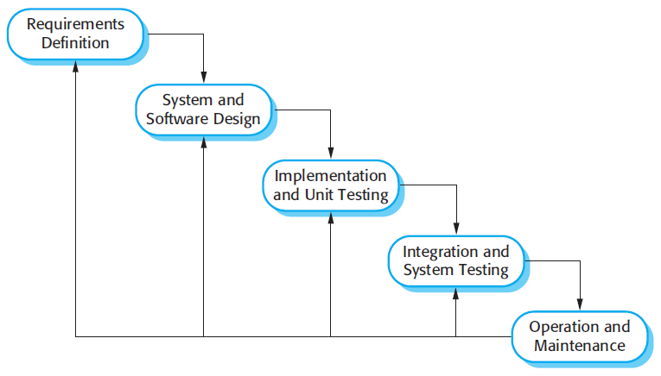

Figure 1 : Waterfall model

Reference: Page 30, chapter 2, Software process model, SOFTWARE ENGINEERING 9th Edition, by Ian Somerville.

* + 1. Roles and responsibilities

|  |  |  |  |
| --- | --- | --- | --- |
| **No** | **Full name** | **Role in Group** | **Responsibilities** |
| 1 | Lại Đức Hùng | Supervisor, Project Manager | * Specify user requirements * Control the development process * Give out technique and business analysis support |
| 2 | Lưu Thành Đạt | Team leader, B.A, Developer, Tester | * Managing process * Designing database * Clarifying requirements * Prepare documents * GUI design * Create test plan * Coding * Testing |
| 3 | Phạm Thanh Tùng | Team member,  B.A, Developer,  Tester | * Designing database * Clarifying requirements * Prepare documents * Create test plan * Coding |

Table 5 : Roles and responsibilities

* + 1. Tools and Techniques

|  |  |
| --- | --- |
| **Tool** | **Name / version** |
| Web server | PHP |
| Development tool | IntelliJ IDEA, NetBeans, Android Studio |
| DBMS | MySQL |
| Source control | Github |
| Modeling tool | Star UML v5.0.1 |
| Document tool | Microsoft Word 2016 |

Table 6: Tools List

|  |  |
| --- | --- |
| **Technique** | **Name / version** |
| Frontend | HTML5, CSS, JavaScript, WordPress, Sketch. |
| Backend | Java, Spring Boot, Hibernate, PHP, Android, Retrofit. |

Table 7: Technique List

1. Project Management Plan
2. 1. 1. Software development life cycle

|  |  |  |  |  |  |
| --- | --- | --- | --- | --- | --- |
| **Phase** | **Description** | **Deliverables** | **Resource needed** | **Dependencies and Constrains** | **Risks** |
| Infrastructure | - Identify and clarify overall requirements.  - Determine the system architecture.  - Build infrastructure for the project. | - Database design.  - System main structure. | 20 man-days | N/A | - Unclear project scope.  - Lack of member share of understand. |
| API services | - Identify requirements for mobile app.  - Build required API for mobile app. | - API for mobile app. | 20 man-days | - Depends on “Database Design”. | - Lack of experience. |
| Mobile apps | - Design the mobile UI  - Build mobile apps for end users and emulator. | - Complete Android Apps. | 60 man-days | - Depends on “API services”. | - Lack of experience.  - Lack of Habit Behavior knowledge. |
| Web App | - Implements all web app modules.  - Design the web UI.  - Build the web app. | - Complete Web Apps. | 20 man-days | - Depends on “API services”. | - Lack of experience. |

Table 8: Software Development Life Cycle Detail

* + 1. Phase Detail

  2. 2. 1. Phase 1: Infrastructure

|  |  |  |
| --- | --- | --- |
| **Task** | **Description** | **Author** |
| 1. Assessment | - Determine requirements.  - Determine requirements for System and API. | * DatLT * TungPT |
| 2. Selection | - Determine system architecture: Java Web & Android.  - Determine software design pattern: Repository & Service.  - Determined all core functions. | * DatLT * TungPT |
| 3. Development | - Create the main structure of project. | * DatLT * TungPT |
| 4. Review | - Review all completed works and presentation.  - Create sprint backlog. | * DatLT * TungPT |

Table 9: Phase 1: Infrastructure

* + - 1. Phase 2: Web Service

|  |  |  |
| --- | --- | --- |
| **Task** | **Description** | **Author** |
| 1. Assessment | - Determine requirements for Web service. | * DatLT * TungPT |
| 2. Selection | - Determine all functions according to requirements of Web service. | * DatLT * TungPT |
| 3. Development | - Create API for mobile app based on functions on the web app. | * DatLT * TungPT |
| 4. Review | - Review all completed works and presentation.  - Create sprint backlog. | * DatLT * TungPT |

Table 10: Phase 3: Web service

* + - 1. Phase 3: Mobile Application

|  |  |  |
| --- | --- | --- |
| **Task** | **Description** | **Author** |
| 1. Assessment | - Determine requirements for System and Mobile app. | * DatLT * TungPT |
| 2. Selection | - Determine all functions according to requirements of Mobile app. | * DatLT * TungPT |
| 3. Development | - Implement all the functions based on the designed UI and the provided API. | * DatLT * TungPT |
| 4. Review | - Review all completed works and presentation.  - Create sprint backlog. | * DatLT * TungPT |

Table 11: Phase 4: Mobile app

* + 1. All Meeting Minutes

Meeting minutes are contained in folder “Meeting minutes”.

1. Coding Convention

This “Coding Convention” is using for develop project in both Java web admin and Android application:

* Naming Conventions:
* Folders (Java web & Android): folders name are always unique and written in lowercase.

Ex: customer, servlet, sample…

* Packages (Android application): packages/folders name are always unique and written in lowercase.
* Classes/Interfaces: classes or interfaces should be noun, name using Pascal case, in mixed case with the first letter of each internal word capitalized.

Ex: User, ImageSession, CustomerDAO…

* Methods: methods should be verb, name using Camel case, in mixed case with the first letter lower case, with the first of each internal word capitalized.

Ex: run (), crawlNew (), getSearchResults () …

* Variables: name using Camel case, in mixed case with the first letter lower case, with the first of each internal word capitalized. Variable names should not start with underscore _ or dollar sign $ characters, even though both are allowed.

Ex: count, myVariable, isValidated…

* Constants: constants should be all uppercase with words separated by underscores.

Ex: MAX_VALUE, GET_SEARCH_RESULT

* Comment:
* All source files should begin with a comment that lists the class name, description, date, author:

/*

* Class name

*

* Description

*

* Date

*

* Author

*/

* All methods should begin with a comment that lists the method name, description, date, author:

/*

* Method name

*

* Description

*

* Date

*

* Author

*/

* Comment code is 2 slashes “//”
* Comment to explain code need 4 slashes “////”
* Block comment used to provide description of files, methods, structures and algorithms.
* Indentation: Four spaces should be used as the unit of indentation
* Declarations: one declaration per line. Do not put different types on the same line

Ex: int minValue;

1. Software Requirement Specification
2. User Requirement Specification
   * 1. Guest Requirement

Guest is a person who doesn’t have access to the system. Guest can use some functions in the system. To use all functions, guest must login. These are some functions that guest can use:

* Login.
* Register.
  + 1. User Requirement

User is a guest who logged into the system with user’s role. There are some functions that user can use:

* Manage habit:
* Add habit
* View habit
* Edit habit
* Delete habit
* Mangage tracking
* Manage group:
* Add group
* Delete group
* Manage settings:
* Sort habit
* Set reminders
* Export data
* Send feedback
* View statistics.
* Sugguest habit.
* View top habit.
* Manage profile.
* Log out.
  + 1. Admin Requirement

Admin is the person who manages the system, a super user of system. There is some functions admin can use:

* Manage users.
* Reset password
* View statistics.
* Manage feedbacks.
* View feedbacks
* Reply feedback

1. System Requirement Specification
   * 1. External Interface Requirement
        1. User Interface

* General requirement for graphic user interface is the GUI should be simple, clear, intuitive, and reminiscent.
* The interface design is an iterated process includes design, sketching and user assessment.
  + - 1. Hardware Interface
* Smartphone, desktop, laptop or tablet has the ability to connect to the internet.
* The system uses the standard hardware and data communications resources of a standard computer.
  + - 1. Software Interface
* Run with Chromes (v60 or higher), Firefox (v46.1 or higher)
* The screen must bigger than 1024x768.
* Mobile application: Android studio (version 3.1.4), Genymotion (version 2.12.2).
  + - 1. Communication Protocol
* Using HTTP/HTTPS protocol.
  + 1. System Overview Use Case

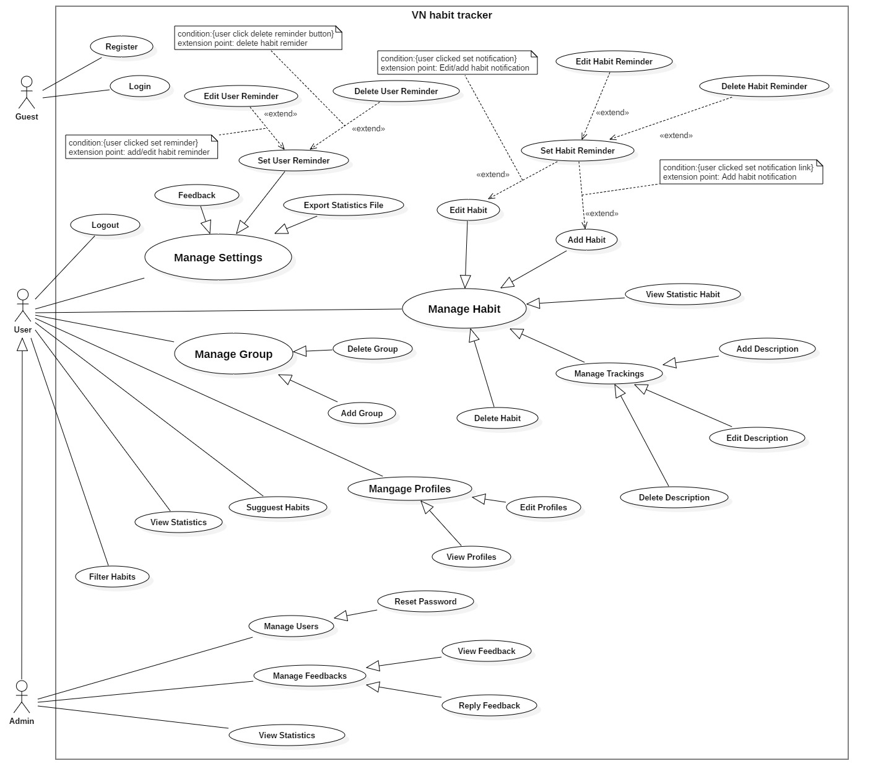

Figure 2- System Overview Use Case Diagram

* + 1. List of Use Case
       1. <Guest> Overview Use Case

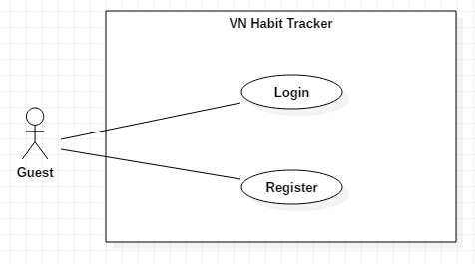

Figure 3- <Guest>Overview Use Case

##### <Guest> Login

**Use Case Diagram**

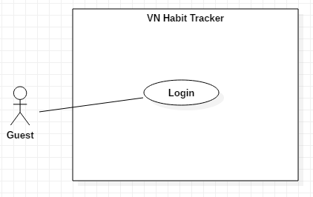

Figure 4 - <Guest> Login

**Use Case Specification**

|  |  |  |  |
| --- | --- | --- | --- |
| **USE CASE – UC_01** | | | |
| **Use Case No.** | 01 | **Use Case Version** | 1.0 |
| **Use Case Name** | Login | | |
| **Author** | DatLT | | |
| **Date** | 13/11/2018 | **Priority** | Normal |
| **Actor:**   * Guest   **Summary:**   * This use case allows the guest log in the system.   **Goal:**   * Guest logged in the system.   **Triggers:**   * Guest clicks “Đăng nhập” button. * Guest sends the login command.   **Preconditions:**   * Guest at “Đăng nhập” page.   **Post Conditions:**   * **Success:** Guest login the system. * **Fail:** System shows error message.   **Main Success Scenario:**   |  |  |  | | --- | --- | --- | | **Step** | **Actor Action** | **System Response** | | 1 | Guest goes to Login page by clicking “Đăng nhập” button. | System requires information:   * Username: free text input. * Password: free text input. | | 2 | Guest inputs information. |  | | 3 | Guest clicks “Đăng nhập” button. | System validates the information and shows confirmation message.  [Exception 1,2,3] |   **Alternative:** N/A.  **Exceptions:**   |  |  |  | | --- | --- | --- | | **No** | **Cause** | **System Response** | | 1 | Network problem. | System shows “Đăng nhập không thành công!” message. | | 2 | Username is blank. | System shows “Tên tài khoản rỗng” message. | | 3 | Password is blank. | System shows “Mật khẩu rỗng” message. |   **Relationships:** N/A.  **Business Rules:**   * After logged in, system redirect to main page. * A notification pop-up when user login success. * System must ensure has no duplicate user. * Password must be in rage of 6 – 30 characters. | | | |

Table 12 - <Guest> Login

##### <Guest> Register

**Use Case Diagram**

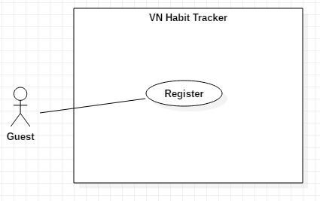

Figure 5 - <Guest> Register

**Use Case Specification**

|  |  |  |  |
| --- | --- | --- | --- |
| **USE CASE – UC_02** | | | |
| **Use Case No.** | 02 | **Use Case Version** | 1.0 |
| **Use Case Name** | Register | | |
| **Author** | DatLT | | |
| **Date** | 13/11/2018 | **Priority** | Normal |
| **Actor:**   * Guest.   **Summary:**   * This use case allows the guest registers an account.   **Goal:**   * Guest registers an account.   **Triggers:**   * Guest clicks “Đăng ký” button.   **Preconditions:**   * Guest must have an email account. * Guest at “Đăng ký” page.   **Post Conditions:**   * **Success:** System shows “Đăng ký thành công!” message. * **Fail:** System shows “Đăng ký không thành công!” message.   **Main Success Scenario:**   |  |  |  | | --- | --- | --- | | **Step** | **Actor Action** | **System Response** | | 1 | Guest goes to Login page by clicking “Đăng ký” button. | - System requires information:   * Username: text input. * Email: text input. * Password: text input. * Password again: text input. | | 2 | Guest inputs information. |  | | 3 | Guest clicks “Đăng ký” button. | System validates the information and shows confirmation message.  [Exception 1,2,3,4,5,6] |   **Alternative:** N/A  **Exceptions:**   |  |  |  | | --- | --- | --- | | **No** | **Cause** | **System Response** | | 1 | Username is empty. | System shows “Tên tài khoản không được rỗng.” message. | | 2 | Password is empty. | System shows “Mật khẩu không được rỗng.” message. | | 3 | Password is less than 6 character. | System shows “Mật khẩu phải có độ dài từ 6 ký tự.” message. | | 4 | Email is empty. | System shows “Email không được rỗng.” message. | | 5 | Email is wrong format. | System shows “Email không hợp lệ.” message. | | 6 | Network problem. | Show message “Đăng ký không thành công!” |   **Relationships:**  N/A  **Business Rules:**   * After guest registered, system redirect to login page. * Email must has not duplicate with email is existed. * System must ensure has no duplicate user. * Password must be in rage of 6 – 30 characters. * Email must follow format: ^[^\s@]+@[^\s@]+\.[^\s@]+$ | | | |

Table 13 - <Guest> Register

* + - 1. <User> Overview Use Case

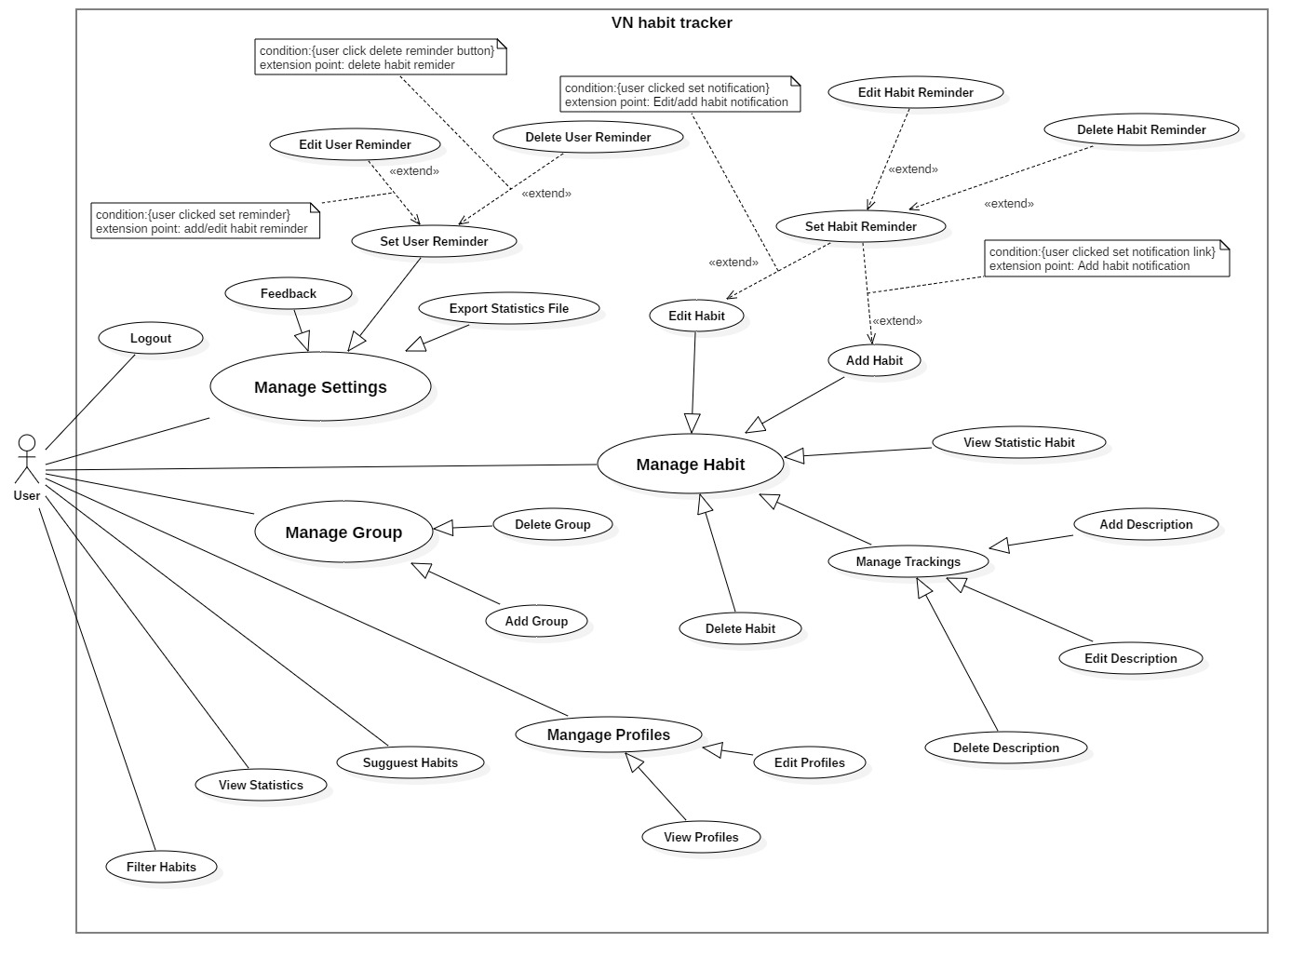

Figure 6 - <User> Overview Use Case

##### <User> Feedback

**Use Case Diagram**

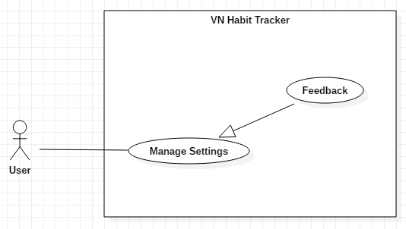

Figure 7 - <User> Feedback and Contact Us

**Use Case Specification**

|  |  |  |  |
| --- | --- | --- | --- |
| **USE CASE – UC_03** | | | |
| **Use Case No.** | 03 | **Use Case Version** | 1.0 |
| **Use Case Name** | Feedback | | |
| **Author** | TungPT | | |
| **Date** | 13/11/2018 | **Priority** | Normal |
| **Actor:**   * User   **Summary:**   * This use case allows the user to feedback.   **Goal:**   * Feedback of the user.   **Triggers:**   * User click on Settings button. * After that, user click on “Feedback” button.   **Preconditions:**   * Guest must login.   **Post Conditions:**   * **Success:** System shows “Gửi feedback thành công!” message. * **Fail:** System shows “Gửi feedback không thành công!” message.   **Main Success Scenario:**   |  |  |  | | --- | --- | --- | | **Step** | **Actor Action** | **System Response** | | 1 | User click on “Feedback” button. | System shows a form for user feedback.  + Name: text input  + Your email: text input  + Message: text input | | 2 | User inputs information. |  | | 3 | User clicks on “Gửi” button. | System validates the information and shows confirmation message.  [Exception 1,2] | | 4 | User click on “Đồng ý” button. | System shows “Gửi feedback thành công” message.  [Exception 3] |   **Alternative:** N/A.  **Exceptions:**   |  |  |  | | --- | --- | --- | | **No** | **Cause** | **System Response** | | 1 | Lost internet. | System shows “Lỗi kết nối!” message. | | 2 | Text blank. | System shows “Không được để trống!” message. | | 3 | User click on “Hủy bỏ” button. | Closed this form. |   **Relationships:**  N/A.  **Business Rules:**   * User rating of the system and what needs improvement. * After feedback success. The user returns to the settings page. * User send feedback about error, bug… on the system. * User ensure enter right email. * Feedback saves on database. * Admin only view feedback and can’t edit feedback of the user. | | | |

Table 14 - <User> Feedback

##### <User> Set User Reminder

**Use Case Diagram**

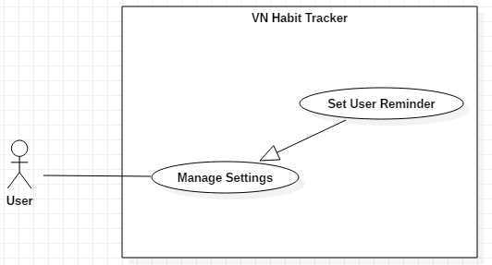

Figure 8 - <User> Set User Reminder

**Use Case Specification**

|  |  |  |  |
| --- | --- | --- | --- |
| **USE CASE – UC_04** | | | |
| **Use Case No.** | 04 | **Use Case Version** | 1.0 |
| **Use Case Name** | Set User Reminder | | |
| **Author** | DatLT | | |
| **Date** | 13/11/2018 | **Priority** | Normal |
| **Actor:**   * User   **Summary:**   * This use case allows the user set a reminder for system.   **Goal:**   * Set reminder for system.   **Triggers:**   * User clicks on Settings button. * After that, user clicks on Reminder button.   **Preconditions:**   * Guest must login.   **Post Conditions:**   * **Success:** System shows list of the reminder. * **Fail:** System not show list of the reminder.   **Main Success Scenario:**   |  |  |  | | --- | --- | --- | | **Step** | **Actor Action** | **System Response** | | 1 | User clicks on Reminder button. | - System shows a form for use set reminder.   * Nội dung nhắc nhở: text input * Chọn ngày và giờ: datetime * Lặp lại: group button. | | 2 | User inputs information and set time in this form. |  | | 3 | User clicks on “Lưu lại” button. | - System validates the information and reponse result.  [Exception 1] |   **Alternative:** N/A.  **Exceptions:**   |  |  |  | | --- | --- | --- | | **No** | **Cause** | **System Response** | | 1 | User click on “Hủy bỏ” button. | Closed Reminder page. |   **Relationships:**  N/A  **Business Rules:**   * After setting reminder success. The user returns to the settings page. * Only use sound defaults to set reminder. * The system is notified the user on that time. * User can set many reminders for the application. | | | |

Table 15 - <User> Set Reminder

##### <User> Edit User Reminder

**Use Case Diagram**

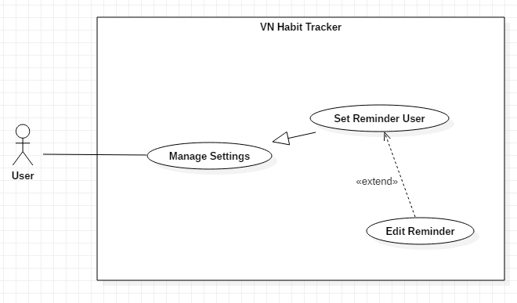

Figure 9 - <User> Edit Reminder

**Use Case Specification**

|  |  |  |  |
| --- | --- | --- | --- |
| **USE CASE – UC_05** | | | |
| **Use Case No.** | 05 | **Use Case Version** | 1.0 |
| **Use Case Name** | Edit User Reminder | | |
| **Author** | DatLT | | |
| **Date** | 13/11/2018 | **Priority** | Normal |
| **Actor:**   * User   **Summary:**   * This use case allows the user edit a reminder for system.   **Goal:**   * Edit reminder for system.   **Triggers:**   * User click on Settings button. * User click on Reminder button.   **Preconditions:**   * Guest must login. * Reminder of user must exist.   **Post Conditions:**   * **Success:** System shows list of the reminder. * **Fail:** System not show list of the reminder.   **Main Success Scenario:**   |  |  |  | | --- | --- | --- | | **Step** | **Actor Action** | **System Response** | | 1 | User clicks into reminder want to delete. | - System shows a form for use set reminder.   * Nội dung nhắc nhở: text input * Chọn ngày và giờ: datetime * Lặp lại: group button. | | 2 | User sets in this form. |  | | 3 | User click on “Cập nhật” button. | - System validates the information and reponse result.  [Exception 1] |   **Alternative:** N/A.  **Exceptions:**   |  |  |  | | --- | --- | --- | | **No** | **Cause** | **System Response** | | 1 | User click on “Hủy bỏ” button. | Closed Reminder page. |   **Relationships:** Extent from Set Reminder User use case.  **Business Rules:**   * Edit reminder is active when reminder is existed. * After update reminder success. The user returns to the settings page. * The system notifies the user on time after user change. * User reset reminders when the habit changes. | | | |

Table 16 - <User> Edit Reminder

##### <User> Delete User Reminder

**Use Case Diagram**

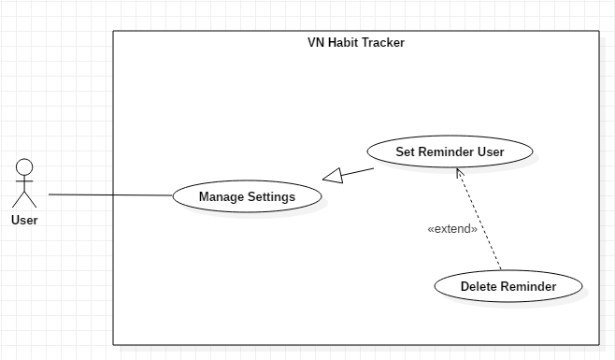

Figure 10 - <User> Delete User Reminder

**Use Case Specification**

|  |  |  |  |
| --- | --- | --- | --- |
| **USE CASE – UC_06** | | | |
| **Use Case No.** | 06 | **Use Case Version** | 1.0 |
| **Use Case Name** | Delete User Reminder | | |
| **Author** | DatLT | | |
| **Date** | 13/11/2018 | **Priority** | Normal |
| **Actor:**   * User   **Summary:**   * This use case allows the user delete a reminder for system.   **Goal:**   * Delete a reminder of the system.   **Triggers:**   * User click on Settings button. * User click on Reminder button.   **Preconditions:**   * Guest must login. * Reminder of user must exist.   **Post Conditions:**   * **Success:** System shows list of user’s reminders without this reminder have been deleted.   **Fail:** System not delete user’s reminder.  **Main Success Scenario:**   |  |  |  | | --- | --- | --- | | **Step** | **Actor Action** | **System Response** | | 1 | User clicks into reminder want to delete. | - System shows a form for use set reminder.   * Nội dung nhắc nhở: text input * Chọn ngày và giờ: datetime * Lặp lại: group button. | | 2 | User click on “Xóa” button. | - The system validates the information and delete this reminder.  [Exception 1] |   **Alternative:** N/A  **Exception:**   |  |  |  | | --- | --- | --- | | **No** | **Actor Action** | **System Response** | | 1 | User clicks on Back button. | Closed Reminder page. |   **Relationships:**  Extent from Set Reminder User use case.  **Business Rules:**   * After deleted reminder success. The user returns to the settings page. * This reminder doesn’t need for user. * Reminder has deleted not pop-up in the system. | | | |

Table 17 - <User> Delete reminder

##### <User> Export statistic file

**Use Case Diagram**

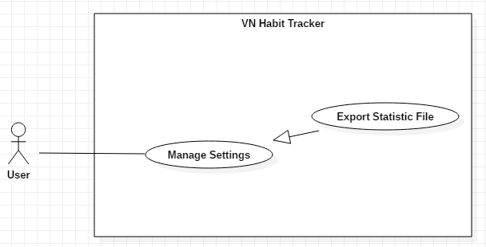

Figure 11 - <User> Export Statistic File

**Use Case Specification**

|  |  |  |  |
| --- | --- | --- | --- |
| **USE CASE – UC_07** | | | |
| **Use Case No.** | 07 | **Use Case Version** | 1.0 |
| **Use Case Name** | Export Statistic File | | |
| **Author** | TungPT | | |
| **Date** | 13/11/2018 | **Priority** | Normal |
| **Actor:**   * User   **Summary:**   * This use case allows the user to export statistic.   **Goal:**   * Export file CSV.   **Triggers:**   * User click on Settings button. * User click on “Xuất file” button.   **Preconditions:**   * Guest must login. * User must have at least one habit.   **Post Conditions:**   * **Success:** System shows “Đã xuất file.” message. * **Fail:** System shows “Xuất file không thành công!” message.   **Main Success Scenario:**   |  |  |  | | --- | --- | --- | | **Step** | **Actor Action** | **System Response** | | 1 | User click on “Xuất file” button. | System shows “Bạn muốn xuất file?” message. | | 2 | User click on “Đồng ý” button. | System shows “Xuất file thành công.” message.  [Exception 1] |   **Alternative:** N/A.  **Exceptions:**   |  |  |  | | --- | --- | --- | | **No** | **Cause** | **System Response** | | 1 | User click on “Hủy bỏ” button. | Closed this form. |   **Relationships:**  N/A  **Business Rules:**   * After Export file success. The system output .csv file and user return to the settings page. * This file CSV save on device. * File CSV show all information of user’s habits. | | | |

Table 18 - <User> Export Statistic File

##### <User> Add Habit

**Use Case Diagram**

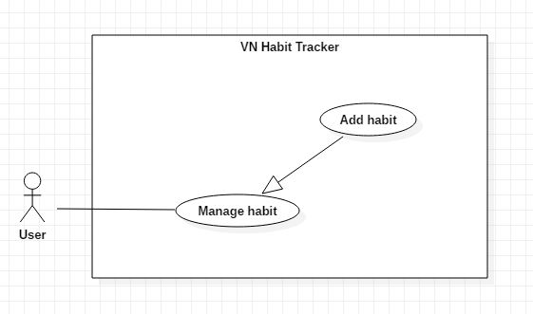

Figure 12 - <User> Add Habit

**Use Case Specification**

|  |  |  |  |
| --- | --- | --- | --- |
| **USE CASE – UC_08** | | | |
| **Use Case No.** | 08 | **Use Case Version** | 1.0 |
| **Use Case Name** | Add Habit | | |
| **Author** | TungPT | | |
| **Date** | 14/11/2018 | **Priority** | Normal |
| **Actor:**   * User   **Summary:**   * This use case allows the user to add a habit.   **Goal:**   * Add a habit.   **Triggers:**   * User click on Add Habit button.   **Preconditions:**   * Guest must login.   **Post Conditions:**   * **Success:** The system displays the habit that is created. * **Fail:** The system not display the habit that is created.   **Main Success Scenario:**   |  |  |  | | --- | --- | --- | | **Step** | **Actor Action** | **System Response** | | 1 | User clicks on Add Habit button. | - System request information in form:   * Tên thói quen: text input. * Đề xuất: button. * Xây dựng hay từ bỏ: select button. * Loại mục tiêu: select option. * Cách theo dõi: select button. * Nhóm thói quen: list group item. * Ngày theo dõi trong tuần: select button. * Thời gian thực hiện: check button. * Màu thói quen: select color. * Nhắc nhở: list reminder item. * Động lực: text input. | | 2 | User inputs information. |  | | 2 | User clicks on “Lưu lại” button. | - System validates the information and shows result in the main page.  [Exception 1, 2]  - This habit is created. |   **Alternative:** N/A.  **Exceptions:**   |  |  |  | | --- | --- | --- | | **No** | **Cause** | **System Response** | | 1 | Name habit is blank. | System shows “Tên thói quen không được rỗng” message. | | 2 | User clicks on Back button. | - Closed habit page. |   **Relationships:**  Add group, Set notification.  **Business Rules:**   * The habit’s name must be under 255 characters and not null. * After adding habit success. The user returns to the habit page. * The Habit displayed on the main screen with the date the user has selected. * In next day, daily habits reset. * In next week, weekly habits reset. * In next month, monthly habits reset. * In next year, yearly habits reset. | | | |

Table 19 - <User> Add Habit

##### <User> Delete Habit

**Use Case Diagram**

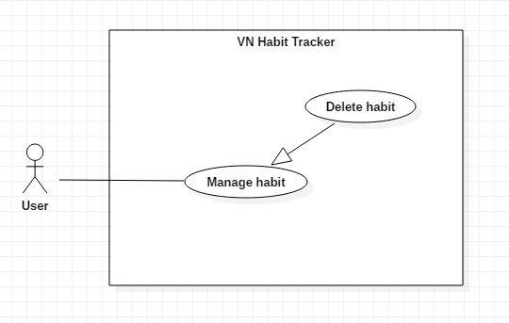

Figure 13 - <User> Delete Habit

**Use Case Specification**

|  |  |  |  |
| --- | --- | --- | --- |
| **USE CASE – UC_09** | | | |
| **Use Case No.** | 09 | **Use Case Version** | 1.0 |
| **Use Case Name** | Delete Habit | | |
| **Author** | TungPT | | |
| **Date** | 14/11/2018 | **Priority** | Normal |
| **Actor:**   * User   **Summary:**   * This use case allows the user to delete a habit.   **Goal:**   * Delete a habit.   **Triggers:**   * User clicks into the habit. * User clicks on “Xóa” button.   **Preconditions:**   * Guest must login. * The habit is existed.   **Post Conditions:**   * **Success:** System shows “Đã xóa thói quen!” message. * **Fail:** System shows “Xóa thói quen không thành công!” message.   **Main Success Scenario:**   |  |  |  | | --- | --- | --- | | **Step** | **Actor Action** | **System Response** | | 1 | User clicks into the habit. | System shows the habit detail page:   * Chart Habit button. * Edit Habit button. * Journal button. * Calendar button. * Display Chart of this habit. | | 2 | User clicks on Edit Habit button. | The system request information in form:   * Tên thói quen: text input. * Đề xuất: button. * Xây dựng hay từ bỏ: select button. * Loại mục tiêu: select option. * Cách theo dõi: select button. * Nhóm thói quen: list group item. * Ngày theo dõi trong tuần: select button. * Thời gian thực hiện: check button. * Màu thói quen: select color. * Nhắc nhở: list reminder item. * Động lực: text input. | | 2 | User clicks on “Xóa” button. | - System validates the information and shows result in the main page.  [Exception 1]  - System shows “Đã xóa thói quen” message. |   **Alternative:** N/A.  **Exceptions:**   |  |  |  | | --- | --- | --- | | **No** | **Cause** | **System Response** | | 1 | User clicks on Back icon. | - Closed habit page. |   **Relationships:**  N/A  **Business Rules:**   * User must at least one habit. * When a user deleted a habit, this habit is deleted on the server. * The information of the habit is also deleted on the local. * After deleted habit success. The user return to the habit detail page. | | | |

Table 20 - <User> Delete Habit

##### <User> Edit Habit

**Use Case Diagram**

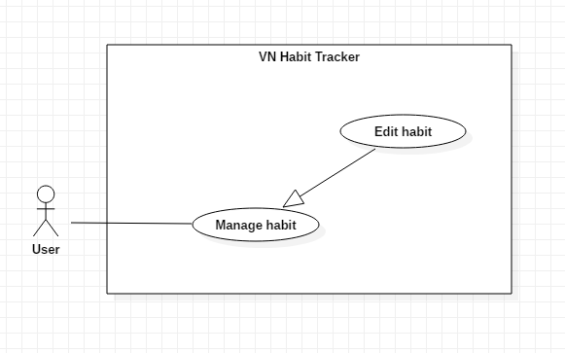

Figure 14 - <User> Edit Habit

**Use Case Specification**

|  |  |  |  |
| --- | --- | --- | --- |
| **USE CASE – UC_10** | | | |
| **Use Case No.** | 10 | **Use Case Version** | 1.0 |
| **Use Case Name** | Edit Habit | | |
| **Author** | TungPT | | |
| **Date** | 14/11/2018 | **Priority** | Normal |
| **Actor:**   * User.   **Summary:**   * This use case allows the user to edit a habit.   **Goal:**   * Edit habit when user input.   **Triggers:**   * User clicks into the habit. * User clicks on Edit Habit button.   **Preconditions:**   * Guest must login. * The habit is existed.   **Post Conditions:**   * **Success:** System shows “Cập nhật thói quen thành công!” message. * **Fail:** System shows “Cập nhật thói quen không thành công!” message.   **Main Success Scenario:**   |  |  |  | | --- | --- | --- | | **Step** | **Actor Action** | **System Response** | | 1 | User clicks into the habit. | - System shows the habit detail page:   * Chart Habit button. * Edit Habit button. * Journal button. * Calendar button. * Display Chart of this habit. | | 2 | User clicks on Edit Habit button. | - System request information in form:   * Tên thói quen: text input. * Đề xuất: button. * Xây dựng hay từ bỏ: select button. * Loại mục tiêu: select option. * Cách theo dõi: select button. * Nhóm thói quen: list group item. * Ngày theo dõi trong tuần: select button. * Thời gian thực hiện: check button. * Màu thói quen: select color. * Nhắc nhở: list reminder item. * Động lực: text input. | | 3 | User edits required field. |  | | 4 | User clicks on “Cập nhật” button. | - System validates the information and shows result in the main page.  [Exception 1, 2]  - System shows “Đã cập nhật thói quen” message. |   **Alternative:** N/A.  **Exceptions:**   |  |  |  | | --- | --- | --- | | **No** | **Cause** | **System Response** | | 1 | Name habit is blank. | The system shows “Tên thói quen không được trống!” message. | | 2 | User clicks on Back button. | - Closed habit page. | |  |  |  |   **Relationships:**  N/A  **Business Rules:**   * User must at least one habit. * The habit’s name must be under 255 characters and not null. * The information of Habit is sent to the server. * After Edit habit success. The user returns to the habit detail page. * User can change information of the habit if this habit is difficult to implement. | | | |

Table 21 - <User> Edit Habit

##### <User> Set Habit Reminder

**Use Case Diagram**

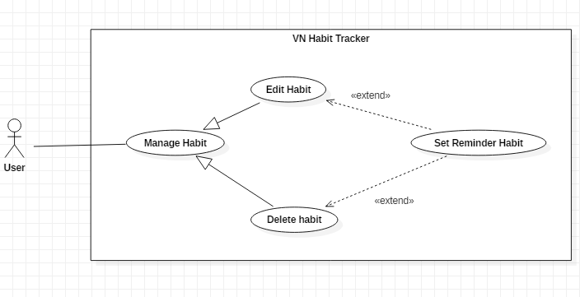

Figure 15 - <User> Set Habit Reminder

**Use Case Specification**

|  |  |  |  |
| --- | --- | --- | --- |
| **USE CASE – UC_11** | | | |
| **Use Case No.** | 11 | **Use Case Version** | 1.0 |
| **Use Case Name** | Set Habit Reminder | | |
| **Author** | TungPT | | |
| **Date** | 13/11/2018 | **Priority** | Normal |
| **Actor:**   * User   **Summary:**   * This use case allows the user to set the reminder.   **Goal:**   * Set reminder for a habit.   **Triggers:**   * User clicks on Add Habit button or Edit Habit button. * User clicks on Reminder button.   **Preconditions:**   * Guest must login.   **Post Conditions:**   * **Success:** Mobile devices show the pop-up with sound. * **Fail:** System does not show pop-up.   **Main Success Scenario:**   |  |  |  | | --- | --- | --- | | **Step** | **Actor Action** | **System Response** | | 1 | User clicks on Add Habit button.  [Alternative 1] | - System request information in form:   * Tên thói quen: text input. * Đề xuất: button. * Xây dựng hay từ bỏ: select button. * Loại mục tiêu: select option. * Cách theo dõi: select button. * Nhóm thói quen: list group item. * Ngày theo dõi trong tuần: select button. * Thời gian thực hiện: check button. * Màu thói quen: select color. * Nhắc nhở: list reminder item. * Động lực: text input. | | 2 | User clicks on Reminder button. | - System shows a form for use set reminder.   * Nội dung nhắc nhở: text input. * Chọn ngày và giờ: datetime. * Lặp lại: group button. | | 3 | User inputs information and set time in this form. |  | | 4 | User clicks on “Lưu lại” button. | - System validates the information and reponse result.  [Exception 1] |   **Alternative:**   |  |  |  | | --- | --- | --- | | **No** | **Actor Action** | **System Response** | | 1 | User clicks on Edit Habit button. | - The ystem request information in form:   * Tên thói quen: text input. * Đề xuất: button. * Xây dựng hay từ bỏ: select button. * Loại mục tiêu: select option. * Cách theo dõi: select button. * Nhóm thói quen: list group item. * Ngày theo dõi trong tuần: select button. * Thời gian thực hiện: check button. * Màu thói quen: select color. * Nhắc nhở: list reminder item. * Động lực: text input. |   **Exceptions:**   |  |  |  | | --- | --- | --- | | **No** | **Cause** | **System Response** | | 1 | User click on “Hủy bỏ” button. | Closed habit’s reminder page. |   **Relationships:**  Extent from Edit Habit, Add Habit use case.  **Business Rules:**   * The habit must be existed first. * After set reminder of habit successfully. The user returns to the habit page. * Reminder of habit pop-up when time comes. * Reminder only created when habit is created. * Name reminder not null. | | | |

Table 22 - <User> Set Habit Reminder

##### <User> Delete Habit Reminder

**Use Case Diagram**

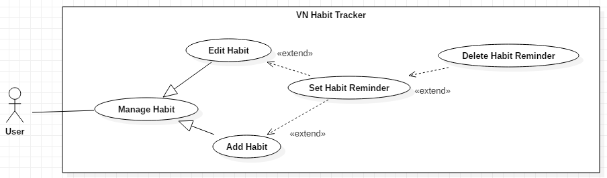

Figure 16 - <User> Delete Habit Reminder

**Use Case Specification**

|  |  |  |  |
| --- | --- | --- | --- |
| **USE CASE – UC_11** | | | |
| **Use Case No.** | 11 | **Use Case Version** | 1.0 |
| **Use Case Name** | Delete Habit Reminder | | |
| **Author** | TungPT | | |
| **Date** | 13/11/2018 | **Priority** | Normal |
| **Actor:**   * User   **Summary:**   * This use case allows the user to set the reminder.   **Goal:**   * Set reminder for a habit.   **Triggers:**   * User clicks on Add Habit button or Edit Habit button. * User clicks on Reminder button.   **Preconditions:**   * Guest must login. * At least one reminder.   **Post Conditions:**   * **Success:** System shows list of user’s reminders without this reminder have been deleted. * **Fail:** System not delete user’s reminder.   **Main Success Scenario:**   |  |  |  | | --- | --- | --- | | **Step** | **Actor Action** | **System Response** | | 1 | User clicks on Add Habit button.  [Alternative 1] | - System request information in form:   * Tên thói quen: text input. * Đề xuất: button. * Xây dựng hay từ bỏ: select button. * Loại mục tiêu: select option. * Cách theo dõi: select button. * Nhóm thói quen: list group item. * Ngày theo dõi trong tuần: select button. * Thời gian thực hiện: check button. * Màu thói quen: select color. * Nhắc nhở: list reminder item. * Động lực: text input. | | 1 | User clicks into reminder want to delete. | The system shows a form for use set reminder.   * Nội dung nhắc nhở: text input * Chọn ngày và giờ: datetime * Lặp lại. | | 2 | User sets in this form. |  | | 3 | User click on “Xóa” button. | - System validates the information and reponse result.  [Exception 1] |   **Alternative:**   |  |  |  | | --- | --- | --- | | **No** | **Actor Action** | **System Response** | | 1 | User clicks on Edit Habit button. | - The ystem request information in form:   * Tên thói quen: text input. * Đề xuất: button. * Xây dựng hay từ bỏ: select button. * Loại mục tiêu: select option. * Cách theo dõi: select button. * Nhóm thói quen: list group item. * Ngày theo dõi trong tuần: select button. * Thời gian thực hiện: check button. * Màu thói quen: select color. * Nhắc nhở: list reminder item. * Động lực: text input. |   **Exceptions:**   |  |  |  | | --- | --- | --- | | **No** | **Cause** | **System Response** | | 1 | User clicks on Back button. | Closed habit’s reminder page. |   **Relationships:**  Extent from Set Habit Reminder use case.  **Business Rules:**   * The habit must be existed first. * After set reminder of habit successfully. The user returns to the habit page. * Reminder of habit pop-up when time comes. * Reminder must be existed. | | | |

Table 23 - <User> Delete Habit Reminder

##### <User> Edit Habit Reminder

**Use Case Diagram**

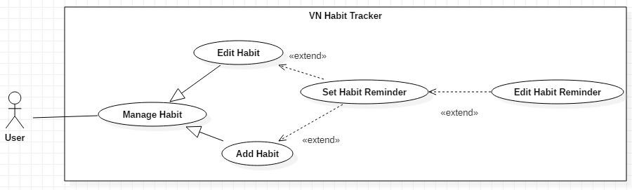

Figure 17 - <User> Edit Habit Reminder

**Use Case Specification**

|  |  |  |  |
| --- | --- | --- | --- |
| **USE CASE – UC_11** | | | |
| **Use Case No.** | 11 | **Use Case Version** | 1.0 |
| **Use Case Name** | Edit Habit Reminder | | |
| **Author** | TungPT | | |
| **Date** | 13/11/2018 | **Priority** | Normal |
| **Actor:**   * User   **Summary:**   * This use case allows the user to edit the reminder.   **Goal:**   * Edit reminder for a habit.   **Triggers:**   * User clicks on Add Habit button or Edit Habit button. * User clicks on Reminder button.   **Preconditions:**   * Guest must login. * At least one reminder.   **Post Conditions:**   * **Success:** System shows new list of the reminder. * **Fail:** System not show list of the reminder.   **Main Success Scenario:**   |  |  |  | | --- | --- | --- | | **Step** | **Actor Action** | **System Response** | | 1 | User clicks on Add Habit button.  [Alternative 1] | - System request information in form:   * Tên thói quen: text input. * Đề xuất: button. * Xây dựng hay từ bỏ: select button. * Loại mục tiêu: select option. * Cách theo dõi: select button. * Nhóm thói quen: list group item. * Ngày theo dõi trong tuần: select button. * Thời gian thực hiện: check button. * Màu thói quen: select color. * Nhắc nhở: list reminder item. * Động lực: text input. | | 2 | User clicks into reminder want to delete. | The system shows a form for use set reminder.   * Nội dung nhắc nhở: text input. * Chọn ngày và giờ: datetime. * Lặp lại. | | 3 | User sets in this form. |  | | 4 | User click on “Cập nhật” button. | - System validates the information and reponse result.  [Exception 1] |   **Alternative:**   |  |  |  | | --- | --- | --- | | **No** | **Actor Action** | **System Response** | | 1 | User clicks on Edit Habit button. | - The ystem request information in form:   * Tên thói quen: text input. * Đề xuất: button. * Xây dựng hay từ bỏ: select button. * Loại mục tiêu: select option. * Cách theo dõi: select button. * Nhóm thói quen: list group item. * Ngày theo dõi trong tuần: select button. * Thời gian thực hiện: check button. * Màu thói quen: select color. * Nhắc nhở: list reminder item. * Động lực: text input. |   **Exceptions:**   |  |  |  | | --- | --- | --- | | **No** | **Cause** | **System Response** | | 1 | User click on “Hủy bỏ” button. | Closed habit’s reminder page. |   **Relationships:**  Extent from Edit Habit, Add Habit use case.  **Business Rules:**   * The habit must be existed first. * After set reminder of habit successfully. The user returns to the habit page. * Reminder of habit pop-up when time comes. * Name of reminder not null. * Reminder is updated when user clicks on “Cập nhật” button in habit page. | | | |

Table 24 - <User> Set Habit Reminder

##### <User> View Statistic Habit

**Use Case Diagram**

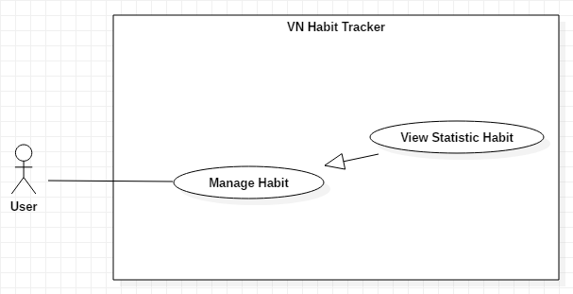

Figure 18 - <User> View Statistic Habit

**Use Case Specification**

|  |  |  |  |
| --- | --- | --- | --- |
| **USE CASE – UC_12** | | | |
| **Use Case No.** | 12 | **Use Case Version** | 1.0 |
| **Use Case Name** | View Statistic Habit | | |
| **Author** | DatLT | | |
| **Date** | 14/11/2018 | **Priority** | Normal |
| **Actor:**   * User   **Summary:**   * This use case allows the user view statistic detail of the habit.   **Goal:**   * View statistic detail of the habit.   **Triggers:**   * User clicks into the habit. * User clicks on view habit detail.   **Preconditions:**   * Guest must login. * The user must have at least one habit.   **Post Conditions:**   * **Success:** Statistic detail have been displayed. * **Fail:** Statistic detail haven’t been displayed.   **Main Success Scenario:**   |  |  |  | | --- | --- | --- | | **Step** | **Actor Action** | **System Response** | | 1 | User clicks into the habit. | - System shows the habit detail page:   * Chart Habit button. * Edit Habit button. * Journal button. * Calendar button. * Chart of this habit. |   **Alternative:** N/A.  **Exceptions:** N/A.  **Relationships:**  N/A.  **Business Rules:**   * After view statistic detail successfully. The user returns to the main page. * User can view another added habit. * User can see the details of a habit. * Habits of users is represented on the chart follow:   + Week  + Month  + Year | | | |

Table 25 - <User> View Statistic Habit

##### <User> Add Description

**Use Case Diagram**

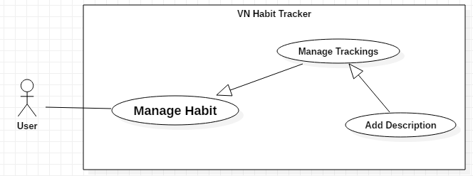

Figure 19 - <User> Add Description

**Use Case Specification**

|  |  |  |  |
| --- | --- | --- | --- |
| **USE CASE – UC_13** | | | |
| **Use Case No.** | 13 | **Use Case Version** | 1.0 |
| **Use Case Name** | Add Description | | |
| **Author** | DatLT | | |
| **Date** | 13/11/2018 | **Priority** | Normal |
| **Actor:**   * User   **Summary:**   * This use case allows the user adds new description.   **Goal:**   * User add new description.   **Triggers:**   * User clicks into the habit. * User clicks on Description button.   **Preconditions:**   * Guest must login. * The habit is existed.   **Post Conditions:**   * **Success:** Description is displayed. * **Fail:** Description isn’t displayed.   **Main Success Scenario:**   |  |  |  | | --- | --- | --- | | **Step** | **Actor Action** | **System Response** | | 1 | User clicks on Description button. | System shows a list of description of this habit. | | 2 | User clicks on Add button. | System shows the form have text box to write in. | | 3 | User inputs information. |  | | 4 | User clicks on “Lưu” button. | System validates the request and shows result in the description page.  [Exception 1, 2] |   **Alternative:** N/A.  **Exceptions:**   |  |  |  | | --- | --- | --- | | **No** | **Cause** | **System Response** | | 1 | Text box is blank. | System shows “Ghi chú không được rỗng!” Message. | | 2 | User click on “Hủy” button. | Closed this form. |   **Relationships:**  Extent from Manage Trackings use case.  **Business Rules:**   * After add a new description successfully. The user returns to the description page. * Users add another description follow type of habit: day, week, month, year. * User notes the process of this habit. * User notes only one description on one day. | | | |

Table 26 - <User> Add Description

##### <User> Edit Description

**Use Case Diagram**

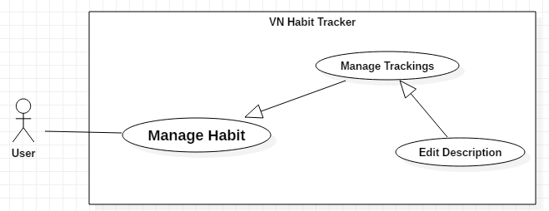

Figure 20 - <User> Edit Description

**Use Case Specification**

|  |  |  |  |
| --- | --- | --- | --- |
| **USE CASE – UC_14** | | | |
| **Use Case No.** | 14 | **Use Case Version** | 1.0 |
| **Use Case Name** | Edit Description | | |
| **Author** | DatLT | | |
| **Date** | 13/11/2018 | **Priority** | Normal |
| **Actor:**   * User   **Summary:**   * This use case allows the user edits a tracking description.   **Goal:**   * User edits a tracking description.   **Triggers:**   * User clicks into the habit. * User clicks on Journal button.   **Preconditions:**   * Guest must login. * The habit is existed. * The description is existed.   **Post Conditions:**   * **Success:** Tracking description is displayed. * **Fail:** Tracking description isn’t displayed.   **Main Success Scenario:**   |  |  |  | | --- | --- | --- | | **Step** | **Actor Action** | **System Response** | | 1 | User clicks on Journal button. | System shows a list of tracking description of this habit. | | 2 | User clicks on the tracking description want to edit. | System shows the form have text box to write in. | | 3 | User inputs information. |  | | 4 | User clicks on “Lưu” button. | System validates the request and shows result in the description page.  [Exception 1] |   **Alternative:** N/A.  **Exceptions:**   |  |  |  | | --- | --- | --- | | **No** | **Cause** | **System Response** | | 1 | User clicks outside form. | Closed this form. |   **Relationships:**  Extent from Manage Trackings use case.  **Business Rules:**   * After edit a tracking description successfully. The user returns to the description page. * User can edit another description. * Users note the process of this habit. * User notes only one description on one day. | | | |

Table 27 - <User> Edit Description

##### <User> Delete Description

**Use Case Diagram**

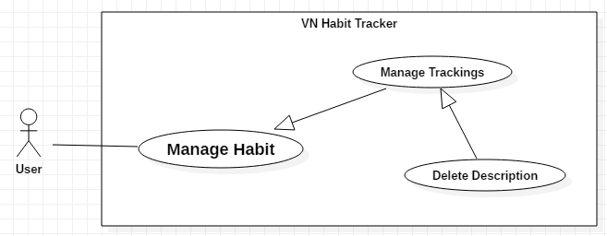

Figure 21 - <User> Delete Description

**Use Case Specification**

|  |  |  |  |
| --- | --- | --- | --- |
| **USE CASE – UC_15** | | | |
| **Use Case No.** | 15 | **Use Case Version** | 1.0 |
| **Use Case Name** | Delete Description | | |
| **Author** | DatLT | | |
| **Date** | 13/11/2018 | **Priority** | Normal |
| **Actor:**   * User   **Summary:**   * This use case allows the user deletes a tracking description.   **Goal:**   * User delete a tracking description.   **Triggers:**   * User clicks into the habit. * User click on Journal button.   **Preconditions:**   * Guest must login. * The habit is existed. * The tracking description is existed.   **Post Conditions:**   * **Success:** Tracking description is displayed. * **Fail:** Tracking description isn’t displayed.   **Main Success Scenario:**   |  |  |  | | --- | --- | --- | | **Step** | **Actor Action** | **System Response** | | 1 | User clicks on journal button. | System shows a list of notes. | | 2 | User clicks on the tracking description want to delete. | System shows the form have text box. | | 3 | User clicks on “Xóa” button. | System validates the request and shows result in the habit page.  [Exception 1] |   **Alternative:** N/A.  **Exceptions:**   |  |  |  | | --- | --- | --- | | **No** | **Cause** | **System Response** | | 1 | User clicks outside form. | Closed this form. |   **Relationships:**  Extent from Manage Trackings use case.  **Business Rules:**   * Habit must exist first. * After delete description successfully. The user returns to the description page. * User can delete another description. * When next day or previous day, list tracking description is display and show all. | | | |

Table 28 - <User> Delete Description

##### <User> Add Group

**Use Case Diagram**

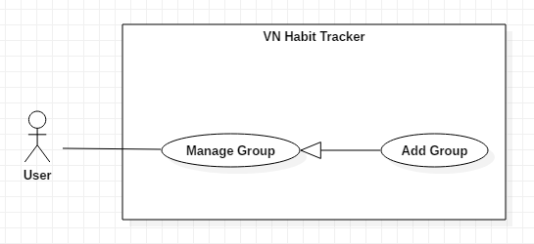

Figure 22 - <User> Add Group

**Use Case Specification**

|  |  |  |  |
| --- | --- | --- | --- |
| **USE CASE – UC_16** | | | |
| **Use Case No.** | 16 | **Use Case Version** | 1.0 |
| **Use Case Name** | Add Group | | |
| **Author** | TungPT | | |
| **Date** | 13/11/2018 | **Priority** | Normal |
| **Actor:**   * User   **Summary:**   * This use case allows the user to add group.   **Group:**   * Add a group while add the habit.   **Triggers:**   * User clicks on Add Habit button or Edit Habit button. * User clicks on Group button.   **Preconditions:**   * Guest must login.   **Post Conditions:**   * **Success:** New group is display in group’s list. * **Fail:** New group isn’t display in group’s list.   **Main Success Scenario:**   |  |  |  | | --- | --- | --- | | **Step** | **Actor Action** | **System Response** | | 1 | User clicks on Add Habit button.  [Alternative 1] | - System request information in form:   * Tên thói quen: text input. * Đề xuất: button. * Xây dựng hay từ bỏ: select button. * Loại mục tiêu: select option. * Cách theo dõi: select button. * Nhóm thói quen: list group item. * Ngày theo dõi trong tuần: select button. * Thời gian thực hiện: check button. * Màu thói quen: select color. * Nhắc nhở: list reminder item. * Động lực: text input. | | 2 | User clicks on Group button. | - System shows group page:   * List of the group’s item. * Name group: Text. * Add button. | | 3 | User inputs information. |  | | 4 | User clicks on Add button. | - System validates the information and shows result in the group page.  [Exception 1, 2] |   **Alternative:**   |  |  |  | | --- | --- | --- | | **No** | **Actor Action** | **System Response** | | 1 | User clicks on Edit Habit button. | - System request information in form:   * Tên thói quen: text input. * Đề xuất: button. * Xây dựng hay từ bỏ: select button. * Loại mục tiêu: select option. * Cách theo dõi: select button. * Nhóm thói quen: list group item. * Ngày theo dõi trong tuần: select button. * Thời gian thực hiện: check button. * Màu thói quen: select color. * Nhắc nhở: list reminder item. * Động lực: text input. |   **Exceptions:**   |  |  |  | | --- | --- | --- | | **No** | **Cause** | **System Response** | | 1 | Group name is blank. | Shows “Tên nhóm không được trống!” message. | | 2 | User clicks on Back button. | Closed group page. |   **Relationships:**  N/A  **Business Rules:**   * The group name must be under 255 characters and not null. * After adding group success. The user return habit page. * A habit has many groups. * When user login success first, system have 5 group available: Sức khỏe, Tinh thần, Công việc & học tập, Tài chính, Mối quan hệ. | | | |

Table 29 - <User> Add Group

##### <User> Delete Group

**Use Case Diagram**

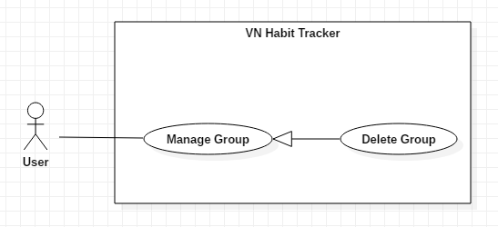

Figure 23 - <User> Delete Group

**Use Case Specification**

|  |  |  |  |
| --- | --- | --- | --- |
| **USE CASE – UC_17** | | | |
| **Use Case No.** | 17 | **Use Case Version** | 1.0 |
| **Use Case Name** | Delete Group | | |
| **Author** | TungNT | | |
| **Date** | 13/11/2018 | **Priority** | Normal |
| **Actor:**   * User   **Summary:**   * This use case allows the user to delete group.   **Group:**   * Delete a group.   **Triggers:**   * User clicks on Add Habit button or Edit Habit button. * User clicks on Group button.   **Preconditions:**   * Guest must login.   **Post Conditions:**   * **Success:** System not shows that group’name is deleted. * **Fail:** System still show that group’name is deleted.   **Main Success Scenario:**   |  |  |  | | --- | --- | --- | | **Step** | **Actor Action** | **System Response** | | 1 | User clicks on Add Habit button.  [Alternative 1] | - System request information in form:   * Tên thói quen: text input. * Đề xuất: button. * Xây dựng hay từ bỏ: select button. * Loại mục tiêu: select option. * Cách theo dõi: select button. * Nhóm thói quen: list group item. * Ngày theo dõi trong tuần: select button. * Thời gian thực hiện: check button. * Màu thói quen: select color. * Nhắc nhở: list reminder item. * Động lực: text input. | | 2 | User clicks on Group button. | Shows a form to ask user want to delete group. | | 3 | User swipe from right to left this group need to delete. | - The system validates the request and shows the added information.  [Exception 1] |   **Alternative:**   |  |  |  | | --- | --- | --- | | **No** | **Actor Action** | **System Response** | | 1 | User clicks on Edit Habit button. | - System request information in form:   * Tên thói quen: text input. * Đề xuất: button. * Xây dựng hay từ bỏ: select button. * Loại mục tiêu: select option. * Cách theo dõi: select button. * Nhóm thói quen: list group item. * Ngày theo dõi trong tuần: select button. * Thời gian thực hiện: check button. * Màu thói quen: select color. * Nhắc nhở: list reminder item. * Động lực: text input. |   **Exceptions:**   |  |  |  | | --- | --- | --- | | **No** | **Cause** | **System Response** | | 1 | User clicks on “Khôi phục” on snackbar after delete group. | That group deleted is restored. |   **Relationships:**  N/A.  **Business Rules:**   * The user only deletes the group created by himself. * When a user deleted a group, this group is deleted on the server. * The information of the group is also deleted to the local. * After deleted group success. The user return to the main page. | | | |

Table 30 - <User> Delete Group

##### <User> View Profiles

**Use Case Diagram**

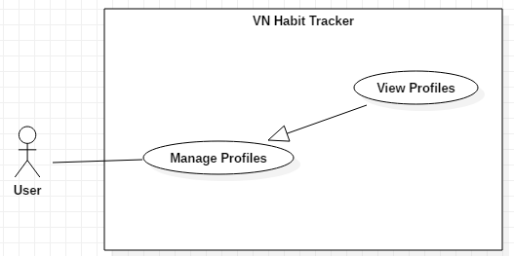

Figure 24 - <User> View Profiles

**Use Case Specification**

|  |  |  |  |
| --- | --- | --- | --- |
| **USE CASE – UC_18** | | | |
| **Use Case No.** | 18 | **Use Case Version** | 1.0 |
| **Use Case Name** | View Profiles | | |
| **Author** | DatLT | | |
| **Date** | 07/10/2018 | **Priority** | Normal |
| **Actor:**   * User   **Summary:**   * This use case allows the user to view profiles and achievement.   **Group:**   * View profiles and achievement.   **Triggers:**   * User clicks on Profiles button.   **Preconditions:**   * Guest must login.   **Post Conditions:**   * **Success:** System shows list of profiles’s user. * **Fail:** System not show list of profiles’s user.   **Main Success Scenario:**   |  |  |  | | --- | --- | --- | | **Step** | **Actor Action** | **System Response** | | 1 | User clicks on Profiles button. | - System shows information in form:   * Ngày tham gia: date time. * Điểm tích lũy: textview. * Cấp độ: textview. * Chuỗi hiện tại: textview. * Chuỗi tốt nhất: textview. * Số ngày sử dụng: textview. * Thói quen đã tạo: textview. * Đề xuất: list habit item.   [Exception 1] |   **Alternative:** N/A.  **Exceptions:**   |  |  |  | | --- | --- | --- | | **No** | **Cause** | **System Response** | | 1 | Network problem. | System shows “Đã có lỗi.” message. |   **Relationships:**  N/A.  **Business Rules:**   * The system suggests habits that corresponds to the level of the current user. * The information of user is sent to the server. * Users can know the progress of their habits. * After view profiles. The user return to the main page. | | | |

Table 31 - <User> View Profiles

##### <User> Edit Profiles

**Use Case Diagram**

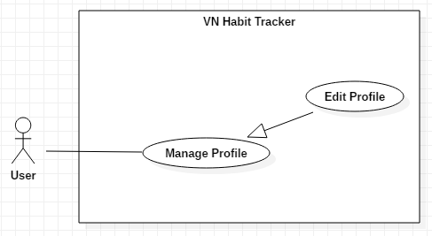

Figure 25 - <User> Edit Profiles

**Use Case Specification**

|  |  |  |  |
| --- | --- | --- | --- |
| **USE CASE – UC_19** | | | |
| **Use Case No.** | 19 | **Use Case Version** | 1.0 |
| **Use Case Name** | Edit Profile | | |
| **Author** | DatLT | | |
| **Date** | 13/11/2018 | **Priority** | Normal |
| **Actor:**   * User   **Summary:**   * This use case allows the user to edit profile.   **Group:**   * Edit profile of the user.   **Triggers:**   * User clicks on Settings button. * User clicks on “Thông tin” button. * User clicks on “Cập nhật thông tin” button.   **Preconditions:**   * Guest must login.   **Post Conditions:**   * **Success:** System shows “Cập nhật thông tin thành công!” message. * **Fail:** System shows “Cập nhật thông tin không thành công!” message.   **Main Success Scenario:**   |  |  |  | | --- | --- | --- | | **Step** | **Actor Action** | **System Response** | | 1 | User clicks on “Cập nhật thông tin” button. | The system request information in form:   * Tên: text input * Email: text input * Age: number input * Phone: number input | | 2 | User clicks on “Cập nhật” button | - The system validates the request and shows the added information.  [Exception 1, 2] | | 3 | User clicks on “Lưu” button. | That information about the user is edited. |   **Alternative:** N/A.  **Exceptions:**   |  |  |  | | --- | --- | --- | | **No** | **Cause** | **System Response** | | 1 | Name is empty. | Shows “Tên không được bỏ trống!” message. | | 2 | User clicks on “Hủy bỏ” button. | Closed this form. |   **Relationships:**  N/A  **Business Rules:**   * Name user not null. * The information of User is sent to the server. * After Edit profile success. The user return to the profile page. | | | |

Table 32 - <User> Edit Profiles

##### <User> Suggest Habit

**Use Case Diagram**

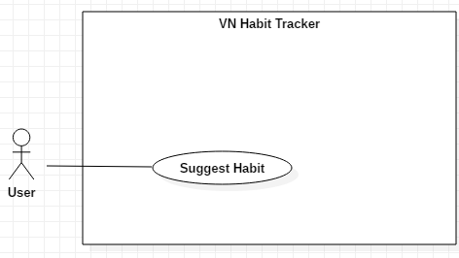

Figure 26 - <User> Suggest Habit

**Use Case Specification**

|  |  |  |  |
| --- | --- | --- | --- |
| **USE CASE – UC_20** | | | |
| **Use Case No.** | 20 | **Use Case Version** | 1.0 |
| **Use Case Name** | Suggest Habit | | |
| **Author** | DatLT | | |
| **Date** | 13/11/2018 | **Priority** | Normal |
| **Actor:**   * User   **Summary:**   * This use case allows the user is suggesting from the application.   **Group:**   * Suggest for the user.   **Triggers:**   * User click on Add Habit button or Edit Button. * User click on “Đề xuất” button.   **Preconditions:**   * Guest must login.   **Post Conditions:**   * **Success:** System shows success message. * **Fail:** System shows error message.   **Main Success Scenario:**   |  |  |  | | --- | --- | --- | | **Step** | **Actor Action** | **System Response** | | 1 | User click on Add Habit button. | The system request information in form:   * Tên thói quen: text input. * Đề xuất: button. * Xây dựng hay từ bỏ: select button. * Loại mục tiêu: select option. * Cách theo dõi: select button. * Nhóm thói quen: list group item. * Ngày theo dõi trong tuần: select button. * Thời gian thực hiện: check button. * Màu thói quen: select color. * Nhắc nhở: list reminder item. * Động lực: text input. | | 2 | User click on “Đề xuất” button. | System shows list of top 5 habit follow each group.   * Sức khỏe. * Tinh thần. * Công việc & học tập. * Mối quan hệ. * Tài chính. |   **Alternative:**   |  |  |  | | --- | --- | --- | | **No** | **Cause** | **System Response** | | 1 | User click on Edit Habit button. | The system request information in form:   * Tên thói quen: text input. * Đề xuất: button. * Xây dựng hay từ bỏ: select button. * Loại mục tiêu: select option. * Cách theo dõi: select button. * Nhóm thói quen: list group item. * Ngày theo dõi trong tuần: select button. * Thời gian thực hiện: check button. * Màu thói quen: select color. * Nhắc nhở: list reminder item. * Động lực: text input. |   **Relationships:**  N/A.  **Exception:** N/A.  **Business Rules:**   * The information about the habit of the user is sent to the server. * After suggest habit success. The user returns to the add habit page. * When user clicks choice habit in group, system auto fill into habit name on habit page. | | | |

Table 33 - <User> Suggest Habit

##### <User> Filter Habits

**Use Case Diagram**

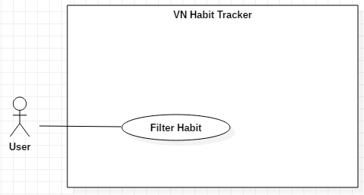

Figure 27 - <User> Filter Habit

**Use Case Specification**

|  |  |  |  |
| --- | --- | --- | --- |
| **USE CASE – UC_21** | | | |
| **Use Case No.** | 21 | **Use Case Version** | 1.0 |
| **Use Case Name** | Filter Habit | | |
| **Author** | DatLT | | |
| **Date** | 13/11/2018 | **Priority** | Normal |
| **Actor:**   * User   **Summary:**   * This use case allows the user want to filter habit.   **Group:**   * Filter habit.   **Triggers:**   * User click on filter button.   **Preconditions:**   * Guest must login.   **Post Conditions:**   * **Success:** System displayed filter detail. * **Fail:** System not displayed filter detail.   **Main Success Scenario:**   |  |  |  | | --- | --- | --- | | **Step** | **Actor Action** | **System Response** | | 1 | User clicks on filter button. | - System request information in form:   * Loại mục tiêu: check box. * Loại thói quen: check box. * Nhóm: list item. | | 2 | User click on “Áp dụng” button. | - System auto filter habit in main page.  [Exception 1] |   **Alternative:** N/A.  **Exception:**   |  |  |  | | --- | --- | --- | | **No** | **Actor Action** | **System Response** | | 1 | User click on “Hủy bỏ” button. | - Closed this form. |   **Relationships:**  N/A  **Business Rules:**   * After filter habit success. The user returns to the main page. * Users can filter and find habits easily follow:   + Day, Week, Month, Year.  + Build or quit a habit.  + Name of group. | | | |

Table 34 - <User> Filter Habit

##### <User> View Statistics

**Use Case Diagram**

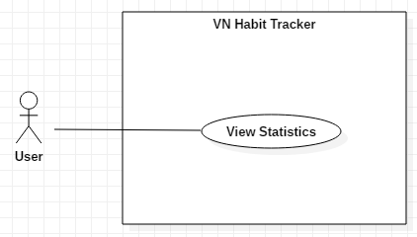

Figure 28 - <User> View Statistics

**Use Case Specification**

|  |  |  |  |
| --- | --- | --- | --- |
| **USE CASE – UC_22** | | | |
| **Use Case No.** | 22 | **Use Case Version** | 1.0 |
| **Use Case Name** | View Statistics | | |
| **Author** | DatLT | | |
| **Date** | 13/11/2018 | **Priority** | Normal |
| **Actor:**   * User   **Summary:**   * This use case allows the user want to view all statistics of the habit.   **Group:**   * View all statistic of the habit.   **Triggers:**   * User click on statistic button.   **Preconditions:**   * Guest must login.   **Post Conditions:**   * **Success:** System shows list habits. * **Fail:** System not show list habits.   **Main Success Scenario:**   |  |  |  | | --- | --- | --- | | **Step** | **Actor Action** | **System Response** | | 1 | User click on statistic button. | - Display information in chart about all habits follow week, month and year:   * Tổng số thói quen: text. * Tổng số lượt hoàn thành: text. * Chart habit. |   **Alternative:** N/A.  **Exception:** N/A.  **Relationships:**  N/A.  **Business Rules:**   * The information is loaded from the system. * User views statistic all of the habit follow week, month, year. * After view statistics. The user return to the main page. | | | |

Table 35 - <User> View Statistics

##### <User> View Top Habits

**Use Case Diagram**

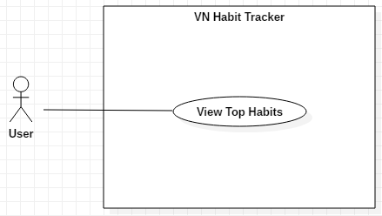

Figure 29 - <User> View Top Habits

**Use Case Specification**

|  |  |  |  |
| --- | --- | --- | --- |
| **USE CASE – UC_23** | | | |
| **Use Case No.** | 23 | **Use Case Version** | 1.0 |
| **Use Case Name** | View Top Habits | | |
| **Author** | DatLT | | |
| **Date** | 13/11/2018 | **Priority** | Normal |
| **Actor:**   * User   **Summary:**   * This use case allows the users view habits that most user community.   **Group:**   * View top habits from community.   **Triggers:**   * User click on top habit button.   **Preconditions:**   * Guest must login.   **Post Conditions:**   * **Success:** System shows list top habits. * **Fail:** System not shows list top habits.   **Main Success Scenario:**   |  |  |  | | --- | --- | --- | | **Step** | **Actor Action** | **System Response** | | 1 | User click on top habits button. | System request information in list habits that community use most. |   **Alternative:** N/A.  **Exception:** N/A.  **Relationships:**  N/A.  **Business Rules:**   * User view habits that most user community. * The system suggested for user that habits are most use. | | | |

Table 36 - <User> View Top Habits

##### <User> Logout

**Use Case Diagram**

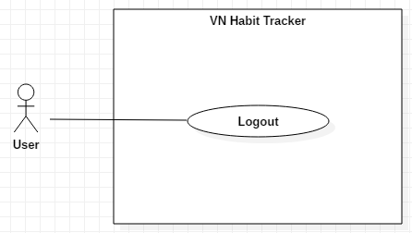

Figure 30 - <User> Logout

**Use Case Specification**

|  |  |  |  |
| --- | --- | --- | --- |
| **USE CASE – UC_25** | | | |
| **Use Case No.** | 25 | **Use Case Version** | 1.0 |
| **Use Case Name** | Logout | | |
| **Author** | DatLT | | |
| **Date** | 14/11/2018 | **Priority** | Normal |
| **Actor:**   * User   **Summary:**   * This use case allows the user want to logout from application.   **Goal:**   * User logout the system.   **Triggers:**   * User clicks Settings button. * User clicks “Đăng xuất” button.   **Preconditions:**   * Guest login success.   **Post Conditions:**   * **Success:** System shows success message. * **Fail:** System shows error message.   **Main Success Scenario:**   |  |  |  | | --- | --- | --- | | **Step** | **Actor Action** | **System Response** | | 1 | User clicks “Đăng xuất” button. | System shows “Bạn muốn đăng xuất?” message. | | 2 | User clicks “Đồng ý” button. | - User logout the system.  [Exception 1] |   **Alternative:** N/A.  **Exception:**   |  |  |  | | --- | --- | --- | | **No** | **Actor Action** | **System Response** | | 1 | User click “Hủy bỏ” button. | Closed this form. |   **Relationships:**  N/A.  **Exception:** N/A.  **Business Rules:**   * After logout from the system, system return login page. * User can login with another account. * Database of this user is clear on system. | | | |

Table 37 - <User> Logout

* + - 1. <Admin> Overview Use Case

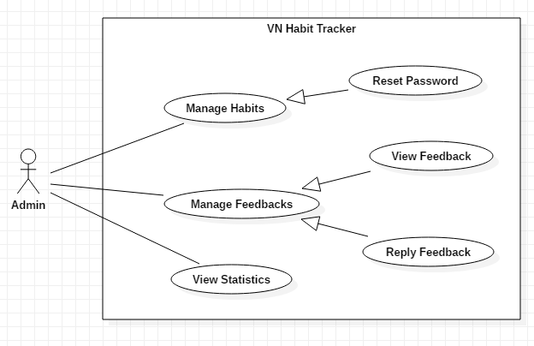

Figure 31 - <Admin> Overview Use Case

##### <Admin> Reset Password

**Use Case Diagram**

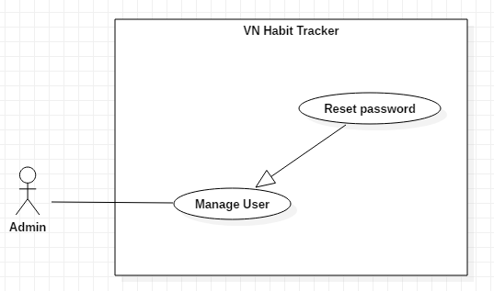

Figure 32 - <Admin> Reset Password

**Use Case Specification**

|  |  |  |  |
| --- | --- | --- | --- |
| **USE CASE – UC_25** | | | |
| **Use Case No.** | 25 | **Use Case Version** | 1.0 |
| **Use Case Name** | Reset Password | | |
| **Author** | TungPT | | |
| **Date** | 15/11/2018 | **Priority** | Normal |
| **Actor:**   * Admin   **Summary:**   * This use case allows the admin to reset password.   **Goal:**   * Reset password.   **Triggers:**   * Admin clicks on “quản lý người dùng” button. * Admin accept request of user. * Admin clicks on “tạo lại mật khẩu” button.   **Preconditions:**   * Admin must login. * User must send request.   **Post Conditions:**   * **Success:** System shows “Tạo mới mật khẩu thành công.” message. * **Fail:** System shows “Tạo mới mật khẩu thất bại” message.   **Main Success Scenario:**   |  |  |  | | --- | --- | --- | | **Step** | **Actor Action** | **System Response** | | 1 | Admin accept request of user to reset password. | The system shows “Đã chấp nhận yêu cầu” message. | | 2 | Admin clicks on “Tạo mới mật khẩu” button. | The system shows all list user use applications. | | 3 | Admin clicks into a user. | - The system sent a link to the user to change password.  [Exception 1] |   **Alternative:** N/A.  **Exceptions:**   |  |  |  | | --- | --- | --- | | **No** | **Cause** | **System Response** | | 1 | Network. | Shows “mất kết nối! Xin thử lại” message. |   **Relationships:**  N/A  **Business Rules:**   * After reset password of a user. Admin return to the main page. * Admin sent a hyperlink for a user. * User take password by email. * After reset password, password of this user default: 12345678 | | | |

Table 38 - <Admin> Reset Password

##### <Admin> View Feedback

**Use Case Diagram**

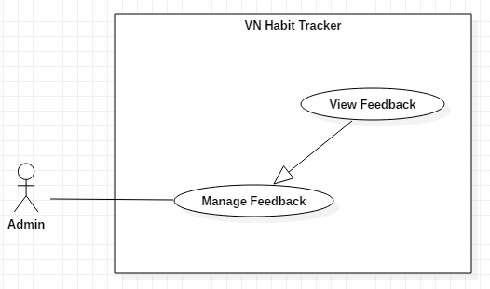

Figure 33 - <Admin> View Feedback

**Use Case Specification**

|  |  |  |  |
| --- | --- | --- | --- |
| **USE CASE – UC_26** | | | |
| **Use Case No.** | 26 | **Use Case Version** | 1.0 |
| **Use Case Name** | View Feedback | | |
| **Author** | TungPT | | |
| **Date** | 15/11/2018 | **Priority** | Normal |
| **Actor:**   * Admin   **Summary:**   * This use case allows the admin to view all feedback of users.   **Group:**   * View feedback of users.   **Triggers:**   * Admin click on “Quản lý feedback” button.   **Preconditions:**   * Admin must login. * User sent feedback.   **Post Conditions:**   * **Success:** System shows message. * **Fail:** System shows message.   **Main Success Scenario:**   |  |  |  | | --- | --- | --- | | **Step** | **Actor Action** | **System Response** | | 1 | Admin clicks on “quản lý feedback” button. | The system shows all feedback of users. | | 2 | Admin clicks into a feedback. | - The system shows content of this feedback.  [Exception 1] |   **Alternative:** N/A.  **Exceptions:**   |  |  |  | | --- | --- | --- | | **No** | **Cause** | **System Response** | | 1 | Network. | Shows “Mất kết nối! Xin thử lại” message. | | 2 | Admin clicks on “Đóng” icon. | - Close list of feedbacks. |   **Relationships:**  N/A  **Business Rules:**   * After view feedback of user. Admin return to the main page. * The feedback of user is private and only admin is seen. * Admin can create statistic from feedback of user. * Admin only see feedback, can’t edit or delete feedback of the user. | | | |

Table 39 - <Admin> View Feedback

##### <Admin> View Statistics

**Use Case Diagram**

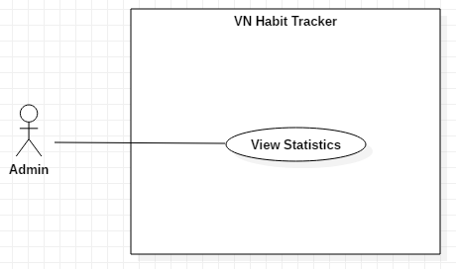

Figure 34 - <Admin> View Statistics

**Use Case Specification**

|  |  |  |  |
| --- | --- | --- | --- |
| **USE CASE – UC_28** | | | |
| **Use Case No.** | 28 | **Use Case Version** | 1.0 |
| **Use Case Name** | View Statistics | | |
| **Author** | TungPT | | |
| **Date** | 15/11/2018 | **Priority** | Normal |
| **Actor:**   * Admin   **Summary:**   * This use case allows the Admin view statistic detail of user’s habits.   **Goal:**   * View statistics detail of user’s habits.   **Triggers:**   * Admin clicks on “Thống kê theo người dùng” button.   **Preconditions:**   * Admin login with role admin.   **Post Conditions:**   * **Success:** Statistic detail have been displayed. * **Fail:** Statistic detail haven’t been displayed.   **Main Success Scenario:**   |  |  |  | | --- | --- | --- | | **Step** | **Actor Action** | **System Response** | | 1 | User clicks on “Thống kê theo người dùng” button. | System shows statistics detail of user’s habits.  + View by week.  + View by month.  + View by year. | | 2 | User clicks on “Tuần” button. | - System shows the information of the habit belong to week.  [Exception 1, 2] | | 3 | User clicks on “Tháng” button. | - System shows the information of the habit belong to month.  [Exception 1, 2] | | 4 | User clicks on “Năm” button. | - System shows the information of the habit belong to year.  [Exception 1, 2] |   **Alternative:** N/A.  **Exceptions:**   |  |  |  | | --- | --- | --- | | **No** | **Cause** | **System Response** | | 1 | User clicks on Close icon. | Closed this page. | | 2 | Network. | System shows “Lỗi không thể kết nối!” message. |   **Relationships:**  N/A  **Business Rules:**   * After view statistic of user’s habits successfully. Admin return to the main page. * Admin can view all user’s habits. | | | |

Table 40 - <Admin> View Statistics

1. Software System Attribute

### Usability

* Provide a convenient way to interact with system.
* Screen layout and navigation are clear and easy to use.
* Interface are simple and clear, user can easy to manage habit.
* The system usability is easy to use that needs less than 2 days of training for company staffs to use the system.

### Reliability

* System notification success rate is less than 2 failed notifications per 1000 sent.

### Availability

* User connects to internet to login into the application.
* User uses offline after login and connect internet to push data to the server.
* The system updates every day at 00:01 am.

### Security

* Private: Each role of user has a specific permission to interact with the system.
* Only admin can manage user and feedback of user.
* All input data are validated before saving to database.

### Maintainability

* The code is easy to maintain and upgrade.
* Maintain the whole system every 1 months.
* Accidental problem is resolved within acceptable time.

### Portability

* The website is running on Windows 7 or above.
* The mobile application running on a device with API 23 or above.

### Performance

* All requests are handled in maximum time of 5 seconds base on Heroku server.

1. Conceptual Diagram

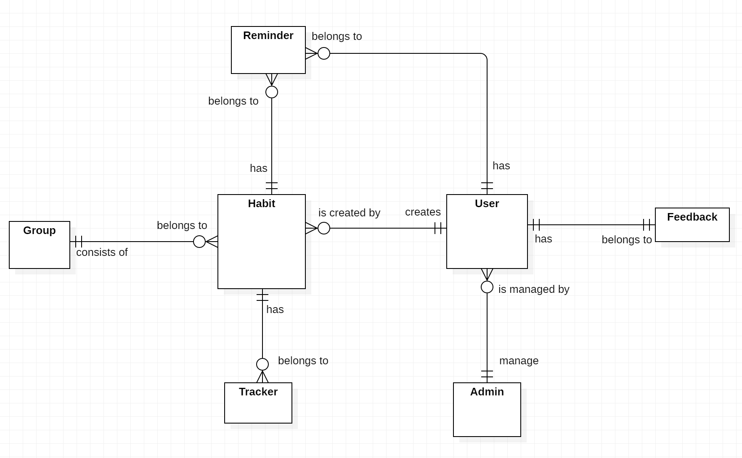

Figure 35 - Conceptual Diagram

***Data Dictionary***

|  |  |
| --- | --- |
| **Entity Data dictionary: describe all content of all entities** | |
| **Entity Name** | **Description** |
| User | Contain the user information. |
| Admin | Contain the admin information. |
| Feedback | Contain the feedback information. |
| Habit | Contain the habit information. |
| Tracker | Contain the vehicle information. |
| Reminder | Contain the reminder information. |
| Group | Contain the group information. |

Table 41 - Conceptual Diagram Dictionary

1. Software Design Description
2. Design Overview

- This document describes the technical and user interface design of MSSC System. It includes the architectural design, the detailed design of common functions and business functions and the design of database model.

- The architectural design describes the overall architecture of the system and the architecture of each main component and subsystem.

- The detailed design describes static and dynamic structure for each component and functions. It includes class diagrams, class explanations and sequence diagrams for each use cases.

- The database design describes the relationships between entities and details of each entity. - Document overview:

* + Section 2: gives an overall description of the system architecture design.
  + Section 3: gives component diagrams that describe the connection and integration of the system.
  + Section 4: gives the detail design description which includes class diagram, class explanation, and sequence diagram to details the application functions.
  + Section 5: describe screens design.
  + Section 6: describe a fully attributed ERD.
  + Section 7: describe algorithms.

1. System architecture design


5. * 1. Web application architecture description

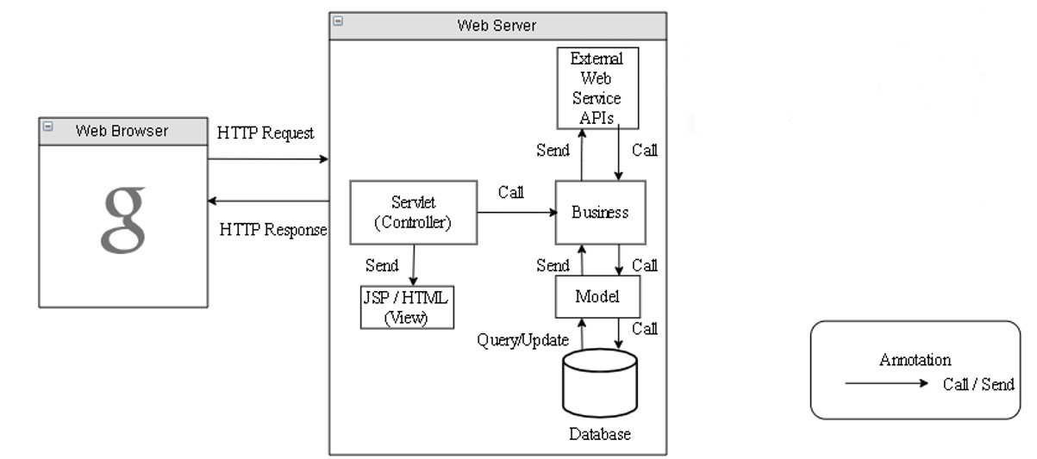

Figure 36 - Web application architecture description

In Web Application, the system is developed under J2EE MVC architecture style. We choose this architecture for Web application because of in scope of the 4 - member team, MVC architecture makes it easier to split the big project into small modules and make it easier to assign each module for members in our team.

This project follows MVC architecture with following components:

* **Servlet (Controller)** is the parts of the application that acts like event handler to handle user interaction. Typically, the controller reads data from a request and calls appropriate Business’s method, then selects view to return to user.
* **JSP/HTML (View)** is the parts of the application that handles the display of the data. The selection of View is under control of Controller.
* **Business** is the parts of the application that do business processing to solve domain problems.
* **Model** is the parts of the application that acts like a data transfer object between the system and database.
* **Web Service** is the parts of the application that acts like an event handler for web and mobile communication via REST method.
  + 1. Mobile application architecture description

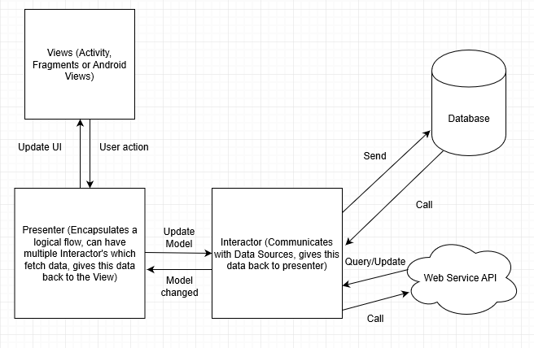

Figure 37 - Mobile application architecture description

Numerous architectural patterns appeared, but MVP (Model View Presenter) can fulfill the complete requirements of Android developers.

MVP is one of the patterns, which Android community prefers at this time.

In Android, the application should be easily extensible and maintainable. Therefore, in order to maintain the level, it is important to define separated layers well. And, MVP makes things easier for developers and it makes the views independent of the data source.

* **The Model**
* It represents the layer, which holds the business logic as well as controls how data is created, stored and modified. In Android, it is a data access layer, for example, database API or Remote server API.
* The Model consists of components that are responsible for functionalities like for generating, storing, exposing and fetching the data.
* All these functionalities usually perform in the background thread. Because, these functionalities could be time-consuming, and they can potentially block the main thread UI.
* **The View**
* It is a passive interface, which displays data, and the routes user actions to Presenter.
* In Android, the View is represented by Activity, Fragment or View.
* The View component contains a visual part of the application.
* The View contains the UI and it does not contain any logic or knowledge of the displayed data.
* **The Presenter**
* The Presenter is in between Model and the View. And, it triggers the business logic, and lets to know ‘the View’ when to update.
* It recovers data received from the Model and shows it in the View.
* It interacts with the Model, then fetches and transforms the data from the Model to update the view.

1. Component Diagram

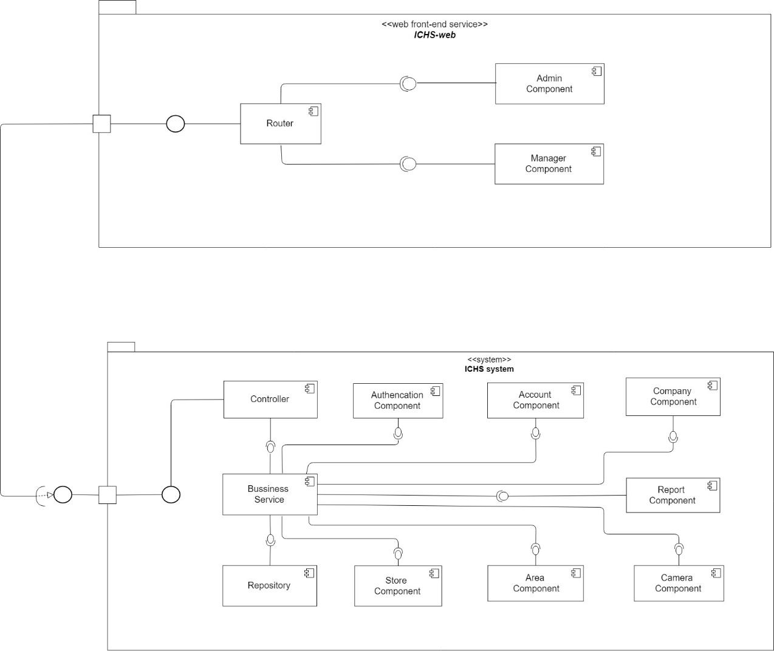

Figure 38 – Component Diagram

| **Components Dictionary: Describes components** | |
| --- | --- |
| Business Service | Component which handles business process for Web Sever. Include |
| Repository | Component which handles storing and retrieving data from database. |
| Controller | Component which handles request and response, accept input, convert it to commands for model and view. |
| Router | Handle request and response, accept input and convert it to commands for back-end |
| Admin Component | Handle admin’s activities in the system |
| Manager Component | Handle manager’s activities in the system |

Table 42 – Component Dictionary

1. Detailed Description
   * 1. Class diagram

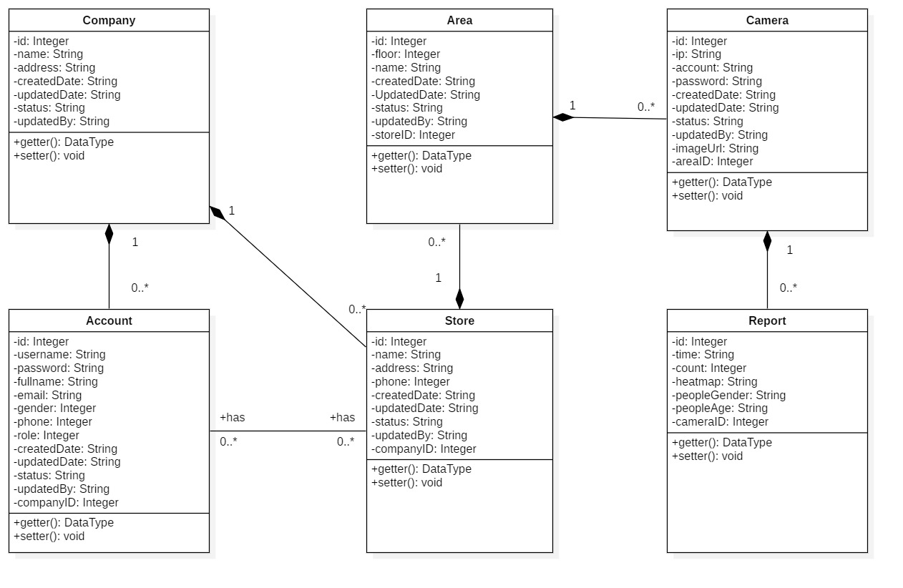

Figure 39 - Class Diagram

|  |  |  |
| --- | --- | --- |
| **CLASS DICTIONARY: DESCRIBE CLASS** | | |
| **Class Name** | **Mapping column with Conceptual diagram** | **Description** |
| **Company** | Company | Contains the information of Company |
| **Account** | Account | Contains the information of Account |
| **Store** | Store | Contains the information of Store |
| **Area** | Area | Contains the information of Area |
| **Camera** | Camera | Contains the information of Camera |
| **Report** | Report | Contains the information of Report |

Table 43 - Class Diagram Dictionary

* + 1. Class Diagram Explanation
       1. Account

|  |  |  |  |
| --- | --- | --- | --- |
| Attribute | Type | Visibility | Description |
| Id | Integer | Private | Unique identifier of an account |
| Username | String | Private | Username of Account |
| Password | String | Private | Password of Account |
| Email | String | Private | Email of Account |
| Gender | Integer | Private | Gender of Account |
| Phone | Integer | Private | Phone number of Account |
| Role | Integer | Private | Role of Account |
| CreatedDate | String | Private | Date when account is created |
| UpdatedDate | String | Private | Date when account is updated |
| Status | String | Private | Status of account |
| UpdatedBy | String | Private | Which username updates account |
| CompanyID | Integer | Private | Contain information of the mentioned attribute |
| Method | **Return Type** | **Visibility** | **Description** |
| getter | DataType | Public | Get value for attribute |
| Setter | Void | Public | Set value for attribute |

Table 44 – Class Diagram Explanation <Account>

* + - 1. Company

|  |  |  |  |
| --- | --- | --- | --- |
| Attribute | Type | Visibility | Description |
| Id | Integer | Private | Unique identifier of a company |
| Name | String | Private | Name of company |
| Address | String | Private | Address of company |
| CreatedDate | String | Private | Date when company is created |
| UpdatedDate | String | Private | Date when company is updated |
| Status | String | Private | Status of company |
| UpdatedBy | String | Private | Which username updates company |
| Method | **Return Type** | **Visibility** | **Description** |
| getter | DataType | Public | Get value for attribute |
| Setter | Void | Public | Set value for attribute |

Table 45 - Class Diagram Explanation <Company>

* + - 1. Store

|  |  |  |  |
| --- | --- | --- | --- |
| Attribute | Type | Visibility | Description |
| Id | Integer | Private | Unique identifier of a store |
| Name | String | Private | Name of store |
| Address | String | Private | Address of store |
| Phone | Integer | Private | Phone of store |
| CreatedDate | String | Private | Date when store is created |
| UpdatedDate | String | Private | Date when store is updated |
| Status | String | Private | Status of store |
| UpdatedBy | String | Private | Which username updates store |
| CompanyID | Integer | Private | Contain information of the mentioned attribute |
| Method | **Return Type** | **Visibility** | **Description** |
| getter | Void | Public | Get value for attribute |
| Setter | Void | Public | Set value for attribute |

Table 46 - Class Diagram Explanation <Store >

* + - 1. Area

|  |  |  |  |
| --- | --- | --- | --- |
| Attribute | Type | Visibility | Description |
| Id | Integer | Private | Unique identifier of an area |
| Floor | Integer | Private | Floor of area |
| Name | String | Private | Name of area |
| CreatedDate | String | Private | Date when area is created |
| UpdatedDate | String | Private | Date when area is updated |
| Status | String | Private | Status of area |
| UpdatedBy | String | Private | Which username updates area |
| StoreID | String | Private | Contain information of the mentioned attribute |
| Method | **Return Type** | **Visibility** | **Description** |
| getter | Void | Public | Get value for attribute |
| setter | Void | Public | Set value for attribute |

Table 47 - Class Diagram Explanation <Area>

* + - 1. Camera

|  |  |  |  |
| --- | --- | --- | --- |
| Attribute | Type | Visibility | Description |
| Id | Integer | Private | Unique identifier of a camera |
| Ip | String | Private | Ip of camera |
| Account | String | Private | Account of camera |
| Passsword | String | Private | Password of camera |
| CreatedDate | String | Private | Date when camera is created |
| UpdatedDate | String | Private | Date when camera is updated |
| Status | String | Private | Status of camera |
| UpdatedBy | String | Private | Which username updates camera |
| AreaID | Integer | Private | Contain information of the mentioned attribute |
| Method | **Return Type** | **Visibility** | **Description** |
| getter | Void | Public | Get value for attribute |
| Setter | Void | Public | Set value for attribute |

Table 48 – Class Diagram Explanation <Camera>

* + - 1. Report

|  |  |  |  |
| --- | --- | --- | --- |
| Attribute | Type | Visibility | Description |
| Id | Integer | Private | Unique identifier of a report |
| Time | String | Private | Time of report |
| Count | String | Private | Number of counted people |
| Heatmap | String | Private | The matrix heatmap of people |
| CameraID | Integer | Private | Contain information of the mentioned attribute |
| Method | **Return Type** | **Visibility** | **Description** |
| getter | Void | Public | Get value for attribute |
| Setter | Void | Public | Set value for attribute |

Table 49 – Class Diagram Explanation <Report>

* + 1. Interaction Diagram
       1. Add habit

*Summary: this diagram show process of user adds habit*

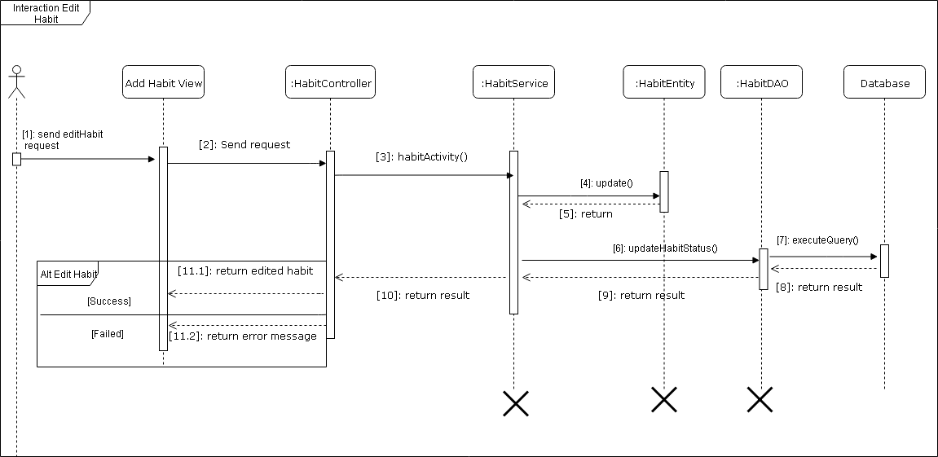

Figure 40 - Sequence Diagram for add habit <User>

* + - 1. Edit Habit

*Summary: this diagram show process of user edits a habit.*



Figure 41 -Sequence Diagram for edit habit <User>

* + - 1. Delete Habit

*Summary: this diagram show process of user deletes a habit*

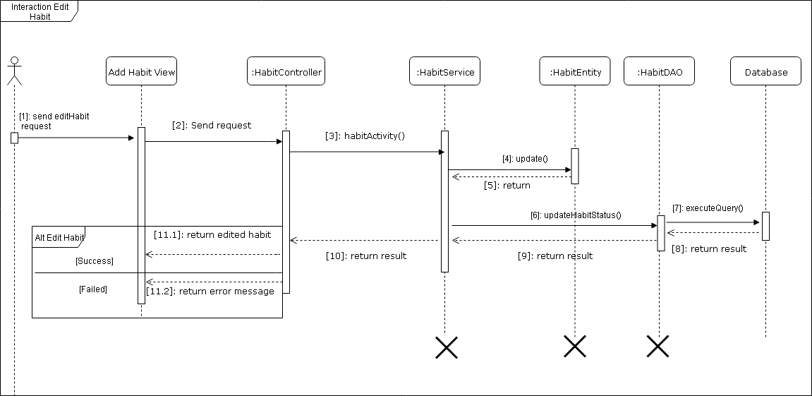

Figure 42 - Sequence Diagram for delete habit <User>

* + - 1. Add Reminder

*Summary: this diagram show process of user add reminder.*

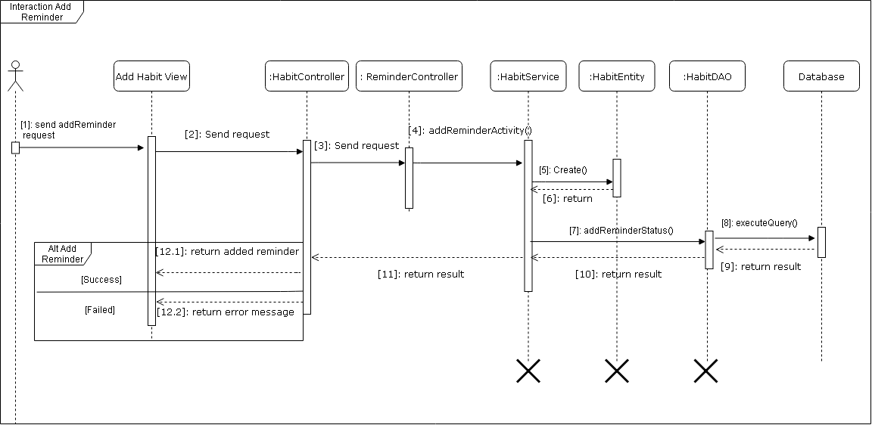

Figure 43 - Sequence Diagram for add reminder <User>

* + - 1. Edit Reminder

*Summary: this diagram show process of user edit reminder.*

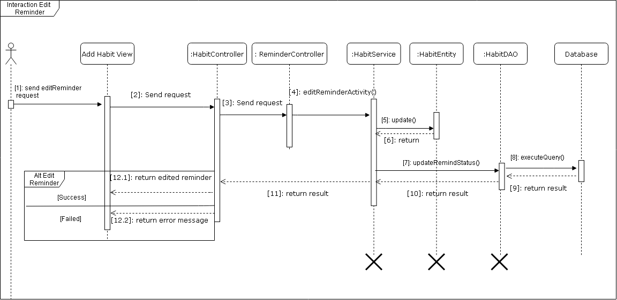

Figure 44 - Sequence Diagram for edit reminder <User>

* + - 1. Delete Reminder

*Summary: this diagram show process of user deletes reminder for habit.*

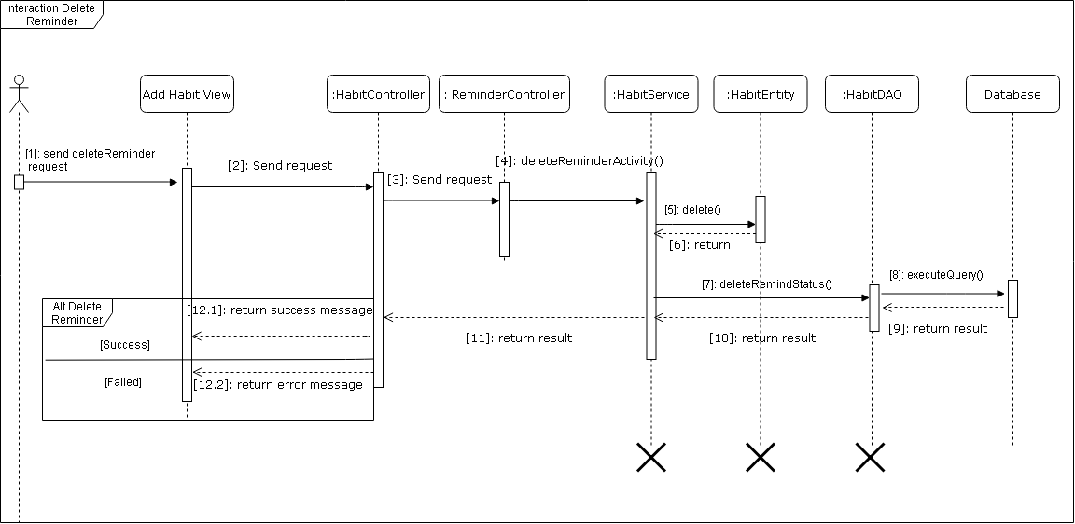

Figure 45 - Sequence Diagram for delete reminder <User>

* + 1. Activity diagram

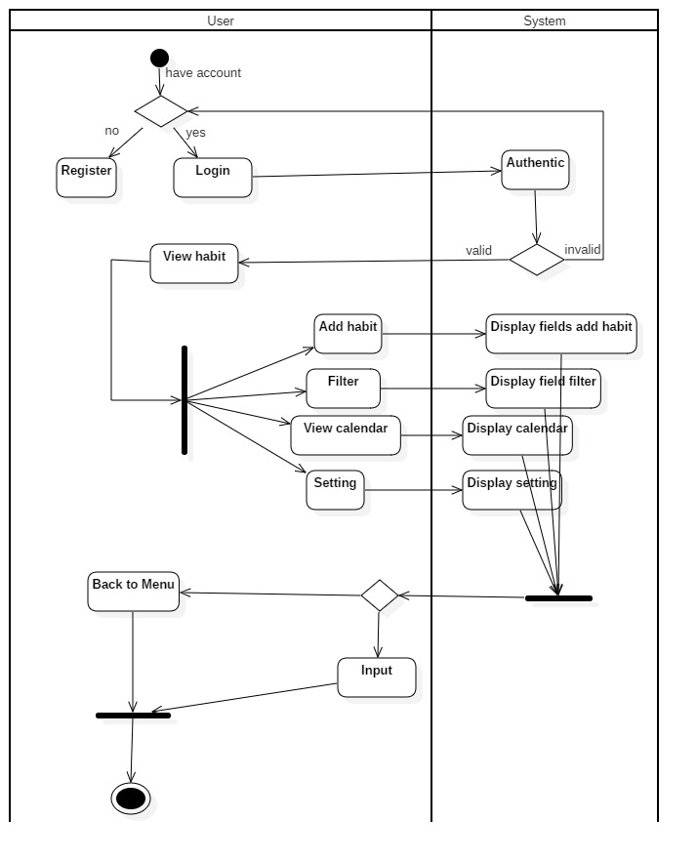

Figure 46 - Activity Diagram for habit

1. User Interface Design
   * 1. Mobile application user interface
     2. Login

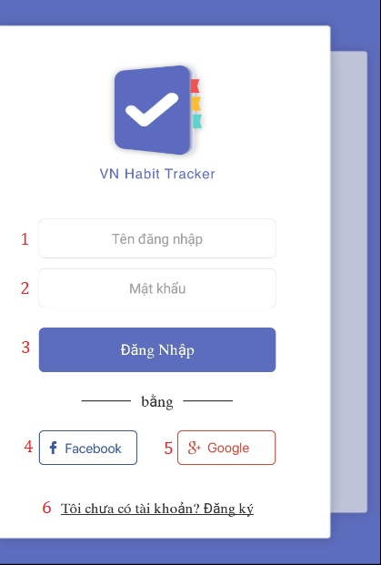

Figure 47 - User Interface <Login>

**Field**

|  |  |  |  |  |  |  |  |
| --- | --- | --- | --- | --- | --- | --- | --- |
| **No** | **Field Name** | **Description** | **Read only** | **Mandatory** | **Control Type** | **Data Type** | **Length** |
| 1 | Username | Username to login | No | Yes | Textbox | String |  |
| 2 | Password | Password to login | No | Yes | Textbox | String |  |

Table 51 - Login <Field>

**Buttons/Hyperlinks:**

|  |  |  |  |  |
| --- | --- | --- | --- | --- |
| **No** | **Function** | **Description** | **Validation** | **Outcome** |
| 3 | Login | Login into system | Validate all required fields | Navigate to page |
| 4 | Login with facebook | Login into system | Validate all required fields | Navigate to page |
| 5 | Login with google | Login into system | Validate all required fields | Navigate to page |
| 6 | Register | Creates account |  | Register page |

Table 52 - Login <Buttons/Hyperlinks>

* + 1. Register

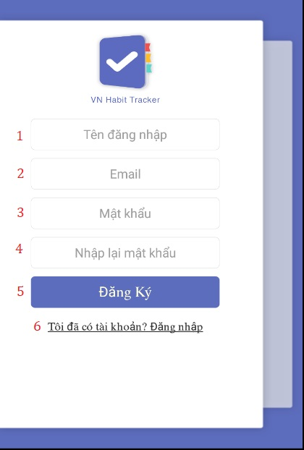

Figure 48 - User Interface <Register>

**Field**

|  |  |  |  |  |  |  |  |
| --- | --- | --- | --- | --- | --- | --- | --- |
| **No** | **Field Name** | **Description** | **Read only** | **Mandatory** | **Control Type** | **Data Type** | **Length** |
| 1 | Username | Username to register | No | Yes | Textbox | String |  |
| 2 | Email | Email to register | No | Yes | Textbox | String |  |
| 3 | Password | Password to register | No | Yes | Textbox | String |  |
| 4 | Re-enter password | Input password again | No | Yes | Textbox | String |  |

Table 53 - Register <Field>

**Buttons/Hyperlinks:**

|  |  |  |  |  |
| --- | --- | --- | --- | --- |
| **No** | **Function** | **Description** | **Validation** | **Outcome** |
| 5 | Register | Create an account | Validate all required fields | Navigate to page |
| 6 | Login with an account | Login into system | N/A | Login page |

Table 54 - Register <Buttons/Hyperlinks>

* + 1. Main Page

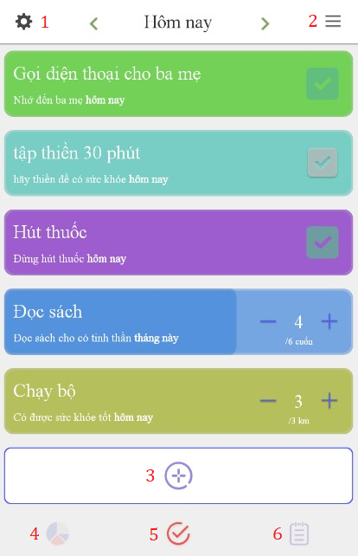

Figure 49 - User Interface <Main page>

**Buttons/Hyperlinks:**

|  |  |  |  |  |
| --- | --- | --- | --- | --- |
| **No** | **Function** | **Description** | **Validation** | **Outcome** |
| 1 | Settings | Settings of user | N/A | Settings page |
| 2 | Filter | Sort habits by type | N/A | Filter page |
| 3 | Add habits | Create new build or quit habits | N/A | Add habit page |
| 4 | Statistic | Show statitis | N/A | Statistic page |
| 5 | Main Screen | Show list habits | N/A | Main menu page |
| 6 | Profiles | View profiles and achivement | N/A | Main menu page |

Table 55 - Main page <Buttons/Hyperlinks>

* + 1. Add Habit

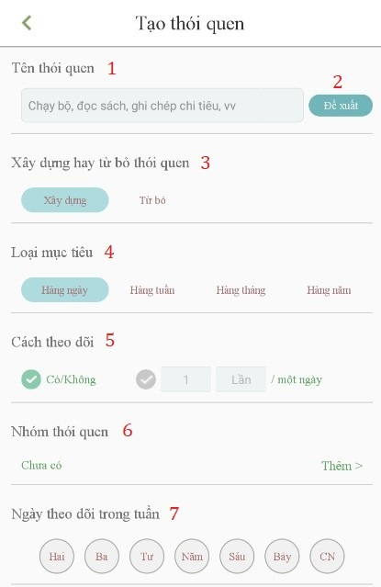

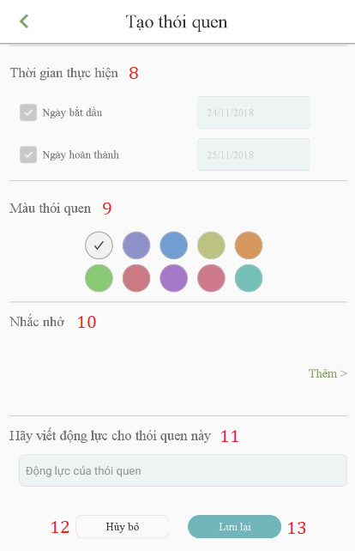

Figure 50 - User Interface <Add Habit>

**Field**

|  |  |  |  |  |  |  |  |
| --- | --- | --- | --- | --- | --- | --- | --- |
| **No** | **Field Name** | **Description** | **Read only** | **Mandatory** | **Control Type** | **Data Type** | **Length** |
| 1 | Habit name | Name of habit | No | Yes | Textbox | String |  |
| 3 | Habit type | Build or quit a habit | No | Yes | Radio button | String |  |
| 4 | Habit target | Taget of habit | No | Yes | Radio button | String |  |
| 5 | Tracking | Choice Yes/No or check times | No | Yes | Radio button | String |  |
| 7 | Day in week | Choice day | No | No | Radio button | String |  |
| 8 | execution time | Start and finish date of habit | No | No | checkbox | String |  |
| 9 | Habit color | Color of habit | No | Yes | Radio button | String |  |
| 11 | Habit description | Description of habit | No | No | Textbox | String |  |

Table 56 - Add Habit <Field>

**Buttons/Hyperlinks:**

|  |  |  |  |  |
| --- | --- | --- | --- | --- |
| **No** | **Function** | **Description** | **Validation** | **Outcome** |
| 2 | Habit suggest | Suggest habit for user | N/A | Suggestion page |
| 6 | Habit group | Group of habit | N/A | Group page |
| 10 | Habit reminder | Reminder of habit | N/A | Reminder page |
| 12 | Canel | Close habit page | N/A | Main screen |
| 13 | Save | Habit is created | Validate Habit name required fields | Main screen |

Table 57 - Add Habit <Buttons/Hyperlinks>

* + 1. Edit and Delete Habit

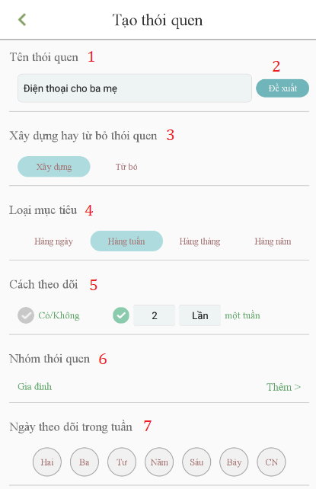

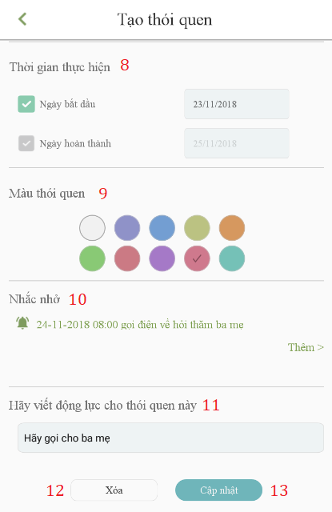

Figure 51 - User Interface <Edit and Delete Habit>

**Field**

|  |  |  |  |  |  |  |  |
| --- | --- | --- | --- | --- | --- | --- | --- |
| **No** | **Field Name** | **Description** | **Read only** | **Mandatory** | **Control Type** | **Data Type** | **Length** |
| 1 | Habit name | Name of habit | No | Yes | Textbox | String |  |
| 3 | Habit type | Build or quit a habit | No | Yes | Radio button | String |  |
| 4 | Habit target | Taget of habit | No | Yes | Radio button | String |  |
| 5 | Tracking | Choice Yes/No or check times | No | Yes | Radio button | String |  |
| 7 | Day in week | Choice day | No | No | Radio button | String |  |
| 8 | execution time | Start and finish date of habit | No | No | checkbox | String |  |
| 9 | Habit color | Color of habit | No | Yes | Radio button | String |  |
| 11 | Habit description | Description of habit | No | No | Textbox | String |  |

Table 58 - Edit and Delete Habit <Field>

**Buttons/Hyperlinks:**

|  |  |  |  |  |
| --- | --- | --- | --- | --- |
| **No** | **Function** | **Description** | **Validation** | **Outcome** |
| 2 | Habit suggest | Suggest habit for user | N/A | Suggestion page |
| 6 | Habit group | Group of habit | N/A | Group page |
| 10 | Habit reminder | Reminder of habit | N/A | Reminder page |
| 12 | Delete | Delete this habit | N/A | Main screen |
| 13 | Save | Habit is updated | Validate Habit name required fields | Main screen |

Table 59 - Edit and Delete Habit <Buttons/Hyperlinks>

* + 1. Edit Detail

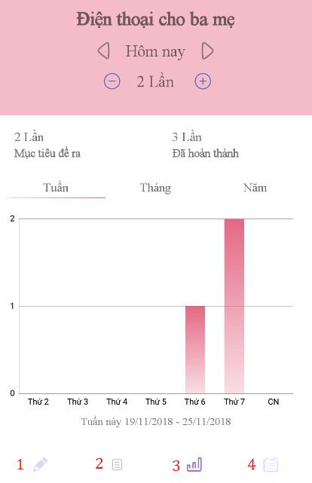

Figure 52 - User Interface <Edit Detail>

**Buttons/Hyperlinks:**

|  |  |  |  |  |
| --- | --- | --- | --- | --- |
| **No** | **Function** | **Description** | **Validation** | **Outcome** |
| 1 | Edit | Edit or delete the habit | N/A | Edit page |
| 2 | Journal | Write notes for this habit | N/A | Journal page |
| 3 | Statistic habit | Show statistic of this habit | N/A | statistic form |
| 4 | Calendar | View calendar of this habit | N/A | Calendar form |

Table 60 - Edit Detail <Buttons/Hyperlinks>

* + 1. Reminder

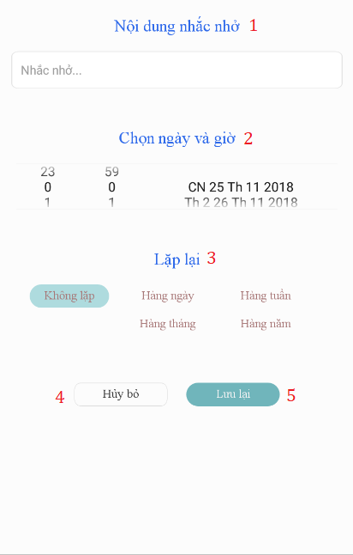

Figure 53 - User Interface <Reminder>

**Field**

|  |  |  |  |  |  |  |  |
| --- | --- | --- | --- | --- | --- | --- | --- |
| **No** | **Field Name** | **Description** | **Read only** | **Mandatory** | **Control Type** | **Data Type** | **Length** |
| 1 | Reminder content | Content of habit’s reminder | No | Yes | Textbox | String |  |
| 2 | Date & time | Set date and time for habit’s reminder | No | Yes | datetime | String |  |
| 3 | Reminder repeat | Repeat of habit’s reminder | No | Yes | Radio button | String |  |

Table 61 - Reminder <Field>

**Buttons/Hyperlinks:**

|  |  |  |  |  |
| --- | --- | --- | --- | --- |
| **No** | **Function** | **Description** | **Validation** | **Outcome** |
| 4 | Cancel | Close reminder page | N/A | Habit page |
| 5 | Save | Save habit’s reminder | Validate Reminder content required fields | Habit page |

Table 62 - Reminder <Buttons/Hyperlinks>

* + 1. Group

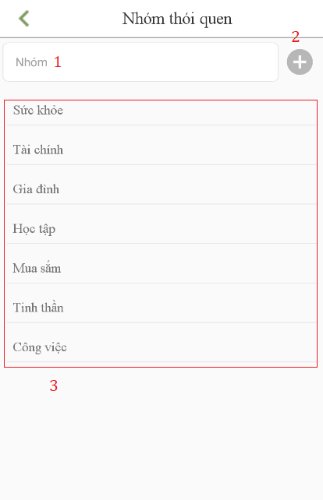

Figure 54 - User Interface <Group>

**Field**

|  |  |  |  |  |  |  |  |
| --- | --- | --- | --- | --- | --- | --- | --- |
| **No** | **Field Name** | **Description** | **Read only** | **Mandatory** | **Control Type** | **Data Type** | **Length** |
| 1 | Group name | Name of group | No | Yes | Textbox | String |  |
| 3 | Group list | List of groups | No | Yes | List items | String |  |

Table 63 - Group <Field>

**Buttons/Hyperlinks:**

|  |  |  |  |  |
| --- | --- | --- | --- | --- |
| **No** | **Function** | **Description** | **Validation** | **Outcome** |
| 2 | Add | Add new name of group | Validate Group name require field | Show group name in group list. |

Table 64 - Group <Buttons/Hyperlinks>

1. Database Design
   * 1. Entity relationship diagram (ERD)

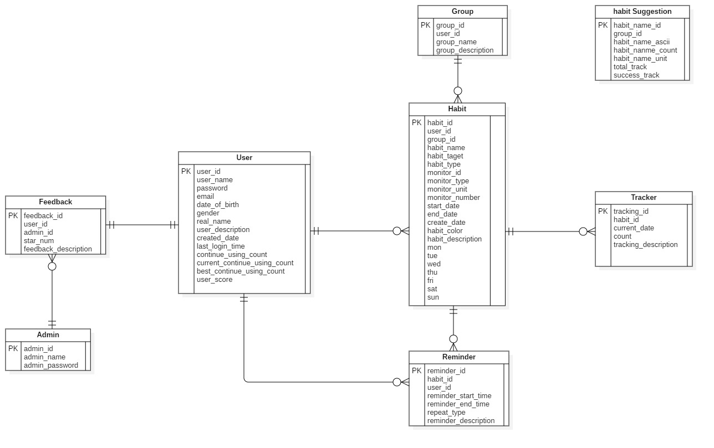

Figure 55 - Entity Relationship Diagram

* + 1. Entity dictionary

|  |  |
| --- | --- |
| **Entity Data Dictionary: describe content of all entities** | |
| **Entity name** | **Description** |
| User | Contains the user’s information. |
| Admin | Contains the admin’s information. |
| Habit | Contains the habit’s information. |
| Reminder | Contains the reminder’s information. |
| Group | Contains the group’s information. |
| Tracking | Contains the tracking’s information. |
| Feedback | Contains the feedback’s information. |
| Habit Suggestion | Contains the habit suggestion’s information. |

Table 65 – Entity Relationship Diagram Dictionary

|  |  |  |  |  |
| --- | --- | --- | --- | --- |
| Table Name | Attributes | Description | Domain | Nulls |
| User | User_id | ID of user | varchar(36) | No |
| username | Username of user | varchar(10) | No |
| password | Password of user | text | No |
| email | Email of user | text | Yes |
| date_of_birth | Date of birth of user | date | Yes |
| gender | Gender of user | tinyint(1) | Yes |
| real_name | real name of user | text | Yes |
| user_description | Description of user | text | Yes |
| created_date | Date of user to register success. | date | Yes |
| last_login_time | Last time to login of user | date | Yes |
| continue_using_count | Application use chain | int(11) | Yes |
| current_continue_using_count | current application use chain | int(11) | Yes |
| best_continue_using_count | best application use chain | int(11) | Yes |
| user_score | Score of user | int(11) | Yes |
| Admin | admin_id | ID of admin | varchar(36) | No |
| admin_name | Username of admin | varchar(36) | No |
| admin_password | Passsword of admin | text | No |
| Habit | habit_id | ID of habit | varchar(36) | No |
| user_id | ID of user | varchar(36) | No |
| group_id | ID of group | varchar(36) | Yes |
| monitor_id | ID of monitor | varchar(36) | No |
| habit_name | Name of habit | text | No |
| habit_target | Target of habit | tinyint(1) | Yes |
| habit_type | Type of habit | tinyint(1) | Yes |
| monitor_type | Type of monitor | tinyint(1) | Yes |
| monitor_unit | Unit of monitor | text | Yes |
| monitor_number | Number of monitor | int(11) | Yes |
| start_date | Start date of habit | date | Yes |
| end_date | End date of habit | date | Yes |
| created_date | Created date of habit | date | Yes |
| habit_color | Color of habit | text | Yes |
| habit_description | Description of habit | text | Yes |
| mon | Monday | tinyint(1) | Yes |
| tue | Tueday | tinyint(1) | Yes |
| wed | Wednesday | tinyint(1) | Yes |
| thu | Thurday | tinyint(1) | Yes |
| fri | Friday | tinyint(1) | Yes |
| sat | saturday | tinyint(1) | Yes |
| sun | sunday | tinyint(1) | Yes |
| Group | group_id | ID of group | varchar(36) | No |
| group_name | Name of group | text | No |
| User_id | ID of user | varchar(36) | Yes |
| Group_description | Description group | text | Yes |
| Reminder | reminder_id | ID of reminder | varchar(36) | No |
| habit_id | ID of habit | varchar(36) | No |
| user_id | ID of user | varchar(36) | No |
| reminder_start_time | Set time reminder | text | No |
| reminder_end_time | Set time reminder | text | Yes |
| repeat_type | type of reminder | text | No |
| reminder_description | Description of reminder | text | Yes |
| Tracker | tracking_id | ID of tracking | varchar(36) | No |
| habit_id | ID of habit | varchar(36) | No |
| current_date | Current date | date | Yes |
| count | count tracking times | int(11) | Yes |
| tracking_description | Description of tracking | text | Yes |
| Habit suggestion | habit_name_id | ID of habit | Varchar(36) | No |
| group_id | Group of habit | varchar(36) | Yes |
| habit_name_uni | Save values uni of habit | text | No |
| habit_name_ascii | Save values ascii of habit | text | No |
| habit_name_count | Number of times tracking habits | int(11) | No |
| total_track | Toal tracking habits | int(11) | No |
| success_track | Success tracking habits | int(11) | No |
| Feedback | Feedback_id | ID of feedback | varchar(36) | No |
| User_id | ID of user | varchar(36) | No |
| Admin_id | ID of admin | varchar(36) | No |
| Star_num | Application reviews | int(11) | Yes |
| Feedback_description | Description of feedback | text | No |

Table 66 – Entity Relationship Diagram Detail Dictionary

1. Algorithms
   * 1. Recommend the best habits for users by linear programming algorithm
        1. Definition

This algorithm is intended to suggest habits that are commonly used by the community and that are comparable to the current user.

* + - 1. Define problem

Helps newcomers or those who have long participated in good habits or give up bad habits to improve themselves.

* + - 1. Soloution

Based on user criteria, we have the following general formula:

|  |
| --- |
|  |

With:  
t: are characters that are nearly identical to the input characters, sorted in decreasing order by user.

d: is the difficulty of the habit.

c: is level of current user.

Based on user criteria, we have the following level of user-formula:

Supposed:

c1: is level 1 – 3**.**

c2: is level 4 – 6.

c3: is level 7 – 10.

With c1, c2, c3 are specified by accumulated points

Accumulated points are calculated by:

For every time a habit is completed**:**

Daily habit**:** +1 score

Weekly habit: +3 score

Monthly habit**:** +12 score

Yearly habit**:** +150 score

* Points are only added at the end of the day / week / month / year

Habit chain**:**

0 – 7 days: +2 score

7 – 30 days: +4 score

30 – 60 days: +8 score

60 – 180 days: +16 score

>180 days: + 32 score

*Based on the cumulative score, there are the following levels:*

Lv1**:** 0 score

Lv2: 10 score

Lv3: 20 score

Lv4: 50 score

Lv5: 120 score

Lv6: 290 score

Lv7: 700 score

Lv8: 1690 score

Lv9: 4080 score

Lv10: 9850 score

Based on a habit, we have the following difficulty of the habit-formula:

We have:

a: is the number of successful tracking of the habit(Successful habits are habits that are completed based on each type of habit (daily/monthly /yearly) or taget (yes/no)).

b: is the total tracking of the habit (success or failure).

Supposed:

p: The habit is done successfully.

p = a / b with a / b >= 0.8

f: The habit is done unsuccessfully.

f = a / b with a / b < 0.8

Supposed:

h: is the difficulty of the habit.

k1: The habit is done successfully.

k2: The habit is done unsuccessfully.

d1: easy habit.

d2: medium habit.

d3: difficult habit.

We have:

Difficulty of the habit =

⬄

If

h >= 0.8 -> d1: easy habit.

0.5 < h < 0.8 -> d2: medium habit.

h < 0.5 -> d3: difficult habit.

Then we recommend for user as below:

For c1, the easy habit is suggested.

For c2, the medium habit is suggested.

For c3, the difficult habit is suggested.

x (n) is a widely used habit, ∀n ∈ N * (x1 most users, x2 many second ...).

Based on the difficulty of the habit-formula and level of user-formula we have the following formula:

If c1 applies:

If c2 applies:

If c3 applies:

* + - 1. Complexity

In total, the complexity of this algorithm is **O ().**

* + - 1. Example

Example:

We have a table of habits with a number of users and the difficulty of the habit has been calculated as follows:

|  |  |  |  |  |  |  |
| --- | --- | --- | --- | --- | --- | --- |
| **Habit name** | Tập thể dục | Hút thuốc | Ngồi thiền | Làm việc nhà | Uống thuốc | Làm bài tập |
| **Turns of use** | 1200 | 570 | 945 | 602 | 754 | 136 |
| **Level of difficult habit** | Easy | Difficult | Medium | Medium | Medium | Easy |

User A has a cumulative score of 15, user B has a cumulative score of 143.

* User A: level 2
* User B: level 5

User A and user B both enter the letter “*t*”. Then:

• User A will be offered easy-to-follow customizable user descending order:

* Tập thể dục
* Làm bài tập

• User B will be offered medium-to-follow customizable user descending order:

Ngồi thiền

* + - 1. Flowchart

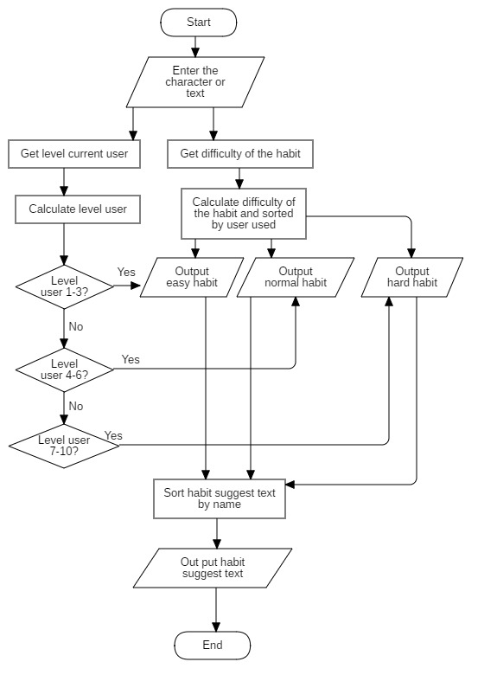

Figure 56 - Flowchart of Recommend the best habits for users by linear programming algorithm

1. System Implementation & Test
2. Introduction
   * 1. Overview

This section describes the approach and methodologies used by group to plan, organize and manage the testing of VHT application. It provides in detail all necessary information about the implementation and testing procedure of the system included test plans, test cases, test result, test environments, pass/fail criteria and risks estimations as well as a checklist to cover all possible cases.

* + 1. Test approach
* Goal: Test all features in the whole VHT application based on the core flow.
* Method: black-box testing.
* Technique: check list.

The testing for this project consists of Integration System test level. Testing the program which was integrated and as a complete system to ensure that the software requirements have been met.

* Integration testing is performed by all member of team and approved by team leader.

System testing is focused on assessing the system’s reliability. This process is concerned with finding errors that result from unanticipated interactions between components and component interface problems.

2. Database Relationship Diagram
4. 2. 1. Physical diagram

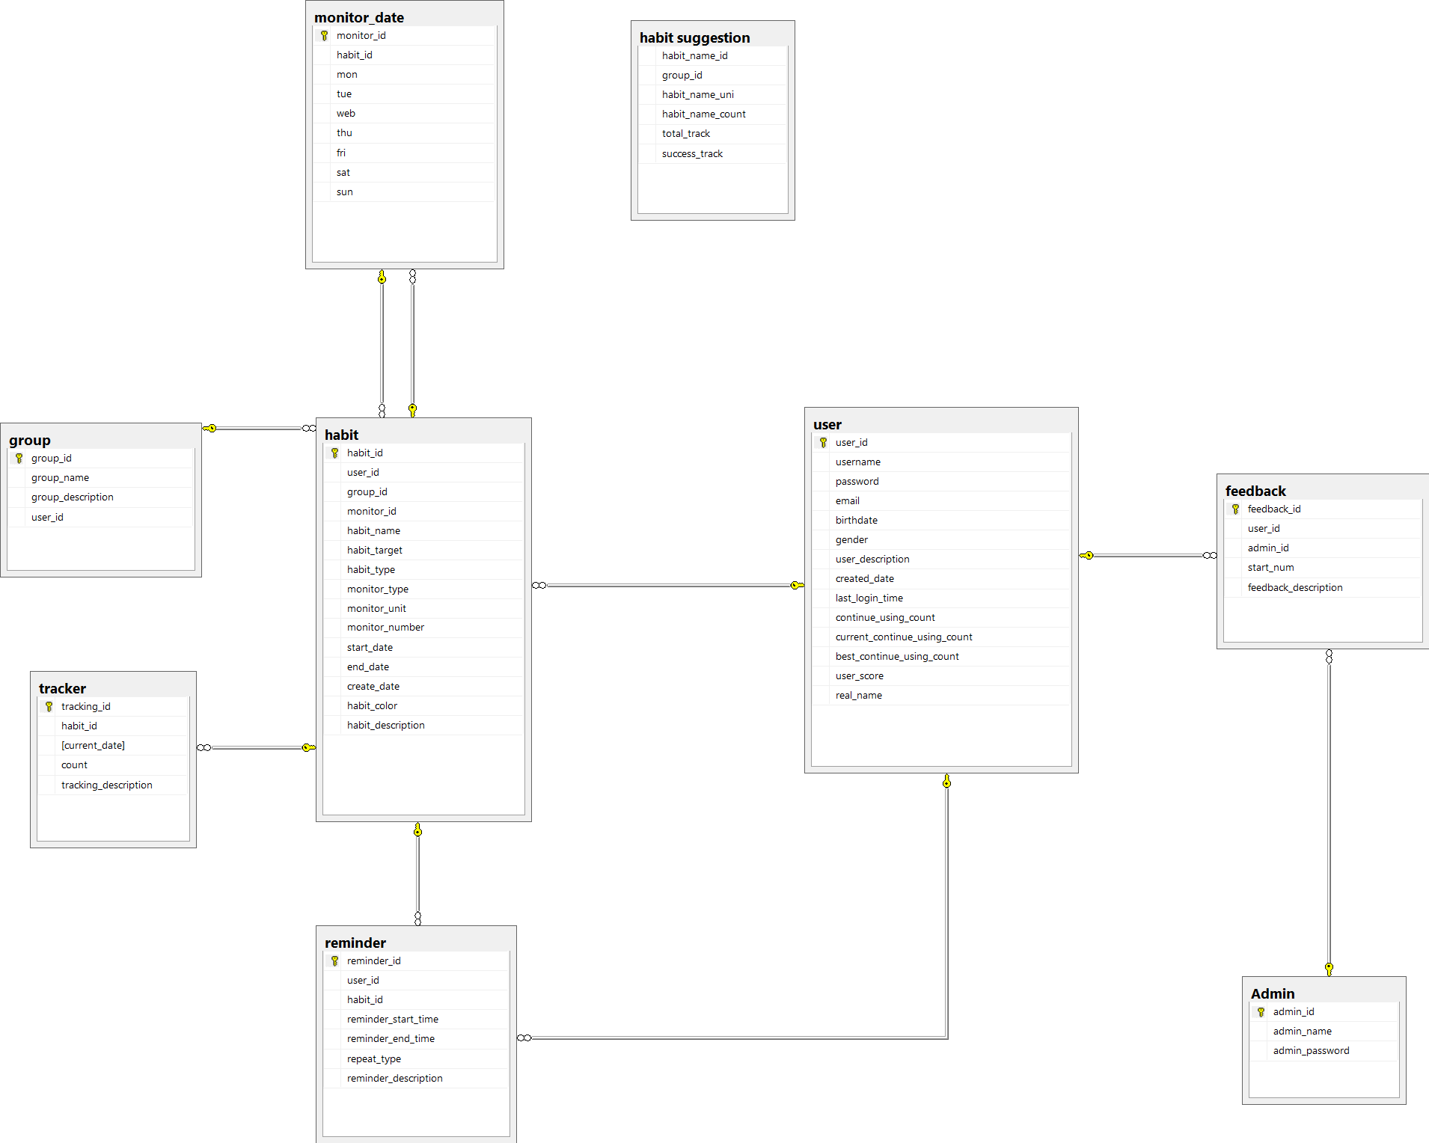

Figure 57 - Physical Diagram

* + 1. Data dictionary

|  |  |
| --- | --- |
| DATA DICTIONARY: DESCRIBE CONTENT OF ALL TABLES | |
| Table name | **Description** |
| User | Contains the user information. |
| Admin | Contains the admin information. |
| Habit | Contains the habit information. |
| Feedback | Contains the feedback information. |
| Group | Contains the group information. |
| Monitor date | Contains the monitor date information. |
| Tracking | Contains the tracking information. |
| Reminder | Contains the reminder information. |
| Habit suggestion | Contains the habit suggestion information. |

Table 67 - physical diagram dictionary

|  |  |  |  |  |
| --- | --- | --- | --- | --- |
| Table Name | Attributes | Description | Domain | Nulls |
| User | User_id | ID of user | varchar(36) | No |
| username | Username of user | varchar(10) | No |
| password | Password of user | text | No |
| email | Email of user | text | Yes |
| date_of_birth | Date of birth of user | date | Yes |
| gender | Gender of user | tinyint(1) | Yes |
| real_name | real name of user | text | Yes |
| user_description | Description of user | text | Yes |
| created_date | Date of user to register success. | date | Yes |
| last_login_time | Last time to login of user | date | Yes |
| continue_using_count | Application use chain | int(11) | Yes |
| current_continue_using_count | current application use chain | int(11) | Yes |
| best_continue_using_count | best application use chain | int(11) | Yes |
| user_score | Score of user | int(11) | Yes |
| Admin | admin_id | ID of admin | varchar(36) | No |
| admin_name | Username of admin | varchar(10) | No |
| admin_password | Passsword of admin | text | No |
| Habit | habit_id | ID of habit | varchar(36) | No |
| user_id | ID of user | varchar(36) | No |
| group_id | ID of group | varchar(36) | Yes |
| monitor_id | ID of monitor | varchar(36) | No |
| habit_name | Name of habit | text | No |
| habit_target | Target of habit | tinyint(1) | Yes |
| habit_type | Type of habit | tinyint(1) | Yes |
| monitor_type | Type of monitor | tinyint(1) | Yes |
| monitor_unit | Unit of monitor | text | Yes |
| monitor_number | Number of monitor | int(11) | Yes |
| start_date | Start date of habit | date | Yes |
| end_date | End date of habit | date | Yes |
| created_date | Created date of habit | date | Yes |
| habit_color | Color of habit | text | Yes |
| habit_description | Description of habit | text | Yes |
| Group | Group_id | ID of group | varchar(36) | No |
| Group_name | Name of group | text | No |
| User_id | ID of user | varchar(36) | Yes |
| Group_description | Description group | text | Yes |
| Monitor date | monitor_id | ID of monitor | varchar(36) | No |
| habit_id | ID of habit | varchar(36) | No |
| mon | Monday | tinyint(1) | Yes |
| tue | Tueday | tinyint(1) | Yes |
| wed | Wednesday | tinyint(1) | Yes |
| thu | Thurday | tinyint(1) | Yes |
| fri | Friday | tinyint(1) | Yes |
| sat | saturday | tinyint(1) | Yes |
| sun | sunday | tinyint(1) | Yes |
| Reminder | reminder_id | ID of reminder | varchar(36) | No |
| habit_id | ID of habit | varchar(36) | No |
| user_id | ID of user | varchar(36) | No |
| reminder_start_time | Set time reminder | text | No |
| reminder_end_time | Set time reminder | text | Yes |
| repeat_type | type of reminder | text | No |
| reminder_description | Description of reminder | text | Yes |
| Tracker | tracking_id | ID of tracking | varchar(36) | No |
| habit_id | ID of habit | varchar(36) | No |
| current_date | Current date | date | Yes |
| count | count tracking times | int(11) | Yes |
| tracking_description | Description of tracking | text | Yes |
| Habit suggestion | group_id | Group of habit | varchar(36) | Yes |
| habit_name_uni | Save values uni of habit | text | No |
| habit_name_ascii | Save values ascii of habit | text | No |
| habit_name_count | Number of times tracking habits | int(11) | Yes |
| total_track | Toal tracking habits | int(11) | Yes |
| success_track | Success tracking habits | int(11) | Yes |
| Feedback | Feedback_id | ID of feedback | varchar(36) | No |
| User_id | ID of user | varchar(36) | No |
| Admin_id | ID of admin | varchar(36) | No |
| Star_num | Application reviews | int(11) | Yes |
| Feedback_description | Description of feedback | text | No |

Table 68 - physical diagram detail dictionary

1. Test plan

The overall purpose of testing is to ensure EMS meets its entire technical, functional and business requirement. The purpose of this document is to describe the overall test plan and strategy for testing the EMS. The approach described in this document provides the framework for all testing related to this application. Individual test cases are written for each version of the application that is released. This document is also updated as required for each release.

* 1. 1. Features to be tested
* Guest: login, register.
* User: Add habit, edit habit, delete habit, suggest habit, view statistic, adjust filter, tracking habit, adjust settings, manage group.
  + 1. Features not to be tested
* Admin: reset password, reply feedback, view statistic.

1. System Testing Test Case
   * 1. Test case
        1. <Guest> Login

|  |  |  |  |  |  |  |
| --- | --- | --- | --- | --- | --- | --- |
| **ID** | **Test Case Description** | **Pre-condition** | **Test case procedure** | **Expected output** | **Result** | **Test Date** |
| AL_1 | Test guest login into the mobile application successfully | - Guest is at “Đăng nhập” screen. | 1. Guest enters “Luudat01” into “Tên đăng nhập” required field.  2. Guest enters “123456” into “Mật khẩu” required field  3. User clicks “Đăng nhập” button | System shows “Đăng nhập thành công” | Pass | 11/11/2018 |
| AL_2 | Test guest login with a blank “Tên đăng nhập” text box. | - Guest is at “Đăng nhập” screen. | 1. Guest inputs a blank in field “Tên đăng nhập”  2. User clicks “Đăng nhập” button. | System shows error message “Tên đăng nhập không được trống”. | Pass | 11/11/2018 |
| AL_3 | Test guest login with a blank “Mật khẩu” text box. | - Guest is at “Đăng nhập” screen. | 1. Guest inputs a blank in field “Mật khẩu”  2. User clicks “Đăng nhập” button. | System shows error message “Mật khẩu không được trống”. | Pass | 11/11/2018 |
| AL_4 | Test guest input wrong username or password. | - Guest is at “Đăng nhập” screen. | 1. Guest inputs “Luudat02” in field “Tên đăng nhập”.  2. Guest inputs “123456” in field “Mật khẩu”  2. User clicks “đăng nhập” button. | System shows error message “Đăng nhập thất bại! Tên đăng nhập hoặc mật khẩu không đúng” | Pass | 11/11/2018 |

Table 69 - Test case <login>

* + - 1. <Guest> Register

|  |  |  |  |  |  |  |
| --- | --- | --- | --- | --- | --- | --- |
| **ID** | **Test Case Description** | **Pre-condition** | **Test case procedure** | **Expected output** | **Result** | **Test Date** |
| AL_1 | Test guest register on the mobile application successfully. | - Guest is at “Đăng ký” screen. | 1. Guest enters “Qtuyen1” into “Tên đăng nhập” required field.  2. Guest enters “0969696969” into “Số điện thoại” required field.  3. Guest enters “tuyen69@gmail.com” into “Email” required field.  4. Guest enters “654321” into “Mật khẩu” required field.  5. Guest enters “654321” into “Nhập lại mật khẩu” required field.  6. User clicks “Đăng ký” button. | System shows “Đăng ký tài khoản thành công”. | Pass | 11/11/2018 |
| AL_2 | Test guest register with a blank “Tên đăng nhập” text box. | - Guest is at “Đăng ký” screen. | 1. Guest inputs a blank in field “Tên đăng nhập”  2. User clicks “Đăng nhập” button. | System shows error message “tên đăng nhập không được trống”. | Pass | 11/11/2018 |
| AL_3 | Test guest login with with a blank “Mật khẩu” text box. | - Guest is at “Đăng ký” screen. | 1. Guest inputs a blank in field “Mật khẩu”  2. User clicks “Đăng nhập” button. | System shows error message “Mật khẩu không được trống”. | Pass | 11/11/2018 |

Table 70 - Test case <Register>

* + - 1. <User> Add Habit

|  |  |  |  |  |  |  |
| --- | --- | --- | --- | --- | --- | --- |
| **ID** | **Test Case Description** | **Pre-condition** | **Test case procedure** | **Expected output** | **Result** | **Test Date** |
| AL_1 | Test user adds a habit successfully. | - Guest logins at user role.  - User is at “Tạo thói quen” screen. | 1. User enters “Chạy bộ” into “Tên thói quen” required field.  2. User clicks “Xây dựng” into “Xây dựng/Từ bỏ” required field.  3. User clicks choose “Hàng ngày” button into “Loại mục tiêu” required field.  4. User clicks “Có/Không” into “Cách theo dõi” required field.  5. User clicks choice “sức khỏe” of the list into “Nhóm thói quen” required field.  6. User tick and choose all day into “Ngày theo dõi trong tuần” required field.  7. User ticks “Ngày bắt đầu”, choose “We 31.10.2018” and tick “Ngày hoàn thành”, choose “Mo 31.12.2018” into “Thời gian thực hiện” required field.  8. User clicks choice red color button into “Màu thói quen” required field.  9. User add “7:00 AM gọi tôi chạy bộ nhé” into “Nhắc nhở” required field.  10. User enters “Sức khỏe là trên hết” intro “Hãy viết động lực cho thói quen này” required field.  11. User clicks “Lưu lại” button. | System shows “Tạo mới thói quen thành công” message. | Pass | 11/11/2018 |
| AL_2 | Test user creates a blank “tên thói quen” text box. | - Guest logins at user role.  - User is at “Tạo thói quen” screen. | 1. User inputs a blank in field “Tên thói quen”  2. User clicks “Lưu lại” button. | System shows “Tên thói quen không được để trống!” message. | Pass | 11/11/2018 |
| AL_3 | Test user input different int type. | - Guest logins at user role.  - User is at “Tạo thói quen” screen.  - User must input name habit into “Tên thói quen” required field. | User clicks choice count time type and inputs “a” into “Cách theo dõi” required field. | System shows “Không được nhập chữ hoặc số phải lớn hơn 0.” message. | Pass | 25/11/2018 |
| AL_4 | Test user inputs negative number. | - Guest logins at user role.  - User is at “Tạo thói quen” screen.  - User must input name habit into “Tên thói quen” required field. | User clicks choice count time type and inputs “-5” into “Cách theo dõi” required field. | System shows “Số phải lớn hơn 0.” message. | Pass | 25/11/2018 |
| AL_5 | Test user no choice weekdays. | - Guest logins at user role.  - User is at “Tạo thói quen” screen.  - User must input name habit in “Tên thói quen” required field. | 1. User unchecks weekdays in “Ngày theo dõi trong tuần” required field.  2. User clicks on “Lưu lại” button. | System shows “Phải chọn ít nhất một ngày trong tuần” message. | Pass | 25/11/2018 |

Table 71 - Test case <Add Habit>

* + - 1. <User> Edit Habit

|  |  |  |  |  |  |  |
| --- | --- | --- | --- | --- | --- | --- |
| **ID** | **Test Case Description** | **Pre-condition** | **Test case procedure** | **Expected output** | **Result** | **Test Date** |
| AL_1 | Test user edit a habit successfully. | Guest logins at user role.  User is at “Chỉnh sửa thói quen” screen. | 1. User enters “Đọc sách” into “Tên thói quen” required field.  2. User clicks choose “Xây dựng” button into “Xây dựng/Từ bỏ” required field  3. User clicks choose “Hàng tháng” button into “Loại mục tiêu” required field.  4. User chooses “sức khỏe” of the list into “Nhóm thói quen” required field.  5. User tick and choose all day into “Ngày theo dõi trong tuần” required field.  6. User ticks “Ngày bắt đầu”, choose “We 31.10.2018” and tick “Ngày hoàn thành”, choose “Mo 31.12.2018” into “Thời gian thực hiện” required field.  7. User ticks choice blue color button into “Màu thói quen” required field.  8. User add “7:00 AM gọi tôi chạy bộ nhé” into “Nhắc nhở” required field.  8. User enters “Sức khỏe là trên hết” intro “Hãy viết động lực cho thói quen này” required field.  9. User clicks “Cập nhật” button. | System shows “Cập nhật thói quen thành công”. | Pass | 11/11/2018 |
| AL_2 | Test user edit a habit with a blank “tên thói quen” text box. | Guest logins at user role.  User is at “Chỉnh sửa thói quen” screen. | 1. User inputs a blank in field “Tên thói quen”  2. User clicks “Cập nhật” button. | System shows error message “Tên thói quen không được để trống!”. | Pass | 11/11/2018 |

Table 72 - Test case <Edit Habit>

* + - 1. <User> Delete Habit

|  |  |  |  |  |  |  |
| --- | --- | --- | --- | --- | --- | --- |
| **ID** | **Test Case Description** | **Pre-condition** | **Test case procedure** | **Expected output** | **Result** | **Test Date** |
| AL_1 | Test user delete a habit successfully. | Guest logins at user role.  User is at “Chỉnh sửa thói quen” screen. | 1. User click choose “Chạy bộ” habit.  2. Uer click “Xóa” button. | System shows “Xóa thói quen thành công”. | Pass | 11/11/2018 |

Table 73 - Test case <Delete Habit>

* + - 1. <User> Search Suggest Habit

|  |  |  |  |  |  |  |
| --- | --- | --- | --- | --- | --- | --- |
| **ID** | **Test Case Description** | **Pre-condition** | **Test case procedure** | **Expected output** | **Result** | **Test Date** |
| AL_1 | Test user input in the habit name field. | User is at “Tạo thói quen” screen. | 1. User enters “c” into “Tên thói quen” required field.  2. User is a beginner  3. “Chạy bộ” is the most selected name. | Suggested text show “Chạy bộ”. | Pass | 11/11/2018 |
| AL_2 | Test user input in the habit name field. | User is at “Tạo thói quen” screen. | 1. User enters “b” into “Tên thói quen” required field.  2. User is an advance user  3. “Bỏ hút thuốc” is the most selected name. | Suggested text show “Bỏ hút thuốc”. | Pass | 11/11/2018 |
| AL_3 | Test user input in the habit name field. | User is at “Tạo thói quen” screen. | 1. User enters “d” into “Tên thói quen” required field.  2. User is a master  3. “Dậy sớm” is the most selected name. | Suggested text show “Dậy sớm”. | Pass | 11/11/2018 |

Table 74 - Test case <Search Suggest Habit>

* + - 1. <User> View Statistic

|  |  |  |  |  |  |  |
| --- | --- | --- | --- | --- | --- | --- |
| **ID** | **Test Case Description** | **Pre-condition** | **Test case procedure** | **Expected output** | **Result** | **Test Date** |
| AL_1 | System show habit follow week type. | - User is at main screen.  - User must have at least a habit. | 1. User choose “tuần” button. | Statistic of week is showed. | Pass | 11/11/2018 |
| AL_3 | System show habit follow month type. | - User is at main screen.  - User must have at least a habit. | 1. User choose “tháng” button. | Statistic of month is showed. | Pass | 11/11/2018 |
| AL_5 | System show habit follow year type. | - User is at main screen.  - User must have at least a habit. | 1. User choose “năm” button. | Statistic of year is showed. | Pass | 11/11/2018 |
| AL_6 | User have not the habit. | - User is at main screen. | 1. User choose “Tuần” or “Tháng” or “Năm” button. | System doesn’t show, nothing is showed. | Pass | 11/11/2018 |

Table 75 - Test case <View Statistic>

* + - 1. <User> Filter

|  |  |  |  |  |  |  |
| --- | --- | --- | --- | --- | --- | --- |
| **ID** | **Test Case Description** | **Pre-condition** | **Test case procedure** | **Expected output** | **Result** | **Test Date** |
| AL_1 | User sort habit follow name. | - User is at main screen.  - User must have at least a habit. | 1. User choose “tên” type in filter that user want to sort. | System sort exactly user choose “tên” type in filter. | Pass | 11/11/2018 |
| AL_2 | User sort habit follow build. | - User is at main screen.  - User must have at least a habit. | 1. User choose “xây dựng” types in filter that user want to sort. | System sort exactly user choose “xây dựng” type in filter. | Pass | 11/11/2018 |
| Al_3 | User sort habit follow quit. | - User is at main screen.  - User must have at least a habit. | 1. User choose “từ bỏ” types in filter that user want to sort. | System sort exactly user choose “từ bỏ” type in filter. | Pass | 11/11/2018 |

Table 76 - Test case <Filter>

* + - 1. <User> Tracking Habit

|  |  |  |  |  |  |  |
| --- | --- | --- | --- | --- | --- | --- |
| **ID** | **Test Case Description** | **Pre-condition** | **Test case procedure** | **Expected output** | **Result** | **Test Date** |
| AL_1 | User track the habit. | User is at “chi tiết thói quen” screen. | 1. User click on a day that can be tracked ... 2. User clink “+” or “-” icon. | “Đạt được” must be changed. | Pass | 11/11/2018 |
| AL_2 | User track next day of the habit. | User is at “chi tiết thói quen” screen. | 1. User click on a day that can be tracked.  2. User clink “+” or “-” icon.  3. That habit is tracked continuously. | “Đạt được” must be changed.  “Chuỗi hiện tại” must be changed. | Pass | 11/11/2018 |
| AL_3 | User track finish day of the habit. | User is at “chi tiết thói quen” screen. | 1. User click on a day that can be tracked.  2. User clink “+” or “-” icon.  3. That habit is tracked continuously.  4. That habit has the longest tracked. | “Đạt được” must be changed.  “Chuỗi hiện tại” must be changed.  “Chuỗi dài nhất” must be changed. | Pass | 11/11/2018 |

Table 77 - Test case <tracking Habit>

* + - 1. <User> Adjust Settings

|  |  |  |  |  |  |  |
| --- | --- | --- | --- | --- | --- | --- |
| **ID** | **Test Case Description** | **Pre-condition** | **Test case procedure** | **Expected output** | **Result** | **Test Date** |
| AL_1 | users choose to arrange weekly habit. | User is at “Cài đặt” screen. | 1.User choose “Sắp xếp thói quen theo loại tuần”. | System shows list of habit follow weekly habits. | Pass | 11/11/2018 |
| AL_2 | users choose to arrange monthly habit. | User is at “Cài đặt” screen. | 1.User choose “Sắp xếp thói quen theo loại tháng”. | System shows list habit follow monthly habits. | Pass | 11/11/2018 |
| AL_3 | users choose to arrange yearly habit. | User is at “Cài đặt” screen. | 1.User choose “Sắp xếp thói quen theo loại năm”. | System shows list habit follow yearly habits. | Pass | 11/11/2018 |
| AL_4 | User set reminder. | User is at main screen. | 1.User choose “Âm thanh thông báo”.  2.User choose “Thêm” for “Nhắc nhở”. | System reminds user when that time comes. | Pass | 11/11/2018 |

Table 78 - Adjust Settings

* + - 1. <User> Manage Group

|  |  |  |  |  |  |  |
| --- | --- | --- | --- | --- | --- | --- |
| **ID** | **Test Case Description** | **Pre-condition** | **Test case procedure** | **Expected output** | **Result** | **Test Date** |
| AL_1 | Test user add new the group in the habit. | User at “Tạo thói quen” screen. | 1. User click “Tạo mới thói quen” button.  2. User clicks “Thêm” button into “Nhóm” required field.  3. User inputs “Tinh thần” into textbox.  4. User clicks Add group button. | System shows “Tạo nhóm thành công” message. | Pass | 25/11/2018 |
| AL_2 | Test user swipe to delete group. | User at “Tạo thói quen” screen. | 1. User click “Tạo mới thói quen” button.  2. User clicks “Thêm” button into “Nhóm” required field.  3. User swipe “Sức khỏe” in the list item. | System shows snackbar “Nhóm Sức khỏe đã bị xóa” message and action “Khôi phục”. | Pass | 25/11/2018 |
| AL_3 | Test user restore the group is deleted. | - User at “Tạo thói quen” screen.  - User must delete a group. | 1. User clicks “Tạo mới thói quen” button.  2. User clicks “Thêm” button into “Nhóm” required field.  3. User swipes “Tinh thần” in the list item.  4. User clicks “Khôi phục” on snackbar. | System shows that group is deleted in list item. | Pass | 25/11/2018 |

Table 79 - Test case <Manage Group>

* + 1. テストケース
       1. <ゲスト>ログイン

|  |  |  |  |  |  |  |
| --- | --- | --- | --- | --- | --- | --- |
| **ID** | **テストケースの説明** | **事前条件** | **テストケースの手順** | **予想出力** | **結果** | **実行日** |
| AL_1 | ゲストのモバイルアプリケーションへのログインを正常にテストする。 | ゲストは「Đăng nhập」画面にあります。 | 1. ゲストは必須フィールド 「Tên đăng nhập」に 「Luudat 01」と入力します。  2. ゲストは必須フィールド 「Mật khẩu」に 「123456」を入力します。  3. ユーザーが「Đăng nhập」ボタンをクリックする。 | システムは 「Đăng nhập thành công」が表示されます。 | Pass | 11/11/2018 |
| AL_2 | 空白のテキストボックスを使用したゲストログイン。 | ゲストは「Đăng nhập」画面にあります。 | 1. ゲストは「Tên đăng nhập」フィールドに空白を入力します。  2. ユーザーが「Đăng nhập」ボタンをクリックします。 | システムにエラーメッセージ「Tên đăng nhập không được trống」が表示されます。 | Pass | 11/11/2018 |
| AL_3 | 空白のテキストボックスを使用したゲストログイン。 | ゲストは「Đăng nhập」画面にあります。 | 1.ゲストは「Mật khẩu」フィールドに空白を入力します。  2. ユーザーが「Mật khẩu」ボタンをクリックします。 | システムにエラーメッセージ「Mật khẩu không được trống」が表示されます。 | Pass | 11/11/2018 |
| AL_4 | テストゲストのユーザー名またはパスワードが間違っています。 | ゲストは「Đăng nhập」画面にあります。 | 1. ゲストは必須フィールド 「Tên đăng nhập」に 「Luudat 01」と入力します。  2. ゲストは必須フィールド 「Mật khẩu」に 「123456」を入力します。  3. ユーザーが「Đăng nhập」ボタンをクリックする | システムは「Đăng nhập thất bại! Tên đăng nhập hoặc mật khẩu không đúng」が表示されます。 | Pass | 11/11/2018 |

Table 80 - テストケース <ログイン>

* + - 1. <ゲスト> 登録

|  |  |  |  |  |  |  |
| --- | --- | --- | --- | --- | --- | --- |
| **ID** | **テストケースの説明** | **事前条件** | **テストケースの手順** | **予想出力** | **結果** | **実行日** |
| AL_1 | モバイルアプリケーションのゲスト登録を正常にテストする。 | ゲストは 「Đăng ký」画面にあります。 | 1.「Qtuyen1」を「Tên đăng nhập」必須フィールドに入力します。  2.ゲストは「Số điện thoại」必須フィールドに 「0969696969」を入力します。  3.ゲストは「Email」必須フィールドに「tuyen69@gmail.com」と入力します。  4.ゲストは、 「Mật khẩu」必須フィールドに 「654321」入力します。  5.ゲストは 「Nhập lại mật khẩu」必須フィールドに 「654321」を入力します。  6.ユーザーが「Đăng ký」をクリックします。 | システムは 「Đăng ký tài khoản thành công」が表示されます。 | Pass | 11/11/2018 |
| AL_2 | 空白のテキストボックスでゲスト登録をテストする。 | ゲストは 「Đăngký」画面にあります。 | 1.ゲストは「Tên đăng nhập」フィールドに空白を入力します。  2.ユーザーが「Đăng nhập」ボタンをクリックします。 | エラーメッセージ 「tên đăng nhập không được trống」が表示されます。 | Pass | 11/11/2018 |
| AL_3 | 空白のテキストボックスでゲスト登録をテストする。 | ゲストは 「Đăngký」画面にあります。 | 1.ゲストは「Mật khẩu」フィールドに空白を入力します。  2. ユーザーが「Đăng nhập」ボタンをクリックします。 | エラーメッセージ 「Mật khẩu không được trống 」が表示されます。 | Pass | 11/11/2018 |
| AL_4 | 空白のテキストボックスでゲスト登録をテストする。 | ゲストは 「Đăngký」画面にあります。 | 1. ゲストは 「abc @ .com」に入力します。  2. ユーザーが「Đăng nhập」ボタンをクリックします。 | エラーメッセージ 「Email không đúng 」が表示されます。 | Pass | 11/11/2018 |

Table 81 - テストケース <登録>

* + - 1. <ユーザー> 習慣を追加する

|  |  |  |  |  |  |  |
| --- | --- | --- | --- | --- | --- | --- |
| **ID** | **テストケースの説明** | **事前条件** | **テストケースの手順** | **予想出力** | **結果** | **実行日** |
| AL_1 | テストユーザーは習慣をうまく追加します。 | テストユーザーが習慣を正常に追加する。  ユーザーは「Tạo thói quen」画面にあります。 | 1. ユーザは「Tên thói quen」必須フィールドに 「Chạy bộ」を入力する。  2. ユーザーが 「Xây dựng」を 「Xây dựng / Từ bỏ」の欄にクリックする。  3. ユーザーは 「Loại mục tiêu」の必須フィールドから 「Hàng ngày」ボタンを選択します。  4. ユーザーは、リストの「sức khỏe」を「Nhóm thói quen」必須フィールドに選択します。  5. ユーザーのチェックボックスをオンにして、必要なフィールドにすべての曜日を選択します。  6. ユーザーは「Ngày bắt đầu」を選択し、「We 31.10.2018」を選択して「Ngày hoàn thành」にチェックを入れ、「Thời　gian thực hiện」の必須フィールドに「Mon 31.12.2018」を選択します。  7. ユーザーは選択した赤色のボタンを「Màu thói quen」の必須フィールドに合わせます。  8. ユーザーは、「Nhắc nhở」必須フィールドに 「7:00 AM gọi tôi chạy bộ nhé」を追加します。  8. ユーザーは、「必須フィールド」に「Sức khỏe là trên hết」と入力してください。  9. ユーザーは 「Lưu lại」ボタンをクリックします。 | システムは 「Tạo mới thói quen thành công」が表示されます。 | Pass | 11/11/2018 |
| AL_2 | テストユーザーは、空白の 「テンキー」テキストボックスを作成します。 | ユーザーロールのゲストログイン。  ユーザーは「Tạo thói quen」画面にあります。 | 1.ユーザは、フィールド 「Tên thói quen」に空白を入力します。  2.ユーザーが「Lưu lại」ボタンをクリックします。 | システムにエラーメッセージ 「Tên thói quen không được để trống！」が表示されます。 | Pass | 11/11/2018 |

Table 82 - テストケース <習慣を追加する>

* + - 1. <ユーザー> 癖を編集する

|  |  |  |  |  |  |  |
| --- | --- | --- | --- | --- | --- | --- |
| **ID** | **テストケースの説明** | **事前条件** | **テストケースの手順** | **予想出力** | **結果** | **実行日** |
| AL_1 | テストユーザーが習慣を正常に編集する | ユーザーロールのゲストログイン。  ユーザーは「Chỉnh sửa thói quen」画面にあります。 | 1.ユーザーは、「姓」フィールドに「召集」を入力します。  2.ユーザーが "Xây dựng"ボタンを "Xây dựng/Từ bỏ"の必須フィールドに選択します。  3.ユーザーは,[オプション]ボタンをクリックして、[必須]フィールドに必要なフィールドを入力します。  4.ユーザーは、リストの「sức khỏe」を「Nhóm thói quen」必須フィールドに選択します。  5.ユーザーのチェックボックスをオンにして、必要なフィールドに「日にち」を入力します。  6.ユーザーは「Ngày bắt đầu」を選択し、「31.10.2018」を選択し、「Ngày hoàn thành」にチェックを入れ、「Thời gian thực hiện」必須フィールドに「Mo 31.12.2018」を選択します。  7.ユーザーが選択した青色のボタンを「Màu thói quen」の必須フィールドに合わせます。  8.ユーザーは、 "Nhắc nhở"必須フィールドに "7:00 AM gọi tôi chạy bộ nhé"を追加します。  8.ユーザは、必須フィールドに「重要な情報を入力してください」と入力します。  9.ユーザーが「クリック」ボタンをクリックします。 | システムは 「Cập nhật thói quen thành công」と表示されます。 | Pass | 11/11/2018 |
| AL_2 | テストユーザーは、空白の "テンキー"テキストボックスを使用して習慣を編集します。 | ユーザーロールのゲストログイン。  ユーザーは「Chỉnh sửa thói quen」画面にあります。 | 1.ユーザは、フィールド "Tên thói quen"に空白を入力します。  2. ユーザーが[Cập nhật]ボタンをクリックします。 | システムにエラーメッセージ "Tên thói quen không được để trống！"が表示されます。 | Pass | 11/11/2018 |

Table 83 - テストケース <癖を編集する>

* + - 1. <ユーザー> 習慣を削除する

|  |  |  |  |  |  |  |
| --- | --- | --- | --- | --- | --- | --- |
| **ID** | **テストケースの説明** | **事前条件** | **テストケースの手順** | **予想出力** | **結果** | **実行日** |
| AL_1 | テストユーザーが習慣を正常に削除する | ユーザーロールのゲストログイン。  ユーザーは「Chỉnh sửa thói quen」画面にあります。 | 1.ユーザーが「Chạy bộ」の習慣をクリックします。  2. "Xóa"ボタンをクリックします。 | システムは "Xóa thói quen thành công" | Pass | 11/11/2018 |

Table 84 - テストケース <習慣を削除する>

* + - 1. <ユーザー> 習慣を提案する

|  |  |  |  |  |  |  |
| --- | --- | --- | --- | --- | --- | --- |
| **ID** | **テストケースの説明** | **事前条件** | **テストケースの手順** | **予想出力** | **結果** | **実行日** |
| AL_1 | 習慣名フィールドにユーザ入力をテストする。 | ユーザーが「Tạo thói quen」画面にあります。 | 1. ユーザーが「Tên thói quen」フィールドに「c」を入力します。  2. ユーザーは初心者です  3. 「Chạy bộ」が最も選択された名前です。 | 推奨テキスト「Chạy bộ」 | Pass | 11/11/2018 |
| AL_2 | 習慣名フィールドにユーザ入力をテストする。 | ユーザーが「Tạo thói quen」画面にあります。 | 1. ユーザーが「Tên thói quen」の必須フィールドに「b」を入力します。  2. ユーザーは上級ユーザーです。  3. 「Tên thói quen」が最も選択された名前です。 | 推奨テキスト「Bỏ hút thuốc」 | Pass | 11/11/2018 |
| AL_3 | 習慣名フィールドにユーザ入力をテストする。 | ユーザーが「Tạo thói quen」画面にあります。 | 1. ユーザーが「Tên thói quen」必須フィールドに「d」を入力します。  2. ユーザーはマスターです。  3. 「Dậy sớm」が最も選択された名前です。 | 推奨テキスト「Dậy sớm」 | Pass | 11/11/2018 |

Table 85 - テストケース <習慣を提案する>

* + - 1. <ユーザー> 統計情報を見る

|  |  |  |  |  |  |  |
| --- | --- | --- | --- | --- | --- | --- |
| **ID** | **テストケースの説明** | **事前条件** | **テストケースの手順** | **予想出力** | **結果** | **実行日** |
| AL_1 | システムは習慣に従って週型を示す。 | -ユーザーはメイン画面にあります。  - ユーザーは少なくとも習慣が必要です。 | 1. ユーザーは 「tuần」ボタンを選択します。 | 週の統計が表示されます。 | Pass | 11/11/2018 |
| AL_2 | システムショーの習慣は月型です。 | -ユーザーはメイン画面にあります。  - ユーザーは少なくとも習慣が必要です。 | 1. ユーザーは 「tháng」ボタンを選択します。 | 月の統計が表示されます。 | Pass | 11/11/2018 |
| AL_3 | システムショーは年式に従う。 | -ユーザーはメイン画面にあります。  - ユーザーは少なくとも習慣が必要です。 | 1. ユーザーは 「năm」ボタンを選択します。 | 年の統計が示されます。 | Pass | 11/11/2018 |
| AL_4 | ユーザーは習慣を持っていません。 | -ユーザーはメイン画面にあります。 | 1.ユーザーが「Tuần」または「Tháng」または「Năm」ボタンを選択します。 | システムが表示されない場合、何も表示されません。 | Pass | 11/11/2018 |

Table 86 - テストケース <統計情報を見る>

* + - 1. <ユーザー> フィルターを調整する

|  |  |  |  |  |  |  |
| --- | --- | --- | --- | --- | --- | --- |
| **ID** | **テストケースの説明** | **事前条件** | **テストケースの手順** | **予想出力** | **結果** | **実行日** |
| AL_1 | ユーザーソート習慣の名前をフォローします。 | -ユーザーはメイン画面にあります。  - ユーザーは少なくとも習慣が必要です。 | 1. ユーザがフィルタリングしたい 「tên」タイプをユーザが選ぶ。 | システムは、ユーザーがフィルターで 「tên」イプを選択するように正確にソートします。 | Pass | 11/11/2018 |
| AL_2 | ユーザーソートの習慣のフォロービルド。 | -ユーザーはメイン画面にあります。  - ユーザーは少なくとも習慣が必要です。 | 1. ユーザがフィルタリングしたい 「xây dựng」タイプをユーザが選ぶ。 | システムは、ユーザーがフィルターで 「xây dựng」イプを選択するように正確にソートします。 | Pass | 11/11/2018 |
| AL_3 | ユーザーソートの習慣は終了します。 | -ユーザーはメイン画面にあります。  - ユーザーは少なくとも習慣が必要です。 | 1. ユーザがフィルタリングしたい 「từ bỏ」タイプをユーザが選ぶ。 | システムは、ユーザーがフィルターで 「từ bỏ」イプを選択するように正確にソートします。 | Pass | 11/11/2018 |

Table 87 - テストケース <フィルターを調整する>

* + - 1. <ユーザー> トラッキングの習慣

|  |  |  |  |  |  |  |
| --- | --- | --- | --- | --- | --- | --- |
| **ID** | **テストケースの説明** | **事前条件** | **テストケースの手順** | **予想出力** | **結果** | **実行日** |
| AL_1 | ユーザーは習慣を追跡します。 | ユーザーは「Chi tiết thói quen」画面にあります。 | 1. ユーザーは、追跡可能な日をクリックします。  2. ユーザーが「+」または「 - 」アイコンをクリックします。 | 「Đạt được」を変更する必要があります。 | Pass | 11/11/2018 |
| AL_2 | 習慣の翌日のユーザートラック。 | ユーザーは「Chi tiết thói quen」画面にあります。 | 1. ユーザーは、追跡可能な日をクリックします。  2. ユーザーが「+」または「 - 」アイコンをクリックします。  3. その習慣は継続的に追跡されます。 | 「Đạt được」を変更する必要があります。  「Chuỗi hiện tại」を変更する必要があります。 | Pass | 11/11/2018 |
| AL_3 | 習慣のユーザトラック終了日。 | ユーザーは「Chi tiết thói quen」画面にあります。 | 1. ユーザーは、追跡可能な日をクリックします。  2. ユーザーが「+」または「 - 」アイコンをクリックします。  3. その習慣は継続的に追跡されます。  4. その習慣は最も長く追跡されています。 | 「Đạt được」を変更する必要があります。  「Chuỗi dài nhất」を変更する必要があります。 | Pass | 11/11/2018 |

Table 88 - テストケース <トラッキングの習慣>

* + - 1. <ユーザー> 設定を調整する

|  |  |  |  |  |  |  |
| --- | --- | --- | --- | --- | --- | --- |
| **ID** | **テストケースの説明** | **事前条件** | **テストケースの手順** | **予想出力** | **結果** | **実行日** |
| AL_1 | ユーザーは毎週の習慣を手配します。 | ユーザーは「Cài đặt」画面にあります。 | 1. ユーザーは「Theo loại tuần」を選択します。 | システムは、リストの習慣が毎週の習慣に従うことを示します。 | Pass | 11/11/2018 |
| AL_2 | ユーザーは毎月の習慣を手配します。 | ユーザーは「Cài đặt」画面にあります。 | 1. ユーザーは「Theo loại tháng」を選択します。 | システムは、リストの習慣が毎月の習慣に従っていることを示します。 | Pass | 11/11/2018 |
| AL_3 | ユーザーは毎年の習慣を手配します。 | ユーザーは「Cài đặt」画面にあります。 | 1. ユーザーは「Theo loại năm」を選択します。 | システムは、リストの習慣が毎年の習慣に従っていることを示します。 | Pass | 11/11/2018 |
| AL_4 | ユーザーはアラームを設定しました。 | ユーザーはメイン画面にあります。 | 1. ユーザーは「Âm thanh thông báo」を選択します。  2. ユーザーは「Nhắc nhở」に「Thêm」を選択します。 | システムは、その時が来たときにユーザーに思い出させます。 | Pass | 11/11/2018 |

Table 89 - テストケース <設定を調整する>

* + - 1. <ユーザー> グループを管理する

|  |  |  |  |  |  |  |
| --- | --- | --- | --- | --- | --- | --- |
| **ID** | **テストケースの説明** | **事前条件** | **テストケースの手順** | **予想出力** | **結果** | **実行日** |
| AL_1 | ユーザーは習慣の中で新しいグループを追加します。 | ユーザーは「Tạo thói quen」画面にあります。 | 1. ユーザーが「tạo mới thói quen」ボタンをクリックします。  2. ユーザーは「nhóm」必要なフィールドに「thêm」ボタンをクリックします。  3. ユーザーは「thêm nhóm」ボタンをクリックします。  4. ユーザーは、フィールドに「Phát triển bản thân」に入ります。  5. ユーザーは「Lưu」ボタンをクリックします。 | システムは、「Tạo nhóm thành công」のメッセージが表示されます。 | Pass | 11/11/2018 |
| AL_2 | ユーザーはグループを編集します。 | ユーザーは「Tạo thói quen」画面にあります。 | 1. ユーザーが「tạo mới thói quen」ボタンをクリックします。  2. ユーザーは「nhóm」必要なフィールドに「thêm」ボタンをクリックします。  3. ユーザーは「Phát triển bản thân」グループをクリックします。  4. ユーザーは、フィールドに「Toàn diện bản thân」に入ります。  5. ユーザーは「Lưu」ボタンをクリックします。 | システムは、「Chỉnh sửa nhóm thành công」のメッセージが表示されます。 | Pass | 11/11/2018 |
| AL_3 | ユーザーがグループを削除します。 | ユーザーは「Tạo thói quen」画面にあります。 | 1. ユーザーが「tạo mới thói quen」ボタンをクリックします。  2. ユーザーは「nhóm」必要なフィールドに「thêm」ボタンをクリックします。  3. ユーザーは「Toàn diện bản thân」グループをクリックします。  4. ユーザーは「Xóa nhóm」ボタンをクリックします。 | システムは、「Xóa nhóm thành công」のメッセージが表示されます。 | Pass | 11/11/2018 |

Table 90 - テストケース <グループを管理する>

1. Software User’s Manual
2. Installation Guide
   * 1. Hardware Requirement

|  |  |
| --- | --- |
| Hardware | Description |
| Internet | Over 8 Mbps |
| Processor | Over Intel® Core(TM) i5 CPU , M 460 @ 2.53GHz |
| RAM | Over 4GB |
| Hard disk driver | Over 40GB |

Table 91 - Hardware Requirement

* + 1. Software Requirement

**For client:**

|  |  |
| --- | --- |
| Software | Application name / version |
| Operating system | Window 10 Pro-64bit |
| Development Environment | AngularJS |
| DBMS | Microsoft SQL server 2014 v17.4 |
| Source control | Github |
| Web browser | Chrome 63 or above  Firefox 49 or above |

Table 92 - Software Requirement for Client

**For android:**

|  |  |
| --- | --- |
| Software | Application name / version |
| Operating system | Android 4.4 or above |
| Development Environment | Android studio |
| DBMS | Microsoft SQL server 2014 v17.4 |
| Source control | Github |

Table 93 - Software Requirement for Android

1. User Guide
   * 1. Login

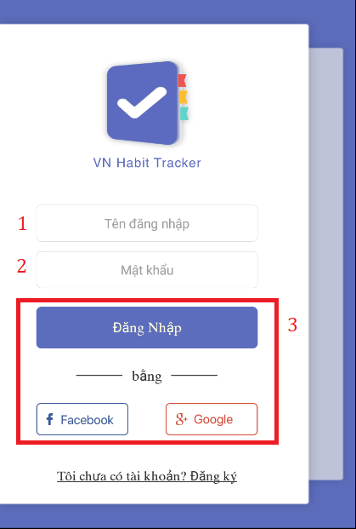

Figure 58 - User Guide <Login>

|  |  |
| --- | --- |
| Step | Description |
| 1 | Fill in field: “Tên đăng nhập” |
| 2 | Fill in field: “Mật khẩu” |
| 3 | Click on “Đăng nhập” button or “Facebook” button or “Google” button |

Table 94 - User Guide <Login>

* + 1. Register

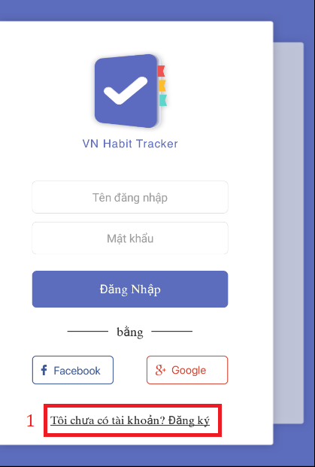

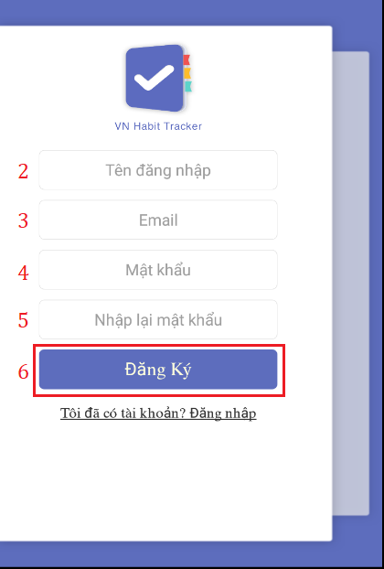

Figure 59 - User Guide <Register>

|  |  |
| --- | --- |
| Step | Description |
| 1 | Click on “Tôi chưa có tài khoản? Đăng ký” hyperlinks. |
| 2 | Fill in field: “Tên đăng nhập” |
| 3 | Fill in field: “EMail” |
| 4 | Fill in field: “Mật khẩu” |
| 5 | Fill in field: “Nhập lại mật khẩu” |
| 6 | Click on “Đăng ký” button. |

Table 95 - User Guide <Register>

* + 1. View Main Page

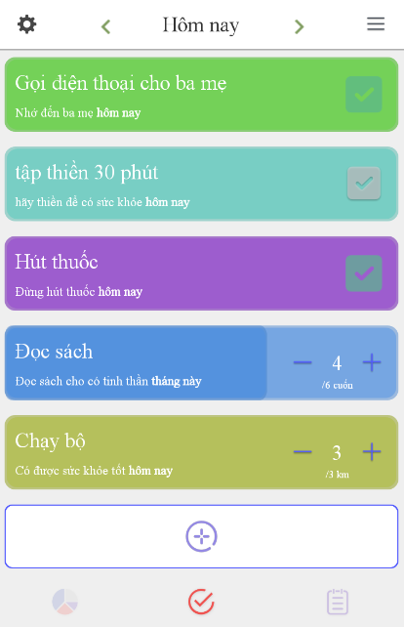

Figure 60 - User Guide <View Main Page>

* + 1. Add Habit

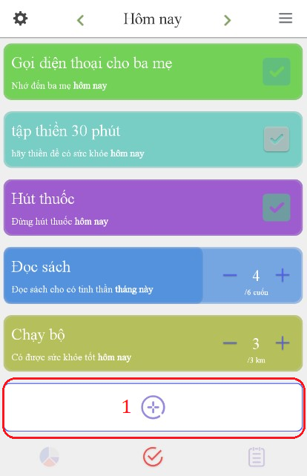

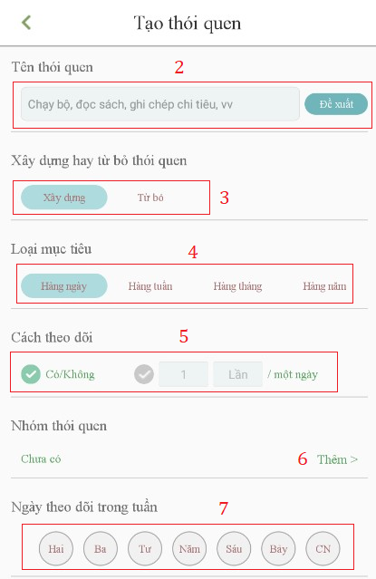

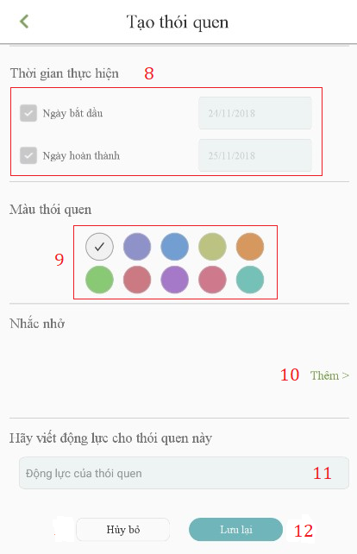

Figure 61 - User Guide <Add Habit>

|  |  |
| --- | --- |
| Step | Description |
| 1 | Click on “+” button. |
| 2 | Fill in field: “Tên thói quen” or click on “đề xuất” button. |
| 3 | Click choice “Xây dưng” or “Từ bỏ” button. |
| 4 | Click choice “Hàng ngày” or “Hàng tuần” or “Hàng tháng” or “Hàng năm” button. |
| 5 | Click choice “Có/Không” button or count time. |
| 6 | Click on “Thêm” hyperlink to add group habit. |
| 7 | Select date time to start and finish. |
| 8 | Set start date and finish date. |
| 9 | Click choice color button for habit. |
| 10 | Click on “Thêm” hyperlink to add reminder for habit. |
| 11 | Fill in field: “Động lực”. |
| 12 | Click on “Lưu” button. |

Table 96 - User Guide <Add Habit>

* + 1. Edit Habit

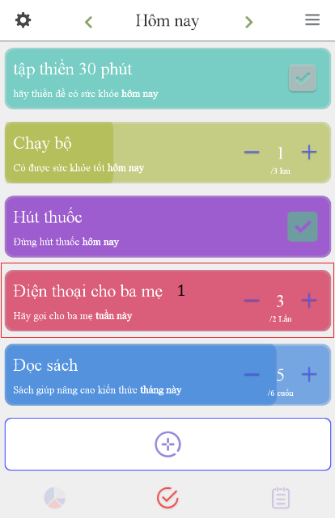

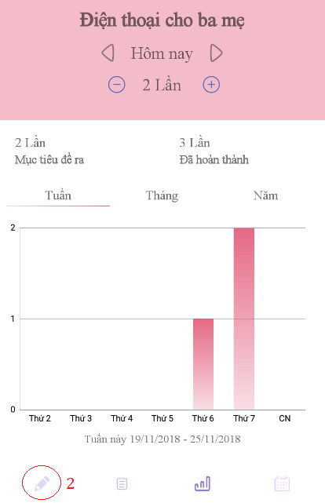

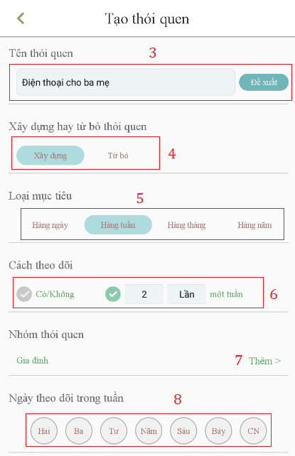

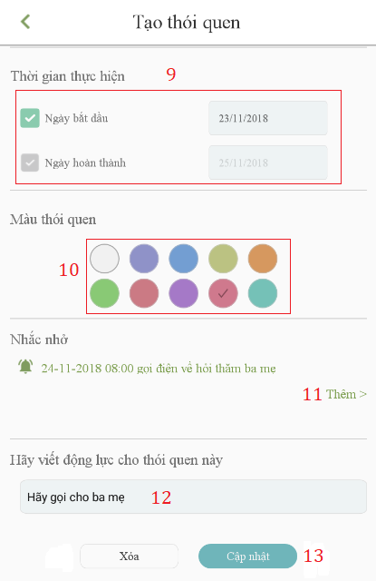

Figure 62 - User Guide <Edit Habit>

|  |  |
| --- | --- |
| **Step** | **Description** |
| 1 | Click into the habit. |
| 2 | Click Edit button. |
| 3 | Fill in field: “Tên thói quen” or click on “đề xuất” button. |
| 4 | Click choice “Xây dưng” or “Từ bỏ” button. |
| 5 | Click choice “Hàng ngày” or “Hàng tuần” or “Hàng tháng” or “Hàng năm” button. |
| 6 | Click choice “Có/Không” button or count time. |
| 7 | Click on “Thêm” hyperlink to add group habit. |
| 8 | Select date time to start and finish. |
| 9 | Set start date and finish date. |
| 10 | Click choice color button for habit. |
| 11 | Click on “Thêm” hyperlink to add reminder for habit. |
| 12 | Fill in field: “Động lực”. |
| 13 | Click on “Cập nhật” button. |

Table 97 - User Guide <Edit Habit>

* + 1. Delete Habit

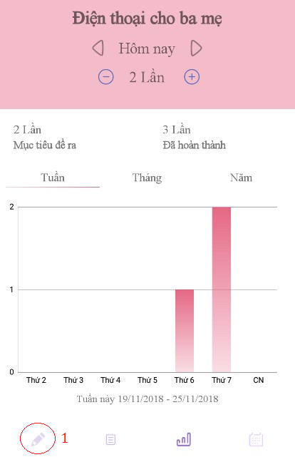

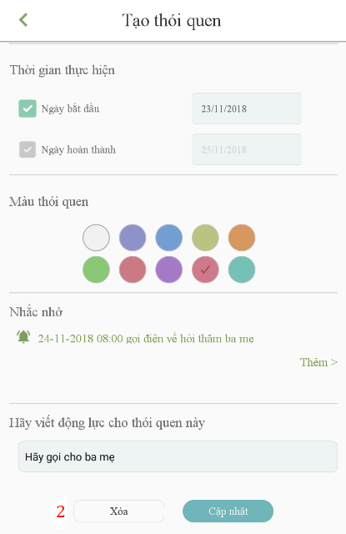

Figure 63 - User Guide <Delete Habit>

|  |  |
| --- | --- |
| Step | Description |
| 1 | Click Edit button. |
| 2 | Click on “Xóa” button. |

Table 98 - User Guide <Delete Habit>

* + 1. View All Statistic habit of User

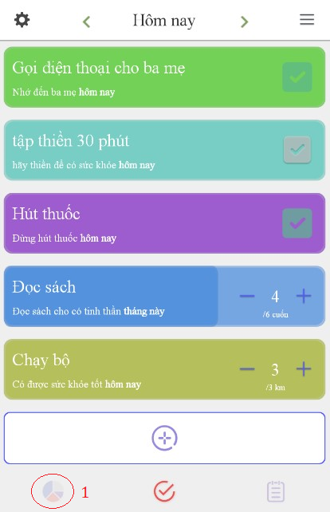

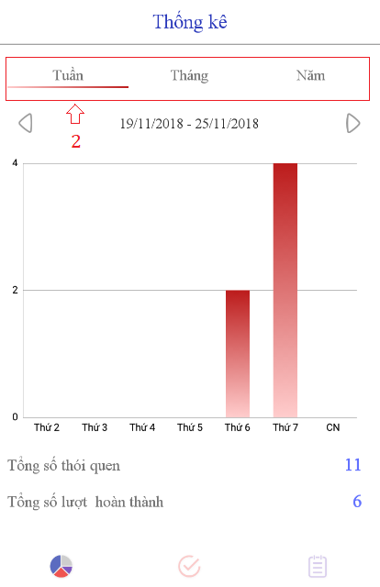

Figure 64 - User Guide <View All Statistic Habit of User>

|  |  |
| --- | --- |
| **Step** | **Description** |
| 1 | Click on Statistic button. |
| 2 | View statistic follow week, month, year. |

Table 99 - User Guide <View All Statistic Habit of User>

* + 1. Add Reminder

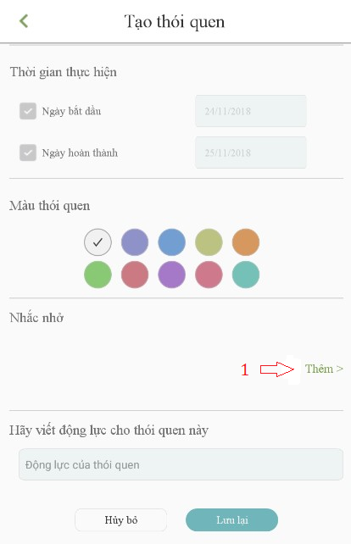

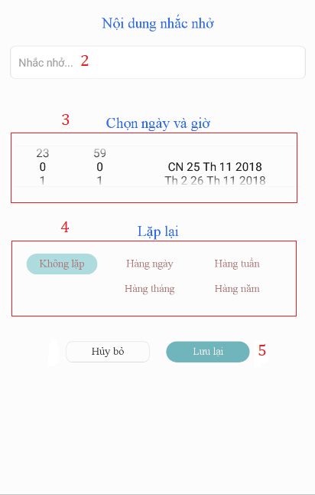

Figure 65 - User Guide <Add Reminder>

|  |  |
| --- | --- |
| **Step** | **Description** |
| 1 | Click on “Thêm” button. |
| 2 | Fill in field: “Tên đăng nhập”. |
| 3 | Set date and time. |
| 4 | Click choice “Hàng ngày” or “Hàng tuần” or “Hàng tháng” or “Hàng năm” button. |
| 5 | Click on “Lưu lại” button. |

Table 100 - User Guide <Add Reminder>

* + 1. Delete Reminder

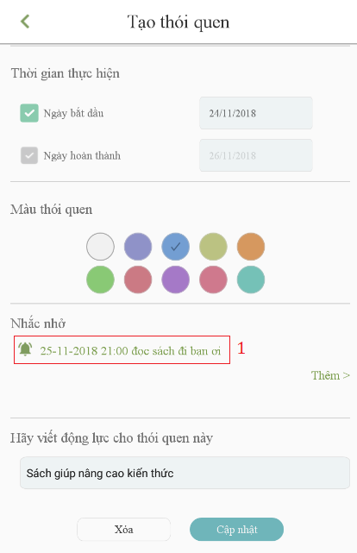

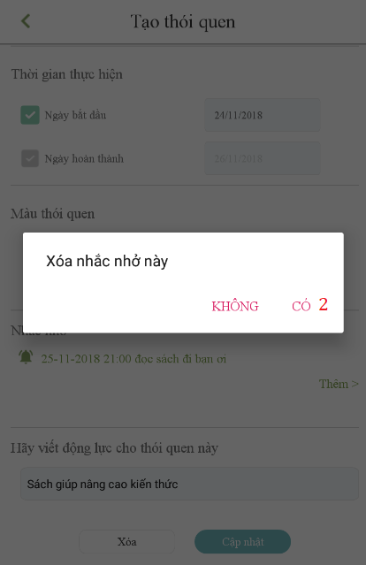

Figure 66 - User Guide <Delete Reminder>

|  |  |
| --- | --- |
| **Step** | **Description** |
| 1 | Click on reminder. |
| 2 | Click on “Có” button. |

Table 101 - User Guide <Delete Reminder>

* + 1. Add Group

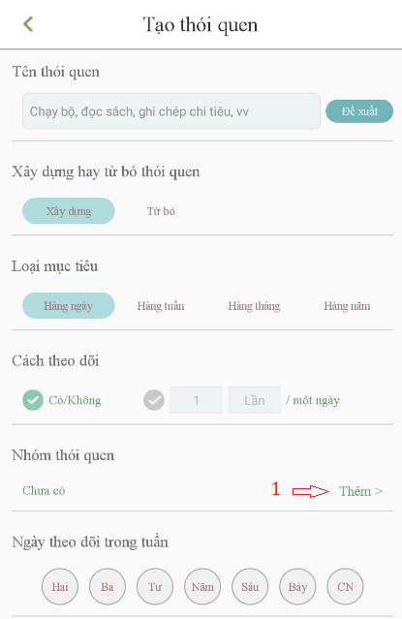

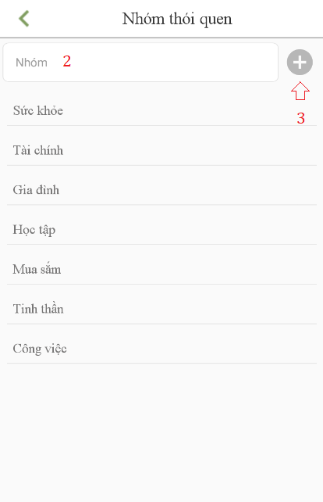

Figure 67 - User Guide <Add Group>

|  |  |
| --- | --- |
| **Step** | **Description** |
| 1 | Click on “Thêm” button on “Nhóm thói quen” required field. |
| 2 | Fill in field: “Nhóm”. |
| 3 | Click on “+” button. |

Table 102 - User Guide <Add Group>

F1. ソフトウェアユーザーマニュアル

1.インストレーションガイド

* + 1. ハードウェア要件

|  |  |
| --- | --- |
| ハードウェア | 記述 |
| インターネット | 8 Mbps以上 |
| プロセッサー | Intel® Core(TM) i5 CPU , M 460 @ 2.53GHz以上 |
| RAM | 4GB以上 |
| ハードディスクドライブ | 40GB 以上 |

Table 103 - ハードウェア要件

* + 1. ソフトウェア要件

|  |  |
| --- | --- |
| ソフトウェア | アプリケーション名前／バージョン |
| オペレーティングシステム | Window 10 Pro-64bit |
| 環境 | VueJS 2.0 |
| DBMS | Microsoft SQL server 2014 v17.4 |
| ソース管理 | Github |
| ウェブブラウザ | Chrome 63 以上 |

Table 104 - ソフトウェア要件

2. ユーザーガイド

* + 1. ログイン



Figure 68 - ユーザーガイド <ログイン>

|  |  |
| --- | --- |
| ステップ | 説明 |
| 1 | ユーザー名の内容を入力します。 |
| 2 | パスワードの内容を入力します。 |
| 3 | 「Login 」のボタンをクリックします。 |

Table 105 - ユーザーガイド <ログイン>

* + 1. 登録





Figure 69 - ユーザーガイド <登録>

|  |  |
| --- | --- |
| ステップ | 説明 |
| 1 | 「Tôi chưa có tài khoản？ Đăng ký」ハイパーリンクをクリックしてください。 |
| 2 | フィールドに入力してください：「Tên đăng nhập」 |
| 3 | フィールドに入力してください:「EMail」 |
| 4 | フィールドに入力してください:「Mật khẩu」 |
| 5 | フィールドに入力してください:「Nhập lại mật khẩu」 |
| 6 | 「Đăng ký」ボタンをクリックしてください。 |

Table 106 - ユーザーガイド <登録>

* + 1. メインページを見る



* + 1. 習慣を追加する





Figure 70 - ユーザーガイド <習慣を追加する>

|  |  |
| --- | --- |
| ステップ | 説明 |
| 1 | 「+」ボタンをクリックします。 |
| 2 | フィールドに入力してください:「Tên thói quen」または 「đề xuất」ボタンをクリックします。 |
| 3 | クリックして選択「Xây dưng」または「từ bỏ」ボタンをクリックします。 |
| 4 | 「Hàng ngày」または「Hàng tuần」または「Hàng tháng」または「Hàng năm」ボタンをクリックします。 |
| 5 | 「Có/Không」ボタンまたは「count time」ボタンをクリックします。 |
| 6 | グループの習慣を追加するには「Thêm」ハイパーリンクをクリックしてください。 |
| 7 | 開始日と終了日を選択します。 |
| 8 | 開始日と終了日を設定します。 |
| 9 | 習慣の色を選択してください。 |
| 10 | 「Thêm」ハイパーリンクをクリックして、習慣のためのリマインダを追加します。 |
| 11 | フィールドに入力してください:「Động lực」. |
| 12 | 「Lưu」ボタンをクリックしてください。 |

Figure 71 - ユーザーガイド <習慣を追加する>

* + 1. 習慣を編集する









Figure 72 - ユーザーガイド <習慣を編集する>

|  |  |
| --- | --- |
| **ステップ** | **説明** |
| 1 | 習慣をクリックしてください。 |
| 2 | 「編集」 ボタンをクリックします。 |
| 3 | フィールドに入力してください:「Tên thói quen」または「đề xuất」ボタンをクリックします。 |
| 4 | クリックして選択「Xây dưng」または「từ bỏ」ボタンをクリックします。 |
| 5 | 「Hàng ngày」または「Hàng tuần」または「Hàng tháng」または「Hàng năm」ボタンをクリックします。 |
| 6 | 「Có/Không」ボタンまたは「count time」ボタンをクリックします。 |
| 7 | グループの習慣を追加するには、「Thêm」ハイパーリンクをクリックしてください。 |
| 8 | 開始日と終了日を選択します。 |
| 9 | 開始日と終了日を設定します。 |
| 10 | 習慣のために選択色のボタンをクリックしてください。 |
| 11 | 「Thêm」ハイパーリンクをクリックして、習慣のためのリマインダを追加します。 |
| 12 | フィールドに入力してください: 「Động lực」. |
| 13 | 「Cậpnhật」ボタンをクリックします。 |

Table 107 - ユーザーガイド <習慣を編集する>

* + 1. 習慣を削除する





Figure 73 - ユーザーガイド <習慣を削除する>

|  |  |
| --- | --- |
| ステップ | 説明 |
| 1 | 「編集」ボタンをクリックします。 |
| 2 | 「Xóa」ボタンをクリックしてください。 |

Table 108 - ユーザーガイド <習慣を削除する>

* + 1. ユーザーの全統計を表示





Figure 74 - ユーザーガイド <ユーザーの全統計を表示>

|  |  |
| --- | --- |
| **ステップ** | **説明** |
| 1 | 統計ボタンをクリックします。 |
| 2 | 週、月、年の順に統計を表示します。 |

Table 109 - ユーザーガイド <ユーザーの全統計を表示>

* + 1. リマインダを追加する





Figure 75 - ユーザーガイド <リマインダを追加する>

|  |  |
| --- | --- |
| **ステップ** | **説明** |
| 1 | 「Thêm」ボタンをクリックしてください。 |
| 2 | フィールドに入力してください: 「Tên đăng nhập」。 |
| 3 | 日付と時刻を設定します。 |
| 4 | 「Hàng ngày」または「Hàng tuần」または「Hàng tháng」または「Hàng năm」ボタンをクリックします。 |
| 5 | 「Lưu lại」ボタンをクリックしてください。 |

Table 110 - ユーザーガイド <リマインダを追加する>

* + 1. リマインダを削除する





Figure 76 - ユーザーガイド <リマインダを削除する>

|  |  |
| --- | --- |
| **ステップ** | **説明** |
| 1 | リマインダーをクリックします。 |
| 2 | 「Có」 ボタンをクリックしてください。 |

Table 111 - ユーザーガイド <リマインダを削除する>

* + 1. グループを追加





Figure 77 - ユーザーガイド <グループを追加>

|  |  |
| --- | --- |
| **ステップ** | **説明** |
| 1 | 「Nhóm thói quen」必須フィールドの 「Thêm」ボタンをクリックしてください。 |
| 2 | フィールドに記入する：「Nhóm」。 |
| 3 | 「+」ボタンをクリックします。 |

Table 112 - ユーザーガイド <グループを追加>

1. Appendix
2. Sofware Engineering 9th Edition, By Ian Sommerville
3. StarUML Documentation For Activity Diagram

http://www.uml-diagrams.org/activity-diagrams-controls.html

1. **StarUML Documentation of IBM**

<https://www.ibm.com/developerworks/rational/library/content/RationalEdge/sep03/f_umlbasics_db.pdf>

1. UML For Drawing Diagram (2.0 Standard)

<http://www.omg.org/spec/UML/2.0>

1. Android Studio Documentation

https://developer.android.com/docs/